Confidentiality:
In the interests of all our patients we operate a strict code of confidentiality in accordance with Caldicott Guidelines, GDPR and the Data Protection Act. We will share this information inside the NHS or with outside organisations only if it is necessary for your treatment and care. Anyone who receives information about you from us is also under a legal duty to keep it confidential.

The Doctors, Nurses and Administration staff will never reveal any details about you or your health unless you ask us to.

If you are over 13 years old, you can expect confidential treatment from your Doctor or Nurse as long as they believe you fully understand what is involved. We will only tell others in an extreme case if we feel you are at risk- e.g. at risk of abuse- and we will discuss this with you first.

You have the right to access any personal information held under the Data Protection Act. You can do this through Online Access, the NHS App or requested directly from the practice.

Complaints, Compliments and Feedback:
We aim to provide a high quality of service; however, we recognise that misunderstandings can occur, and this may cause complaints to arise. Often an early resolution can be achieved by discussing the matter with appropriate practice personnel. Please contact the Practice Manager if you wish to register a complaint.
There are other bodies which you can complain to. Please see our Practice Complaints Procedure.
We also love to hear your positive feedback. Please contact the Practice Manager if you feel we have done well.
We value our patient’s opinions and welcomes your constructive suggestions/comments. These can be given to reception staff. Please consider filling out the Friends and Family test which is available in reception and on our website.

Non-NHS Services:
For non-NHS work such as medical examinations, reports and certificates etc., you will be charged.
Please ask the receptionist of the expected cost. You will be required to pay at the time of appointment or on request for completed documentation.

Disabled Access:
The premises are accessible to disabled patients although parking is limited in the area.

Patient Participation Group:
We are always looking for patients to join our Patient Participation Group. This is a group of practice patients who reflect our patient demographic, represent patients as a group and are happy to be contacted and get involved in helping us to continually assess and improve our services. If you would like to be a member of the group and help us to shape the future of the practice, please contact the Practice.

Change of Contact Details:
Please ensure you update your contact details should they change. This includes your address, your home telephone number, your mobile telephone number or your email address.
We can only use the current information we have for you. If this is not kept up to date, we may not be able to contact you when necessary.
We will use letters from hospitals etc to keep address history updated. If the addresses differ from the details, we have for you, you may be asked to provide up to date proof.
If you move out of the area, you will be asked to register with a GP closer to your new home. You will be given 28 days to find a new GP Practice.

Please see our website for more detailed information on the services we provide or enquire at reception

You may also wish to view the NHS website: www.nhs.uk

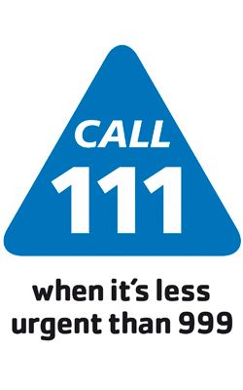
Welcome to
Cheetham Hill & Queens
Medical Centres

244 Cheetham Hill Rd
Cheetham Hill
Manchester
M8 8UP

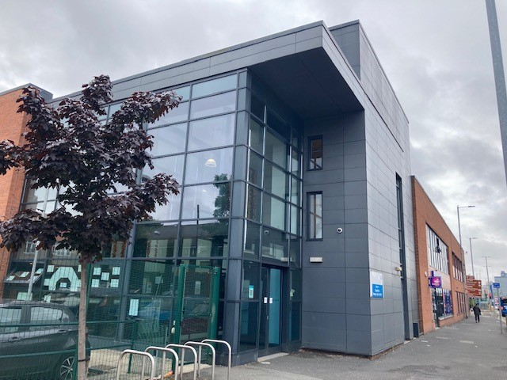

Opening Hours:
Monday - Friday 8.00am – 6.30pm
Closed Bank Holidays

Branch Site
58 Rochdale Rd, Manchester
Telephone: 0161 805 4777

Telephone: 0161 277 6939
Email: NMCCG.admin.CHQ@nhs.net
www.cheethamhillmedicalcentre.co.uk

Out of Hours GP service
Outside of the hours 8am – 6.30pm excluding weekends and bank holidays call 111 or attend a Walk In Centre:

Walk In Centres are available 7 days per week 8am – 8pm at

- North Manchester General as part of an integrated A&E Dept
- City Centre Health 2nd floor Boots 32 Market Street
GP Partners/Salary GPs:
Dr Asad Bokhari
Dr Amjad Ahmed
Dr Farah Kulsoom
Dr Jason Wong
Dr Balveer Della Penna
Dr Vicky Hough
Dr Zainab Naqvi

Specialist Interests:
All the Drs are involved in routine medical care but in addition we offer a range of specialist expertise. Areas of interest include child health, diabetes and minor surgery. Please enquire at reception.

Advanced Nurse Practitioners, Practice Nurses and Health Care Assistants:
Our nursing team provides a wide range of services including asthma, diabetes, COPD, travel health, baby vaccinations.

Assistant Practice Manager: Stacey Simpson
Business Manager: Mike Neville

Reception, & Administrative Staff:
The receptionists and administrative team members are the vital co-ordinators in ensuring the smooth running of the practice and that our patients receive equitable access to our resources. In order to ensure your enquiry is dealt with quickly and efficiently they may have to ask for further information about your condition.
They are bound by the same rules of patient confidentiality as the doctors and nurses.

Other Healthcare Professionals involved with the practice include:
- Primary Care Pharmacists
- Physician Associates
- District Nursing + Macmillan Nurses
- Community Midwives
- Primary Care Mental Health Team

Baby Immunisation clinic is by appointment on Tuesday mornings.

Ante natal clinic: Is held at Woodville Sure Start Children’s Centre, Shirley Road, M8 0NE. Please call the midwives on 0161 720 2133 to make an appointment. You do not need to be referred by a Doctor.

New Patients:
We are happy to accept new patients residing or
moving into our practice area.
Where appropriate please bring your completed registration form together with photographic proof of identity which will help us quickly obtain your medical records from your previous GP practice.
Although we accept the registration of patients outside our practice boundary, you will not be eligible for home visits. In addition to this, some community services will not treat you based on your location. You may be asked to change GP practice should you need to access these services.

Translators:
If you require a translator, please let reception know.
We will normally use a telephone-based interpretation service.

Rights and Responsibilities:
The Practice supports the Government’s NHS zero tolerance
campaign. We ask that you treat all practice staff with respect and courtesy. We have a zero-tolerance policy regarding abusive behaviour and language including racism, sexism, homophobia etc.
We do not tolerate violent or abusive behaviour, and this may result in your removal from the practice list.

Patients have the right to express a preference of practitioner. We will usually be able to accommodate this but cannot guarantee this.

What we will do for you:
- You will be treated in a polite and respectful manner.
- The surgery will be clean and comfortable as far as facilities allow.
- You have the right to confidentiality at all times
- The Doctors endeavour to see patients on time, but sometimes may be delayed helping another patient.
- You will be able to see your medical records subject to the limitations of the law.

What we ask of you:
- That you be available for all your appointments on time.
- Should you need to cancel your appointment give as much notice as possible BUT ALWAYS LET THE PRACTICE KNOW so that we can offer the appointment to other patients.
- You should treat all practice staff with courtesy
- Request help and advice on non urgent matters only during surgery hours.
Appointments:
Routine consultations can be booked up to 6 weeks in advance.
Urgent appointments are available daily, please contact surgery at 8.00am.

Telephone Consultations:
Are available daily and we are happy to give advice over the telephone. Please book with reception.

Please note, the appointment may not always be with the Doctor of your choice. Our reception staff are trained to direct you to the most appropriate health care professional. This could be a GP, Advanced Nurse Practitioner, Pharmacist, Physicians Associate, Physiotherapist, Practice Nurse or Health Care Assistant.

Home Visits:
If the patient is housebound or too ill to leave home and requires a home visit, please telephone the surgery preferably before 11am. The doctor will call first to determine the best course of action.

Results:
You can call for your test results Monday - Friday after 10.30am. To ensure confidentiality we only release results to the patient unless alternative arrangements have been agreed in writing. We do not phone patients with test results unless medication is urgently required.

Repeat Prescriptions:
We operate a responsible repeat prescribing policy. On occasions you will be advised to see a doctor or nurse before you receive your next regular prescription. We aim to have prescriptions authorised by your doctor available for collection within 48 hours (excludes weekends/holidays). Alterations to items on your prescription or new items added by the hospital may take slightly longer to prepare.
Order your repeat prescription by:-
- Submitting your completed tear off strip to the surgery by hand, email or post (not by phone)
- Using the NHS App or through online access
- via the chemist, please speak to your pharmacist about this service. We now offer the electronic prescription service (EPS).
Any repeat medications will need to be reviewed at least every year.

