FRIENDS & FAMILY
RESULTS FEEDBACK
April 2022

96% of patients have said they were extremely likely or likely to recommend our practice!
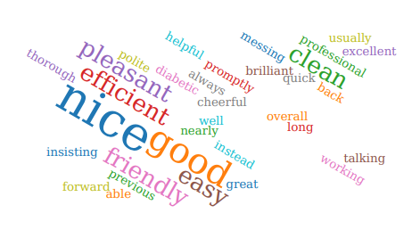
Thank you to everyone who participated in the survey. 24/25 people who responded in APRIL 2022 felt our service was either good or extremely good. 1 person rated our service as “Neither good nor poor”.

We were extremely grateful to receive so many lovely compliments about the care you receive here.

Thank you so much, it is very much appreciated by all the team

We will review all your comments with our PPG at our next meeting.

A full report is available on the practice website

