FRIENDS & FAMILY FEEDBACK
AUGUST 2022

Wow 100% of patients have said they were extremely likely or likely to recommend our practice!

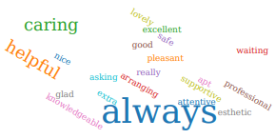
Thank you to everyone who participated in the survey. Everyone who responded in AUGUST 2022 felt our service was either good or extremely good.

We were extremely grateful to receive so many lovely compliments about the care you receive here, it is very much appreciated by the staff team.

We will review all of your comments with our PPG at the next meeting.

A full report will be published on the practice website.

