FRIENDS & FAMILY FEEDBACK
August 2023

Last month 96% of patients have said they thought we are a very good or good practice!
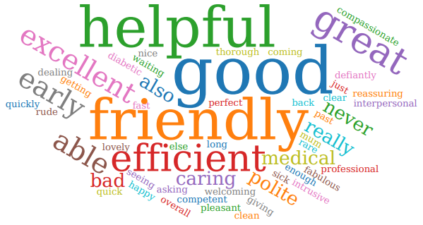
Thank you to everyone who participated in the survey. Everyone who responded in April 2023. 45/50 of those who responded felt our service was either good or extremely good 3 people did not comment. Sadly, 2 patients rated the service as poor. Due to reviews being left anonymously, we have been unable to reach out to these patients to establish what went wrong.

We were extremely grateful to receive so many lovely compliments about the care you receive here, it is very much appreciated by the staff team.

We will review all your comments with our PPG at the next meeting.

A full report will be published on the practice website.

