FRIENDS & FAMILY FEEDBACK
JUNE 2022

86% of patients have said they were extremely likely or likely to recommend our practice!

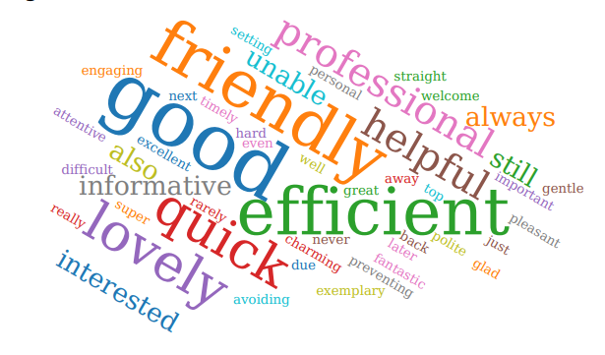
Thank you to everyone who participated in the survey. 38/44 people who responded in JUNE 2022 felt our service was either good or extremely good. 5 people rated our service as “Neither good nor poor” or “Don’t know”. 1 patient rated the service as “Very poor”, however following the feedback left by the patient we were able to identify and resolve the issue accordingly.

We were extremely grateful to receive so many lovely compliments about the care you receive here, it is very much appreciated by the staff team.

We will review all of your comments with our PPG at the next meeting.

A full report will be published on the practice website.

