FRIENDS & FAMILY FEEDBACK
SEPTEMBER 2022

Last month 92% of patients have said they thought we are a very good or good practice!
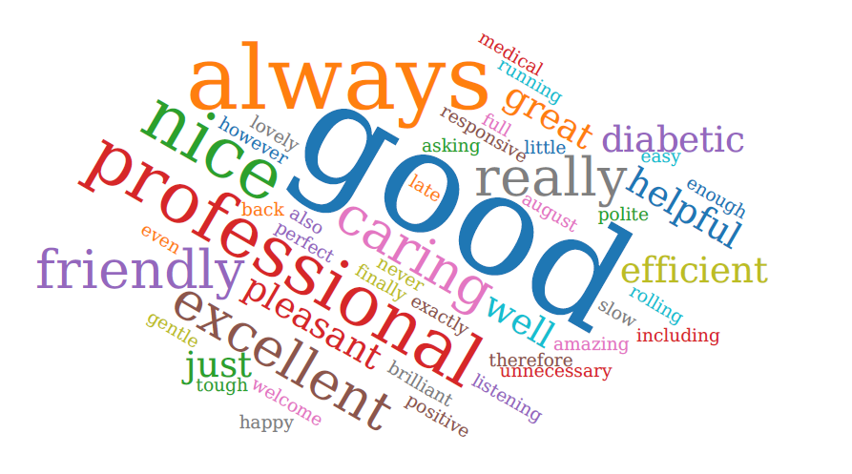
Thank you to everyone who participated in the survey. Everyone who responded in SEPTEMBER 2022. 44/48 of those who responded felt our service was either good or extremely good. 4 people felt we were neither good/bad.

We were extremely grateful to receive so many lovely compliments about the care you receive here, it is very much appreciated by the staff team.

We will review all of your comments with our PPG at the next meeting.

A full report will be published on the practice website.

