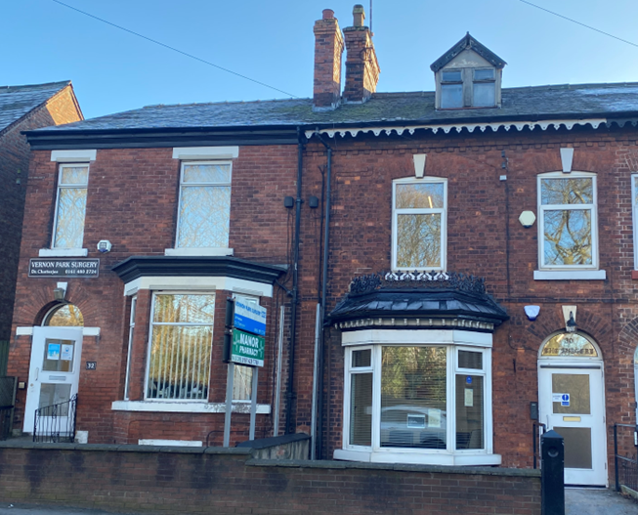
Test Results:
Blood and Urine test results are normally available after 4 working days.
The easiest and quickest way to access your results is via NHS App.
Cervical smear results are normally back within up to 4 weeks however, you will receive a result through the post.
Please phone after 11.00am for results.
The doctor will state whether the results are normal or abnormal and what further action is required, if any.
Please hand any samples into reception before 2pm Monday to Friday.

Complaints
Vernon Park aims to give a friendly and professional service to all our patients. However, if you have any concerns about any aspect of our service, please let us know.
Speak to whomever you feel most comfortable – your GP, our Practice Manger or our reception staff will be happy to help.
In majority of cases, concerns can be resolved easily. However, if you feel we have not dealt with the issues you have raised as you would wis, you can write to:
Complaints,
Stockport – NHS GM,
1st Floor, Stopford House
Piccadilly
Stockport
SK1 3XE

Or by email: gmicb-sto.contactus@nhs.net

Prescriptions:
Vernon Park has an onsite pharmacy – Manor Pharmacy where patients can have their prescriptions dispensed if it is more convenient.
Manor Pharmacy Contact: 0161 429 7769
Repeat Prescriptions ordering:
- Online – The NHS app is the quickest and most convenient way to order repeat prescriptions with the click of a button.
- In person – Please bring your repeat prescription slip or through your local Pharmacy.
- By Post – Post your request to us with a stamped self-addressed envelope.

Pharmacy First Scheme:
Pharmacy First will enable community pharmacists to supply prescription-only medicines, including antibiotics and antivirals where clinically appropriate, to treat seven common health conditions without the need to visit a GP.
What are the seven common conditions?
- Sinusitis
- Sore throat
- Earache
- Infected insect bite
- Impetigo (a bacterial skin infection)
- Shingles
- Uncomplicated urinary tract infections in women.

VERNON PARK SURGERY
30-32 Brinnington Road,
Vernon Park,
Stockport,
SK1 2EX
Telephone: 0161 983 5484
Email: gmicb-sto.vernonpark@nhs.net
Website: www.vernonparksurgery.nhs.uk
Facebook: VernonParkDoctorSurgery

PRACTICE LEAFLET
A guide to our service

The practice operates a zero-tolerance policy. Anyone who abuses the doctors, staff, or other patients verbally or physically or behaves in a threatening manner will be removed from the practice list.

The Practice premises have access for disabled patients.

Our Team
Doctors:
Dr Suvajit Chaterjee (M)
MMBS 1998, DLO 2003, MRCGP 2008
Dr Saqib Rafique (M) – Salaried GP
MMBS 1993, MRCGP 2002

Nurses:
Chelsea Pape (F) - Practice Nurse
Michelle Trelfa (F)- Assistant Practitioner
Sarah Robinson (F) – Trainee Nurse Associate

Administration Team:
Ilham Yasser - Practice Manager
Sandra - Receptionist
Debbie - Receptionist
Natalie - Receptionist
Marie - Receptionist
Maria – Receptionist

We have other professionals who work with us on behalf of the Tame Valley PCN.
Physio – Nick and Cathleen
Mental Health Care Coordinator –
Cancer Care Coordinator – Diane
Dementia & Frailty Health Coach – Victoria and Cheryl
Employment Supper Health Coach – Ed
Wellbeing Coordinator – Homara
Midwife appointments are held at the Brinnington Health Centre – to book an appointment, please contact our reception team.
For more PCN information visit www.tamevalleypcn.nhs.uk
(Vernon Park is a training practice, undergraduate medical students from Manchester University are placed here for a few weeks in a year to gain experience, your records may be used for educational purposes with your consent)

Surgery times and Appointments
GP appointments are available for F2F and telephone consultation Mon-Fri – times do vary.
MONDAY
Reception Opening Hours: 8am to 6:30pm
Nurse consultations are available from 8am to 5pm

TUESDAY
Reception Opening Hours: 8am to 6:30pm
Nurse consultations are available from 8:30am to 3pm

WEDNESDAY
Reception Opening Hours: 8am to 6:30pm
Nurse consultations are available from 9am to 5:30pm

THURSDAY
Reception Opening Hours: 8am to 6:30pm
Nurse consultations are available from 9:30am to 2:30pm

FRIDAY
Reception Opening Hours: 8am to 6:30pm
Nurse consultations are available from 8:30am to 3:30pm
OUT OF HOURS EMERGENCIES
Please visit 111 online queries for out of hours after 6:30pm or 999 in case of an emergency.

Appointments
For non-urgent appointments – please submit your query online using the NHS app with your medical problem and the doctor will contact you after triage.
For urgent appointments, please ring reception at 8am to book an appointment.
As part of the PCN extended clinics, we open certain Saturdays quarterly upon allocation - check our website for dates.
Home Visits
Home visits are reserved for patients who are housebound or too ill to come into the surgery. If you require a visit, please phone before 10am.
You will be asked what the reason for the home visit is and whether you can attend the Surgery. This is to enable to receptionist to pass on the correct details to the doctor. (If appropriate the Doctor may offer a Telephone Consultation instead of a home visit.)
We offer a full general practice services including:
- Cervical Screening
- Child Health & Immunisations
- Asthma Checks
- Diabetic Monitoring
- Blood Pressure Monitoring
- Stop smoking clinics.
- Cardiovascular screening & prevention
- Blood taking
- New patient checks
- Contraception
- Travel Health
- Health Education

