PPG Meeting Minutes – 16 January 2024
Flixton Road Medical Centre Patient Participation Group (PPG) minutes
Tuesday 16 January 2024
Venue – Flixton Road Medical Centre
Attendees:
- Dr M A Khan (Chair)
- Dee Radcliffe (Assistant Practice Manager)
- Sandra Everett
- On-line Sarah Fraser (Bowfell)
Apologies: Jilly Trout, Justine Alderman, and Amna – Anne Challis
Subject | Description | Raised by | Action by
1. Welcome and Introductions | The Chair Dr Khan welcomed everyone to the meeting, apologies as noted above.
2. Apologies | As noted, above.
3. Minutes & actions arising from the last meeting | The draft minutes of the meeting held on the 19 September 2023, had previously been circulated, to all members.  The minutes were accepted by members as a true and accurate record of the meeting.
4. Matters arising | Possible run a poll on our website to ascertain if patients are aware of the group – please see agenda item 5.
5. PPG poll Results Dec 2023/Jan 2024 | Noted  - The results of the PPG poll were presented by the assistant practice manager.  - The presentation covered the poll sent out to patients via our accuRx text service.  Discussed  - The membership of the PPG is low, we had 3 original members and have recently had two care homes added to the membership.  - The total response to the poll was 2014.  The survey questions.  - Are you aware of the Patient Participation (Group) at our practice?  - Would you like more information?  - Are there any issues you would like the group to raise on your behalf.  Are you aware of the Patient Participation (Group) at our practice?  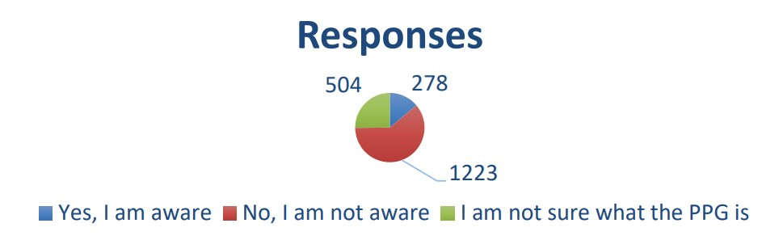  Would you like more information?  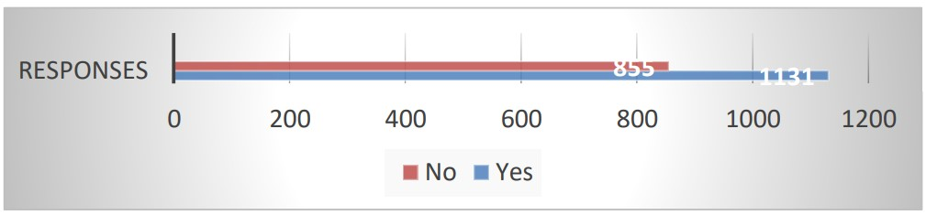  Are there any issues you would like the group to raise on your behalf.  Top picks:  - Need to know more about the group before I can answer the question.  - More accessible appointments.  - None. Fantastic surgery!  - I always very pleased with the service received from this practice being a patient for over 25 years.  - The only issue has been the slow response time to ask my GP.  A discussion ensued that patients need clarity around what the PPG, a letter has been sent to the patient who wrote asking for more information. The letter included the  following:  The patient Participation Group is a forum where patients can contribute their perspectives and insights to help shape the delivery of healthcare services within our practice. It provides an opportunity for open discussions and collaborative efforts between the practice staff and patients to enhance the overall patient experience.  Purpose of the Patient Participation Group:  The primary goal of the PPG is to foster effective communication and partnership between the practice and its patients. By participating in the group, you will have the chance to share your experience, suggestions, and any ideas that can influence positive changes in the services we provide.  Terms Of Reference (TOR):  The Terms of Reference outline the purpose, structure, and operation of the PPG. They serve as a guide to ensure that the group functions effectively and in alignment with its objectives. If you are interested, we can provide you with a copy of the TOR for your perusal.  We advised patients that if they wished to discuss other aspects of the practice and the service we provide, they could write to the assistant practice manager Dee Radcliffe.  Agreed  Design a poster for our website to attract patients. The poster to be sent to Bowfell care to include in their weekly newsletter.  To link with the West Neighbourhood network for help with recruiting members | Members | DRR
6. Friends and Family Test results Dec 2023 | Noted  - The results of the Friends and Family were presented by the assistant practice manager.  Discussion  - Members discussed the results.  Thinking about your GP practice  Overall, how was your experience of our service?  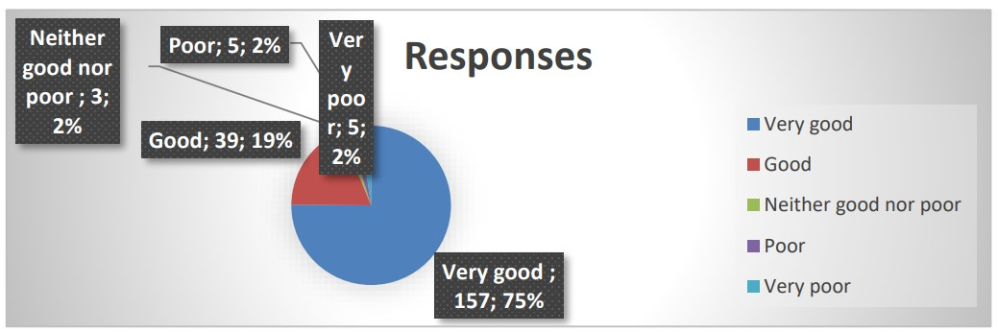  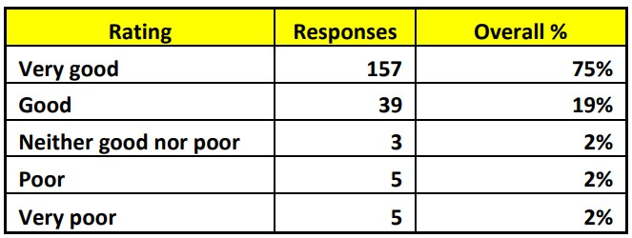  Agreed  Member agreed the results of the friends and family were overall very good, examples of poor and very poor comments, where patient have suggested changes need to be made will be added to our action plan for the surgery. |  | DRR
7. Veteran Friendly Practice Accreditation – Sandra Everett | Noted  - Member Mrs Sandra Everett brought the agenda item, to ascertain if the practice was Armed Forces veteran friendly accredited.  Discussed  - The practice achieved accreditation on 11 September 2022.  - The assistant practice manager has arranged a meeting with The Trafford Veteran organisation to ascertain how we can work together to promote the service.  Agreed  - Approach James Bowman BA Hons CMgr FCMI, Regional Lead Northwest RCGP Veteran Friendly Accreditation Programme for a copy of the accreditation certificate and supporting documents.  - Our website to be updated with the information. |  | DRR
8. Any other Business | - No other business was discussed.  - The chair deemed the meeting closed.
9. Date of next meeting | - The date of the next meeting is scheduled for Tuesday 14 May 2024 at 12:30 pm.  - The Date and time will be circulated for members to confirm their attendance.

