**A guide to using Social Media for Job searching**



**LinkedIn - Is a powerful networking tool for both jobseekers and business but there are rules to follow. Linkedin is the Facebook for professionals and it’s nothing like Facebook!**

[LinkedIn](http://linkedin.com) – To join LinkedIn use the hyperlink on the left, complete the information and click on ‘join now’. This will take you through setting up your profile step by step. Remember LinkedIn is a professional job search website, therefore you should be displaying a photo that reflects the professional you. We have some handy hints in the LinkedIn section!



**Twitter - Is a social networking service in which people can post comments on any matter they wish. It is fast paced and updated in real time. Users are limited to 140 characters per tweet which contributes to the speed of Twitter.**

[Twitter](http://www.twitter.com) – To join Twitter go to the “new to Twitter” section, enter the required details and sign up! This will take you through the relevant sections that you will need to complete. Please see our Twitter section for help.



**Facebook - Is used primarily for connecting with friends or people you know and reconnecting with people from the past. However, it can also be an effective networking tool.**

[Facebook](http://www.facebook.com) – To join Facebook use the hyperlink on the left, complete the information and click sign up. This will take you through setting up your profile page where you can add as much or as little personal information you want, and upload photos as required. See our Facebook section for more information.

##### Privacy and protecting your career prospects

##### Throughout the guide we have included information for each social media site on how to use it securely.

##### At the end of the guide you will find more general information on how to stay safe and use social media.

**Security**

Stay secure!

* A lot of people can find Social Media scary. It is well documented that social media can be used in a harmful way. Understandably people can be concerned about personal information being out in the public domain and conversations taken out of context.
* **However you can protect yourself against these as much as possible by applying the correct security settings and thinking about what you write before you write it.**
* **Remember potential employers can and will search your name online, bringing up accounts you have on all types of social media including Youtube! If you apply the correct security settings you should not be concerned. If you haven’t and your profile is public then potential employers can see everything on your page.**
* You need to think about the impact on others before you write a post or upload a picture, especially when you are job seeking. Anything that could damage your career prospects and could be used against you, simply just don’t write it!
* Applying the correct security settings means that no-one can see your personal information if you don’t want them to.
* Please remember NEVER to give out your bank details on social media. If you are asked for them report urgently to the appropriate website - you can often find assistance through the help section on each social media site (this doesn’t just apply to security issues).
* If something doesn’t sound or feel right, use your instincts and remember you don’t have to remain connected to that person/company. You can use the blocking facilities available with each social media site.

**Above all remember it is your account so if you aren’t happy with content from other people then it is in your control to disconnect yourself from them.**

Acknowledgements:

Stuart Mackinnon

Facebook

LinkedIn

Twitter

Ruth Thompson



LinkedIn

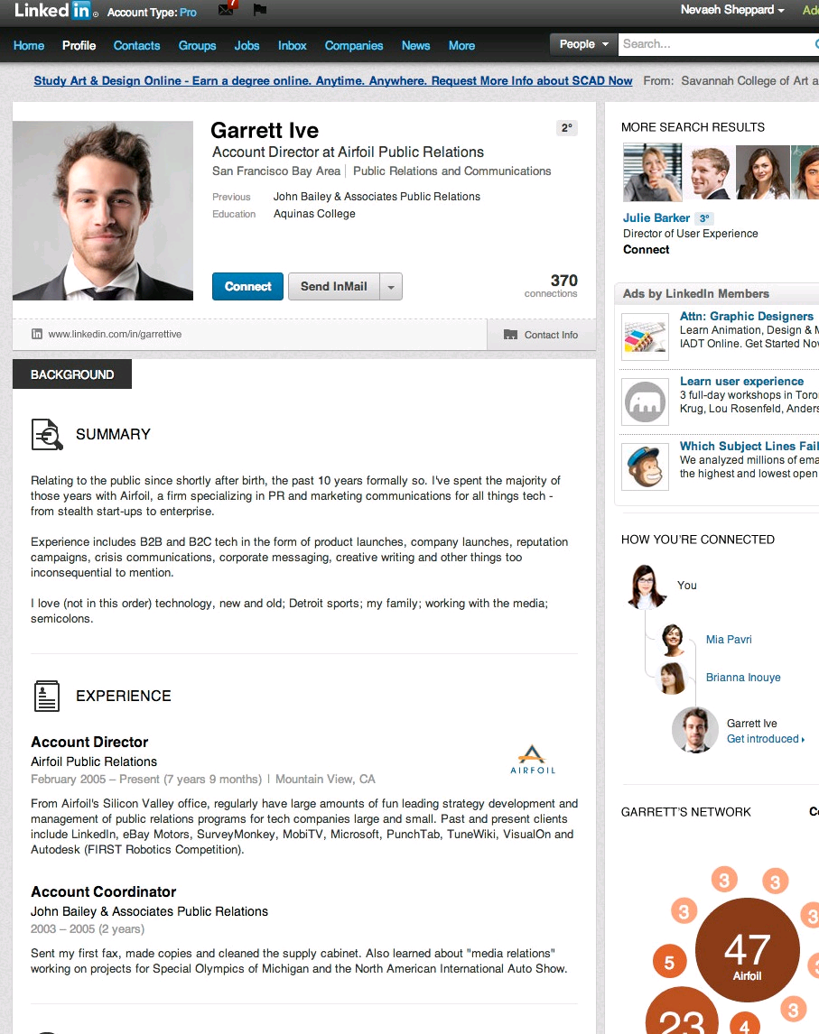

**After setting up your LinkedIn page:**

Ensure that your profile is complete and detailed.

Make sure that the photo represents the professional you

Consider your profile your ‘online’ CV.

Make your profile public

Bear in mind whether you can afford to pay for Linkedin but you can use it just as effectively without paying monthly.

**Security;**

Remember LinkedIn is a professional job search site. Do not disclose personal information unless you are confident that the recipient is genuine.

**LinkedIn Do’s**

* Connect with people who you meet at networking events e.g. Career Events, Work Clubs or Work Experience
* Respect them by sending 1 announcement e-mail only - if they’re interested they will respond.
* Request endorsements or recommendations only from people who know you or your work.

**LinkedIn Don’ts**

* Don’t connect with someone who you don’t know or have anything in common with.
* Stay professional if someone isn’t interested in your product or service.

**LinkedIn Profile and the key headings**

* Profile Summary: This is used to highlight your experience, certification and other skills. It’s very much like your personal profile on your CV. with a little more detail. Mention specific industries as this can often highlight you to recruiters.
* Profile Experience: This is the work experience/history part from your CV. It should include employment (past and present) and education (*Top tip – you can copy and paste from your CV and add more detail if required*)
* Skills and Expertise: This section is where you type in your experience and select the relevant title from the drop down list. Selecting the most relevant ones will help with the job alerts you receive.
* Education: Use this section to highlight your successes in education and all qualifications gained.
* Experience, Summary, Projects and Languages: If you have any work or specialist skills and have evidence of this, this is the place to put it!
* Volunteer Experience and Causes: Just as it says on the tin! Surveyed employers say they consider voluntary work as equally as valuable as paid work experience, so ensure all experience is included.
* Additional Information: Use the additional information section to include links to your company, your website, your blog, Twitter account and any other information held about you.
* **Contacts –** Use this section to link with ex-colleague and friends (Those who networking with would be beneficial to your job search).
* **Groups –** Search for networking groups in your local area and in the area of work you are looking for.
* **Jobs –** The job search facility is very similar to most search engines and you can also view recommendations for you.
* **Companies –** Connect with companies you would like to work for or would help your job search.
* **News –** Provides the latest information on your companies you are linked with and contacts that you are connected to.

**REMEMBER BE ACTIVE, GET KNOWN AND NETWORK TO THE MAX!**



**Facebook**

* Facebook is used by most as a way of contacting old friends and sharing thoughts and photos online for others to see.
* It can be used effectively for job searching if the right approach is taken. It is important to realise that an individual needs to be proactive when using Facebook to look for work, as employers will rarely use this as a means of head hunting.
* Most businesses, both local and Nationwide will have a Facebook profile. They will post information about their services and products and use it as a quick way of letting their audience know about any news they have to share. **This is very important for those seeking employment with the company. This is because up to date information is readily available which can prove useful when questioned at a job interview.**

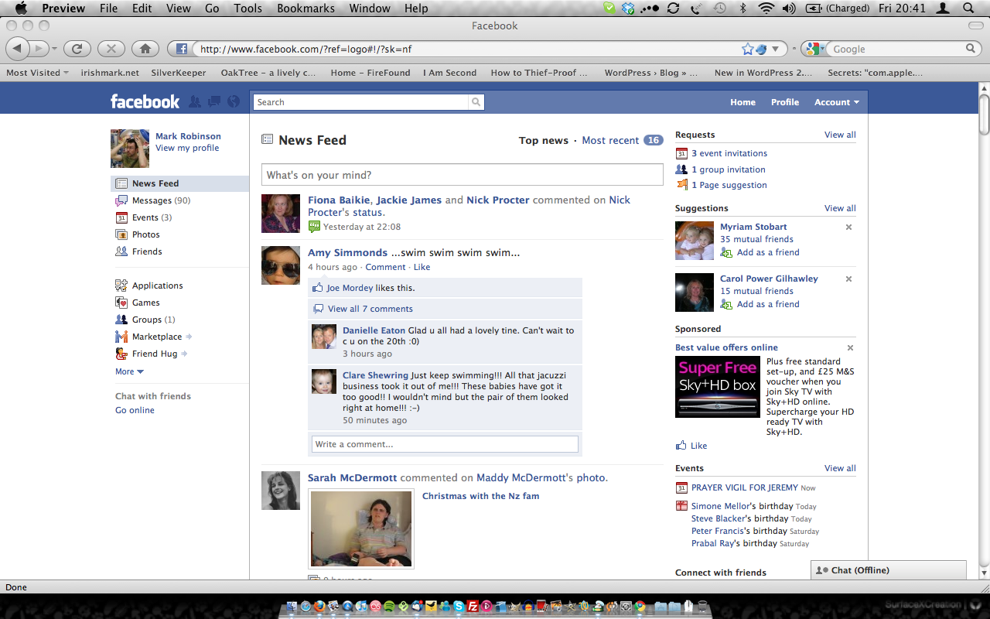

* Generally speaking an employer will advertise a vacancy on Facebook with links to how to apply – for example to their company website.
* The most important thing to remember when using Facebook for job searching/networking is to carefully vet what information others, such as potential employers can see.
* A common misconception is that employers can see your Profile page and find out all sorts of personal information. This is completely avoidable if you take the time to set up your security settings to prevent this.
* It is possible to set up a “page” which is managed by the individual but is separate from their own personal profile. This can then be geared solely towards job searching.

|  |
| --- |
| **Hints and Tips**   * Search for companies you may be interested in – for example those looking for employment in hospitality may look for local hotels on Facebook. * Click “Like” on the pages of companies you are interested in. This will ensure you get their latest updates in your news feed. * There is a search box at the top of the page. Users can search for groups relating to seeking work. These groups can be used for networking or actively searching for work. |

**Jargon buster**

*Profile* – This is a web page managed by the individual which others can see.

*News Feed* – This is found on your home page when you log into Facebook. It lists all recent updates from those whose pages you have “liked”.

*Like* – for each comment/post/photo that someone puts on their page you have the option to click “like”. This shows the person who published it that you like it.

**How to be secure when using Facebook for job searching**

* The little padlock symbol takes you to privacy settings.
* Choose “who can see my stuff”
* You can pick **public** although this is strongly advised against or chose to show your posts to **friends**, **only me** or **custom** (where you decide specifically who can and cant see what you post)



**Twitter**

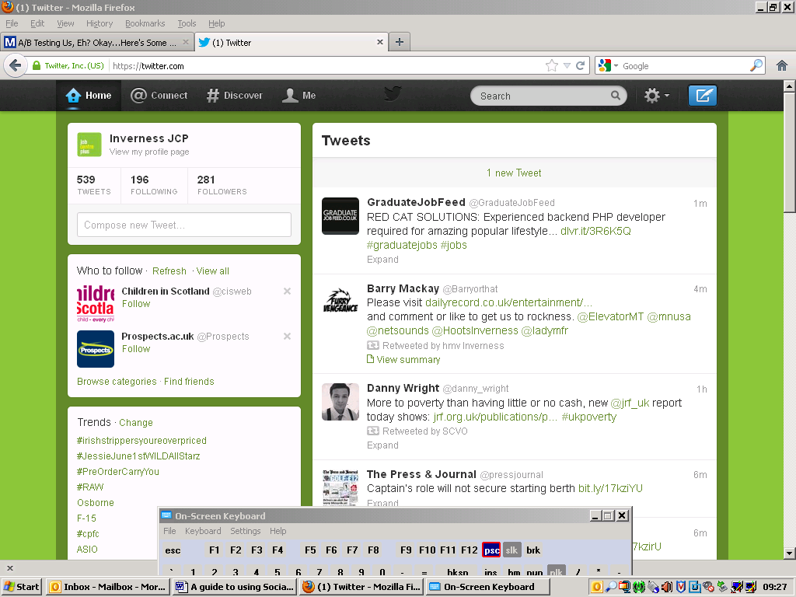

To use Twitter for job search you **don’t** need to have an account, you can just view a company or organisations page. However this prevents you from being able to contact the employer/individual.

If you open an account and follow the company/organisation you will automatically receive updates in your live feed, therefore you will see any vacancies they post if they choose to recruit using Twitter.

* **Search facility**

You can use the search facility to look for jobs, for example typing in “Inverness jobs” will bring up all tweets that mention “Inverness” and “jobs” and you can use this to narrow down vacancies. Or you can check out **@InvernessJCP** as we do our best to re-tweet any of these vacancies.

* **Hashtags**

If you put a hashtag in your tweets it makes it searchable for other Twitter users to find the most popular topic being discussed e.g. #Rockness would bring up all posts relating to Rockness (where tweeters have used the hashtag symbol)

* **Retweet**

This is reposting something someone else has written. Often used to spread news or share valuable findings on Twitter. Shown as RT with the original tweeter’s user name.

* **Mention**

Mentioning another user in your Tweet by including the @ sign followed directly by their username is called a "mention". Also refers to Tweets in which your username was included.

**To apply for jobs using Twitter:** In the Tweet there will be a link taking you to the website where you can get more details on the job and possibly apply directly over the internet. Some smaller businesses may just use Twitter to ask you to contact them direct. Always follow the employer’s instructions as they may not want direct contact through Twitter.

# About public and protected Tweets

### What is the difference between public and protected Tweets?

* When you sign up for Twitter, you have the option to keep your Tweets public (the default account setting) or to protect your Tweets.
* Accounts with protected Tweets require manual approval of each and every person who may view that account's Tweets.

### Who can see my Tweets?

* **Public Tweets** (the default setting) are visible to anyone, whether or not they have a Twitter account.
* **Protected Tweets** may only be visible to your approved Twitter followers.

**Note:** If you at one time had public Tweets, those Tweets will always be public and searchable, even after you change your settings to protected; Only Tweets made **after** updating your settings will be protected. Also, unprotecting your Tweets will cause any previously protected Tweets to be made public.

### When you protect your Tweets, the following restrictions are put in place:

* People will have to request to follow you; each follow request will need approval. [Learn more.](https://support.twitter.com/articles/20169376)
* Your Tweets will only be visible to users you've approved.
* Other users will not be able to retweet your Tweets. [Learn more.](https://support.twitter.com/articles/77606-faqs-about-retweets-rt#protectedtweets_notretweeted)
* Protected Tweets will not appear in Twitter search or Google search.
* @Replies you send to people who aren't following you will not be seen by those users (because you have not given them permission to see your Tweets).
* You cannot share [permanent links to your Tweets](https://support.twitter.com/articles/80586-how-to-link-directly-to-an-individual-tweet) with anyone other than your approved followers.