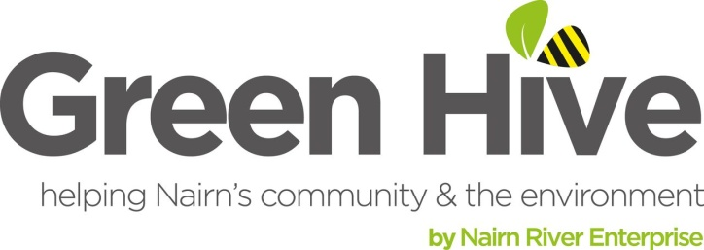

**Green Hive** is the project name of **Nairn River Enterprise**, the not-for-profit organisation formed in 2015.

**Our goal** is to create and support community services and projects that are green, not only benefitting the people of Nairn, but managed and controlled by local people too.

We promote awareness of the **environment** and the importance of **sustainability**. With the purpose of contributing to the enhancement of the local environment; to **well-being**; **regeneration** in the town: **civic pride**; strengthen **community connections**; provide a local **employment** pipeline and **volunteering** opportunities.

We coordinate:

***Viewfield Community Or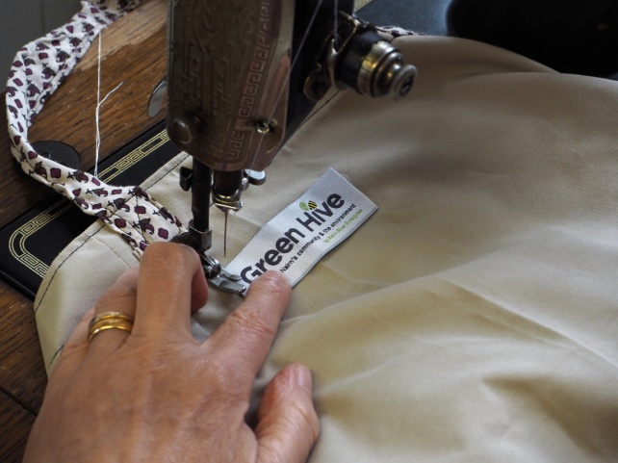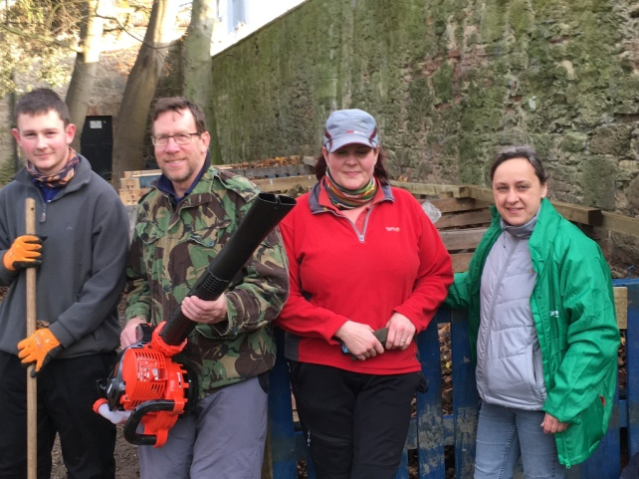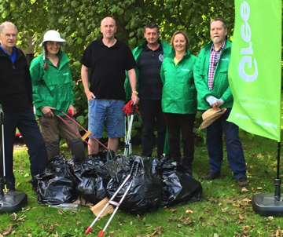chard*** *- managed by volunteers to create a public space to learn about and produce food*

***Bumblebags sewing group*** *- taking unwanted fabric and creating reusable shopping bags*

*L****itter picks*** *- regularly at Nairn beach and riverside*

***Stuff Swap Parties*** *- to share unwanted clothes and household items*

***‘Art is Rubbish’ workshops*** *- turning rubbish in to works of art*

Nairn's environmental charity Green Hive are currently developing a project to take place in the Queens Park area. We need your help to design what takes place in Queens Park. Take part in our survey at

<https://www.surveymonkey.co.uk/r/JRJ857B>

**Contact Kirsty to get involved:** [kirsty@greenhive.co.uk](mailto:kirsty@greenhive.co.uk), 07453 912697

www.greenhive.co.uk