

**HMP Visitors Centre - Is now open**

**Welcoming, comfortable area offering refreshments, children’s play area and other activities**

[](http://www.google.co.uk/url?sa=i&rct=j&q=&esrc=s&source=images&cd=&cad=rja&uact=8&ved=0ahUKEwiYpPj2ntHUAhXKuhQKHYfoDH8QjRwIBw&url=http://www.mycutegraphics.com/graphics/puzzle-clip-art.html&psig=AFQjCNHLi3z2wHB_1aDkBiO54iyIY3bfHA&ust=1498213517915584) 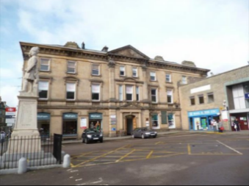 [](https://www.google.co.uk/url?sa=i&rct=j&q=&esrc=s&source=images&cd=&ved=0ahUKEwj0zbWVjNHUAhUE7RQKHaStA64QjRwIBw&url=https://thecliparts.com/the-best-free-clipart-36402/&psig=AFQjCNFUeUemIHp3G9JFKguU0hBhvy2bng&ust=1498208610892320)

[](https://www.google.co.uk/url?sa=i&rct=j&q=&esrc=s&source=images&cd=&cad=rja&uact=8&ved=0ahUKEwi7teTkoNHUAhVF0xoKHXz5CW4QjRwIBw&url=https://www.123rf.com/clipart-vector/coffee_break.html&psig=AFQjCNGYL08Mp077jcenqrUDLde1TsxBpA&ust=1498214119050550) **First floor,** **Rail House, Station Square, Inverness IV1 1LE** [](https://www.google.co.uk/url?sa=i&rct=j&q=&esrc=s&source=images&cd=&cad=rja&uact=8&ved=0ahUKEwjk2pm7jNHUAhVHuBQKHTbzB0wQjRwIBw&url=https://www.christart.com/clipart/image/changing-diapers&psig=AFQjCNHc5722MKtX3HG7b_vxdtYO0eGClA&ust=1498208681392971)

**Opening Hours from Monday 28th August**

**Monday, Wednesday, Friday and Saturday - 11.30am - 4.00pm**

**Tuesday and Thursday - 12.00pm – 8.00pm –**

**Sunday closed**

**(press HMP buzzer for access)**

[](http://www.google.co.uk/url?sa=i&rct=j&q=&esrc=s&source=images&cd=&cad=rja&uact=8&ved=0ahUKEwjIzrnEkdHUAhXJwBQKHaqDB0oQjRwIBw&url=http://www.urbaninfosystems.net/kid-friendly-clip-art/&psig=AFQjCNEetMc3nHpjtGZdcV0KpSRKV62ElA&ust=1498209113578130) 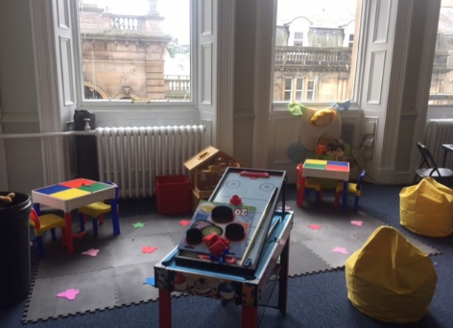 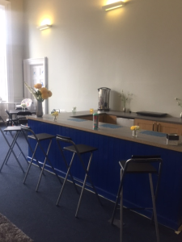 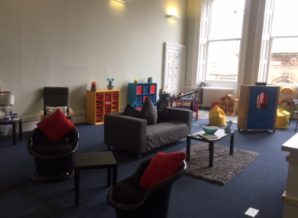 [](http://www.google.co.uk/url?sa=i&rct=j&q=&esrc=s&source=images&cd=&cad=rja&uact=8&ved=0ahUKEwjpsdTSntHUAhVMPxQKHaaHC0EQjRwIBw&url=http://www.bbc.co.uk/cbeebies/shows/lets-play&psig=AFQjCNHLi3z2wHB_1aDkBiO54iyIY3bfHA&ust=1498213517915584)

[](http://www.google.co.uk/url?sa=i&rct=j&q=&esrc=s&source=images&cd=&cad=rja&uact=8&ved=0ahUKEwjN88iEjdHUAhXGORQKHaceC0YQjRwIBw&url=http://nobacks.com/keywords/refreshments/&psig=AFQjCNHWiT4J8JDrAGTb6i2EzU8oq6T8jA&ust=1498208800508719)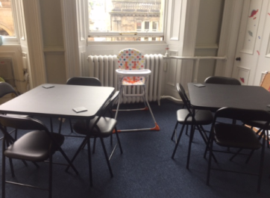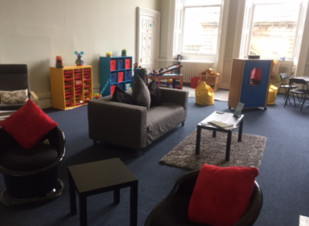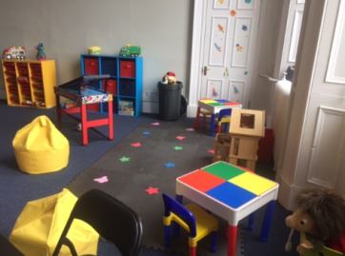

[](http://www.google.co.uk/url?sa=i&rct=j&q=&esrc=s&source=images&cd=&cad=rja&uact=8&ved=0ahUKEwi8z4WEn9HUAhXCchQKHXDSDEUQjRwIBw&url=http://www.mycutegraphics.com/graphics/kids-clip-art.html&psig=AFQjCNHLi3z2wHB_1aDkBiO54iyIY3bfHA&ust=1498213517915584) [](http://www.google.co.uk/url?sa=i&rct=j&q=&esrc=s&source=images&cd=&cad=rja&uact=8&ved=0ahUKEwjZlsbYjNHUAhULbxQKHRkBDZwQjRwIBw&url=http://www.clipartpanda.com/categories/laptop-computer-clipart-for-kids&psig=AFQjCNHBnYSVCe771qbmFGbNa5je4srZ2Q&ust=1498208745152111)

**For more information contact Office - 01463 717227 or Mobile – 07717 780 465**