2024 - 2025

**UNIVERSITY**

**HEALTH**

**SERVICE**

**Richard Verney Health Centre**

**6 Bristo Square**

**Edinburgh**

**EH8 9AL**

**Telephone: 0131 650 2777**

[**www.health-service.ed.ac.uk**](http://www.health-service.ed.ac.uk)

**Email:** [**loth.clinicals70592@nhs.scot**](mailto:loth.clinicals70592@nhs.scot)

Info which may be useful re general health information is available on an App, which is produced by Expert Self Care Ltd and is free to download from your App Store. Look for ESC Student.

**INDEX**

Staff List 3,4

Map of Practice Area

And Location of Practice 5

About the Practice 6,7,8

Services provided by the

University Health Service 9,10

Other Services within the

Health Centre

Rights and Responsibilities 11

Confidentiality

Access to Health Records 12

Suggestions

Complaints

Local Health Board Details 13

**STAFF**

**Doctors:**

Dr Judith Richardson MBChB DRCOG DCH DFSRH FRCGP M Med Ed

Registered Edinburgh 1991

Dr Susan Arnold, MBChB, DRCOG, DFSRH, MRCGP

Registered Aberdeen 2004

Dr Ewan Clark MBChB BMSc DRCOG DFSRH DCH, DIPTRAVMED,MFTM RCPS (Glasgow) MRCSEd MRCGP

Registered Dundee 2004

Dr Nina Talbot, MBChb, DRCOG, DFSRH, DCH, MRCGP

Registered Edinburgh 2006

Dr Michael Diamond, BSc, PhD, MBCHB, MRCGP,DRCOG, Dip BSLM/IBLM

Registered Aberdeen 2010

Dr Sally McNeill MBChB, DRCOG, MRCGP (2006)

Registered Edinburgh 2001

Dr Yilang Li – BSc, MBCHB, MRCGP

Registered Edinburgh 2011

Dr Carolyn Elliott, MBChB, MRCGP, DFSRH, DRCOG

Registered Dundee 2005

Dr Louise Duthie, MBChB, DRCOG, DFSRH, MRCGP

Registered Aberdeen 2005

Dr Diane McCutcheon MBChB, DRCOG, DFSRH,MRCGP (Term Time only)

Registered Edinburgh 2000

Dr Isabelle Crawford BSc, MBChB, MRCGP, DCCH (Term Time only)

Registered Manchester 1991

Dr Kathryn Marshall BSc, MBCHB, MRCGP, DFSRH

Registered Edinburgh 2011

Dr Samuel Walker MBBS, MRCGP

Registered York 2009

Dr Deborah Bassett MBChB(Term time only)

Registered Manchester 2009

Dr Iona Dias MBChB, MTCGP,DRCOG,DFSRH

Registered Edinburgh2011

**Practice Nurses:**

Kris Head Practice Nurse BN Adult Nursing, Independent/Supplementary Prescriber

**Clinical Support Worker:**

Louise Foley SVQ3

**Allied Healthcare Staff:**

Kerrie Crisp BSc (Hons) Advanced Physiotherapy Practitioner

Alistair Simm BSc (Hons) Advanced Physiotherapy Practitioner

Nida Tariq-Jacobs Integrated Pharmacist

**Practice Business & Development Manager:**

Jean Grant, MA(Hons), Dip IA, Dip HSM

**IT Manager: Practice Administrator** Anne-Marie Fraser (HND)Alys Rae

**Medical Typists:**

Alys Rae

Wilma

Sara

**Reception Manager: Records/System Administrator:**

Caroline McGlade BA (Hons) Sharon Murphy

**Receptionists:**

Wilma

Ray

Mavis

Sara

Julie

Chloe

**University Health Service**

Richard Verney Health Centre, 6 Bristo Square, Edinburgh EH8 9AL

Tel: 0131 650 2777

Email: [loth.clinicals70592@nhs.scot](mailto:loth.clinicals70592@nhs.scot)

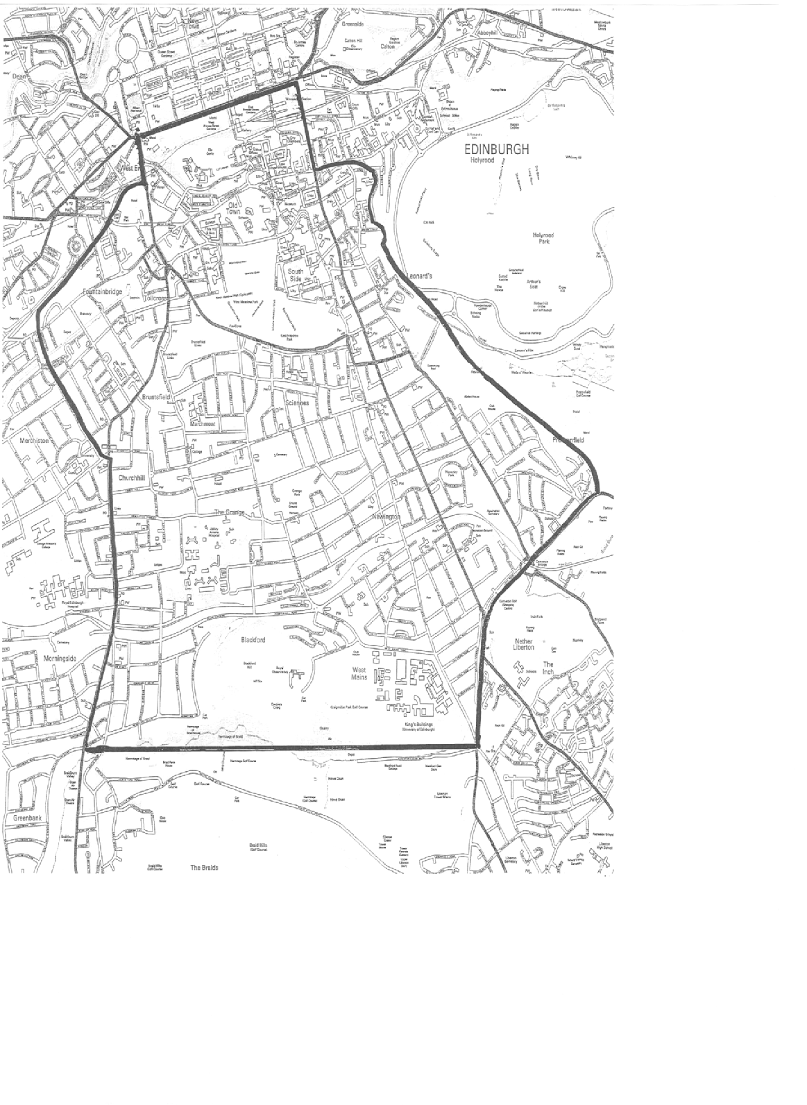.

The entrance to Richard Verney Health Centre is on the opposite side of

Bristo Square to the McEwan Hall – Our reception is on the 3rd floor.

See photo on our website.

**ABOUT THE PRACTICE**

The University Health Service is an independent National Health Service

partnership of general practitioners, who rent premises from the University, and

offer full GP services to patients who live within the practice area (see map page

4), and who choose to register with the practice.

**TRAINING AND EDUCATION:**

The practice has been recognised as the training practice for fully qualified doctors and medical students who have chosen general practice as their career. These doctors work with us and are available for consultation. Video equipment may occasionally be used with the patients consent and consultations with medical students will be checked by a fully qualified doctor as part of their training.

**FACILITIES FOR THOSE WITH IMPAIRED MOBILITY/HEARING:**

The Health and Wellbeing Centre has disabled access via the main entrance in Bristo Square and up the ramp, through the automatic doors into the foyer at pharmacy with lift access through another automatic door and come to 3rd floor reception. Sign posting is in situ.

**HOW TO REGISTER WITH THE PRACTICE:**

Please visit our website and follow the link titled “How to Register With Us”. Here you will find a link to Campus Doctors and all our registration forms are online which you can complete electronically and send securely to the Practice.

Once a parent has registered electronically we would ask that children be registered in person so please come to the reception on the 3rd floor and request paper forms from our staff..

**HOW TO SEE A DOCTOR:**

Our consulting hours are Monday – Friday 9am – 5pm.

On our New Patient Section of the website is a copy of our Signposting poster highlighting where you can seek help for specific health issues. It is not always necessary to be seen by a doctor.

If you wish to book a telephone consultation then please use our Online Services – Or failing this you can phone the Practice on 0131 650 2777.

If you feel that your condition requires a face-to-face consultation, this can ONLY be booked by phoning the Practice and speaking to the reception staff who will ask some basic information before booking the appointment.

You may find our eConsult helpful for advice, however if you think you need a telephone or face to face appointment you will still be required to book these as described above, an eConsult is not a replacement for this. The eConsult service is only available between 8am and 5pm Monday to Friday

**EMAIL CONTACT**

For confidentiality reasons please note that **NO** medical correspondence or requests for appointments or prescriptions can be dealt with through the Practice email address.

**PRACTICE NURSE**

Our Practice Nurse also operates via an appointment system – which can only be booked by calling the Practice on 0131 650 2777 and the receptionist will allocate you an appointment slot.

**INTERPRETERS**

If you feel that you will require a foreign language or sign language interpreter

to allow you to understand your consultation then please telephone reception at least **5** days in advance of your appointment to discuss this.

The NHS does also provide a phone translation service available on the day – please ask reception for more information

**APPOINTMENTS TERM TIME and VACATION**

Monday - Friday 09.00 – 17.00

**Routine consultations by appointment throughout the day.**

**Routine appointments are usually 10mins.**

**PUBLIC HOLIDAYS**: Closed (Dates for these are posted on our website)

**HOME VISITS**

If at all possible we prefer to see patients at the surgery where full investigative

and treatment facilities are available, rather than at home. Should a home visit

be necessary we will be pleased to do this.

It is very helpful if requests for such visits can be phoned in **before 10 a.m.**

(tel: 0131-650-2777).

Please do not feel offended if the receptionists ask for some simple details

of your illness - it does help the doctor to arrange to see you rapidly if your

symptoms sound serious. The Duty Doctor may also telephone and speak to you.

**EMERGENCY CALLS**

Between 08.00 and 18.00 hours, the Practice Duty Doctor can always be

contacted by telephoning: **0131-650-2777**

Out of hours, (that is between 18.00 and 08.00 hrs, Monday – Friday, at weekends, and on public holidays) NHS Lothian is responsible for medical care.

To contact this service, please phone: NHS 24 on tel. No **111**

NHS24 is also available for advice 24 hours a day, 7 days a week.

Tel. No. **111** website: [www.nhs24.com](http://www.nhs24.com)

**REPEAT PRESCRIPTIONS**

If your University Health Service doctor authorises repeat prescriptions for

you, you will be given a ‘Repeat Prescription Ordering Form’, detailing your

medicines and the number of occasions these may be re-prescribed before you

have to see the doctor to review your medication.

When you require ‘repeats’, please either:

1. send it in to us (with a stamped addressed envelope so the prescription can be sent back you),
2. Post the “Repeat Prescription Ordering Form” in our prescription box on the 3rd floor landing outside reception
3. submit to your preferred pharmacy to request on your behalf
4. if you are registered for on line booking you can request “repeats” on line.

In all cases please allow 2-5 days after ordering before attempting to collect the prescription

Please note that you must consult a doctor at the University Health Service

before you can use the repeat prescription facility.

**TEST RESULTS**

Please telephone for test results **from 11am to 4pm**, Monday to Friday

**CHANGE OF ADDRESS**

**It is essential that any change of address be notified to the practice as**

**soon as possible. Failure to do so may result in NHS Lothian withdrawing**

**your registration.**

Please let us know your email address & mobile telephone number and

remember to tell us if you change these.

If you move out with our practice area, you should register with a local general

practitioner. When in doubt about your address, please ask at reception.

Please email us on loth.clinicals70592@nhs.scot (link via our website) or phone us. Please state name, date of birth, old and new address details.

**NON-NHS WORK**

Requests for completion of medical forms (e.g. Camp America), full medical

examinations (e.g. pre-employment, insurance) or shorter medicals should

be discussed with the receptionist in the first instance and not taken

directly into a GP appointment. This will be assessed on whether or not an

appointment is necessary and as this work is not covered by the National

Health Service general medical services, a fee will normally be charged. You

should phone the surgery 4 days after handing in your request for this

information. A charge will be made for private prescriptions issued by the

Doctors for travel.

**SERVICES PROVIDED BY THE UNIVERSITY HEALTH SERVICE**

**CONTRACEPTION**

Contraceptive advice is always available from the doctors and nurses. We

are committed to providing a confidential and easily accessible contraceptive

service for our patients.

Contraceptive implants and intrauterine devices (IUD’s, IUS) are fitted and

removed by doctors at the practice in a dedicated, long acting and reversible

contraceptive (LARC) clinic. You will need to make an appointment at the clinic

or with any doctor/nurse for an initial discussion prior to insertion.

For contraception advice please call to make an appointment with a doctor.

The nurse can advise on the contraceptive pill as well as organising repeat contraceptive pill supplies of certain brands. A list of those included is available at reception or on our website.

Emergency contraception advice can be obtained from any pharmacist.

**CERVICAL SMEAR TESTS**

A Scotland wide recall system is in place routinely for women aged 25-64 years to allow them to have a routine smear every 5 years and up to age 70 for non routine patients. If you receive a letter offering you a smear then please call the practice to make an appointment with a nurse on 0131 650 2777.

**CHILD HEALTH SURVEILLANCE CLINICS:**

This clinic is run by a Health Visitor for well baby checks and baby/childhood immunisations by appointment, but it is not held in the Practice.

If you have a child under 5 years of age, please speak to the Health Visitor as

soon as your family register with us so that an immunisation schedule can be

worked out. The Health Visitor will advise you of your clinic appointment and where it is. See our website for more details.

**ASTHMA**

Appointments are available with our nurse to help those with a diagnosis

of asthma achieve a better understanding of the condition and gain optimal

control of it and for regular annual reviews. Please ask at reception or phone

0131-650-2777 to make an appointment.

**PREGNANCY CARE**

The Doctors in conjunction with our Community Midwives are pleased to

undertake antenatal and postnatal care. Please speak to your doctor who will

make the necessary arrangements.

**LONG TERM CONDITIONS**

Patients diagnosed with long term conditions such as heart disease will be

assessed regularly by nursing staff in conjunction with GP care.

**DIABETES**

Diabetic patients need regular checks & review. Dr M Diamond oversees the care

of patients with diabetes who are registered at the practice in conjunction with

the hospital diabetic clinic where appropriate. Practice Nurse carries out regular diabetic checks as necessary and assists Dr M Diamond in this care.

**PHYSIOTHERAPY**

Patients can look at [www.nhsinform.co.uk/msk](http://www.nhsinform.co.uk/msk) or call 0845 604 0001. This service is not provided by the practice but by NHS Lothian

If you are suffering from any bone, joint or muscle aches you can contact the advanced physiotherapist practitioners who are based with the GP’s at Bristo Square..

They can provide:

* Early assessment and diagnose what’s going on.
* Advice and exercises to help you manage your problem or condition.
* Referral on to specialist services e.g physiotherapy rehab, x-ray, orthopaedics if required.

To book, call the practice and ask for an appointment with physiotherapy. This service is only available to over 16s.

**CHAPERONES**

A doctor may ask a nurse to be present when undertaking an intimate

examination.

**RIGHTS AND RESPONSIBILITIES**

The University Health Service strives to provide first-class, confidential

healthcare, based on clinical need, to all patients, at all times without reservation.

To help us realise this objective we ask you to use the service responsibly –

• Be punctual and let us know if you cannot attend or no longer require an

appointment.

• Be polite and considerate to other patients, practice staff and doctors.

• Tell your GP and any hospital you are attending, if you change address or

telephone number

• Please make a separate appointment for each member of the family who

need to be seen

We aim to inform patients fully about any treatment or services offered.

Abusive, threatening or violent behaviour will not be tolerated under any

circumstances and the police will be called and you may be removed from our

list.

**Fair Processing Notice**

University Health Service keep records about your health and the care you receive. The records may include:

* Basic details about you, such as address and next of kin
* Contacts we have had with you, such as your appointments and clinic visits
* Reports about your health and any treatment/care you need
* Details and records about the treatment and care you receive
* Results of investigations, such as X-rays and laboratory tests
* Relevant information from other health professionals, relatives and carers

**Information Sharing**

The Practice complies with Data Protection and Access to Health Records

legislation. Identifiable information about you will be shared with others in the

following circumstances:

• To provide further medical treatment for you e.g. from the health visitors and

hospital services

• To help you to get other services e.g. from the social work department. This

requires your consent

• When we have a duty to others e.g. in child protection case

• Emergency care summary (basic health information is shared with out of

hours services to assist treating you when the surgery is closed)

• Some of your information may be used for clinical audit whereby a group of cases similar to your own is checked against agreed standards to identify where improvements can be made. Some of these audits are done over Lothian/Scotland or UK wide.

Anonymised patient information will also be used at local and national level

to help the Health Board and Government plan Services. If you do not wish

anonymous information about you to be used in such a way, please let us know.

**Confidentiality**

We maintain our legal duty of confidentiality to you at all times. We keep this information in a secure, confidential manner. All staff working within the Practice are bound by the same high standards of confidentiality. We will only ever use or pass on information about you if others involved in your care have a genuine need for it. We will not disclose your information to third parties without your permission unless there are exceptional circumstances, such as where health and safety of others is at risk or where the law requires information to be passed on.

We will not disclose any of your information to a family member without your consent If you do not want any of your information shared with a specific health professional then you must inform us of this in writing.

**ACCESS TO HEALTH RECORDS**

Patients have the right to access their health records from both paper and

computer sources. All such access applications must be in writing and addressed

to the Practice Manager in the first instance. Specific details must be given as

to the extent of access required identifying dates of entries within the record.

Any confidential reference in the records to third parties will be deleted. In

the extremely rare occasion of a record containing information harmful to the

patient this will be deleted.

Please note we have up to 30 days to process your application and at busy times this can be longer.

**PUBLICATION SCHEME**

The Practice operates a publication scheme in compliance with the Freedom of

Information (Scotland) Act 2002. We use the BMA Scotland format. Details of the scheme or a request for access should be made to the Practice Manager.

**SUGGESTIONS**

If you have any suggestions whereby we might improve the service to you as a

patient, please let us know.

A suggestion box is available on the shelf at the entrance to the 3rd Floor or you can email us.

**COMPLAINTS**

This practice makes every effort to provide a good service but if you have any

comments, compliments or complaints, please ask the receptionist for our

leaflet or see details on our website, giving details of the practice complaints system and how to proceed.

**LOCAL HEALTH BOARD**

Details of primary medical services in the Lothian area may be obtained from

NHS Lothian

2ND Floor

Waverley Gate

2 -4 Waterloo Place

Edinburgh EH1 3EG

Tel: 0131 537 8423