

Angus Mental Health and Wellbeing ECS Hub

REFERRAL FORM

Who is the Hub For?

Anyone aged 16 or older living in Angus who needs support with mental health, wellbeing or substance use.

About the Hub

The Mental Health and Wellbeing Hub is a service that reviews referrals for individuals needing support with mental health, wellbeing, self-harm, or substance use. Staff from the following services will review your referral, Community Mental Health Teams (CMHT), Angus Integrated Drug and Alcohol Recovery Service (AIDARS), Psychological Therapies, Peer Support, and Community Link Workers. You will be contacted or offered an appointment with one of these services.

Important Information

By submitting this form, you consent to the sharing of your information within the Hub team.

This form is not for urgent or emergency support. If you need immediate help, please contact your GP or emergency services.

 | Signed | Date
Please sign to confirm you understand the above
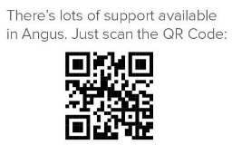
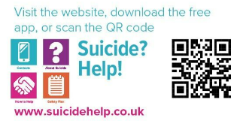
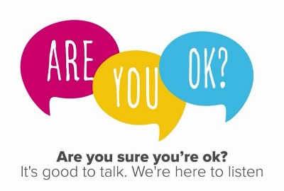

NEXT STEPS

Complete and Submit the Referral Form either by:

- Emailing it to your local Hub (email addresses are at the end of this form).
- Hand it in at your GP practice reception.

Screening Process:

- Your referral will be reviewed within one working day.
- You’ll receive a phone call or letter within 10 working days about the outcome.

Type of Referral | DATE:
Self-Referral  (Please tick YES or NO) | YES | NO
Completed on your behalf (with consent)  (Please tick YES or NO) | YES | NO
Have you read the Service Information leaflet | YES | NO
If this is completed on your behalf please provide further details | Name of person  completing referral:
 | Relationship:
 | Team/Service:

PERSONAL DETAILS
Name:
DOB:
Address:

Postcode:
Contact Number:
Email Address:
GP Practice:

Why do you want support? | Please tick all that apply
Anxiety
Low Mood
Depression
Stress
Loneliness/Isolation
Alcohol use
Drug use
Bereavement
Housing issues
Debt/Financial Worries
Relationship difficulties
Relapsing mental health disorder
Self-harm
Suicidal thinking
Other (please advise why you want support)
For the boxes you have ticked. How does this affect you?

What type of support are you looking for? | Please tick all that apply
Advice and information
To talk to someone
Help with problem solving
Help in a crisis
Relapse prevention
Risk management
Group work
Online support
Identifying goals and how to reach these
Supporting behaviour change
Self-Directed Support
Carers Support
Other (please advise of support wanted)
Any other information you would like us to know about the support you are looking for?

Has anyone helped you in the past or is helping you now? What help have they given you?
E.g. Family of Mental Health Support organisations, Community Mental Health Team, Penumbra, Angus Integrated Drug and Alcohol Recovery Service, Tayside Council on Alcohol, Mental Health and Wellbeing Peer Support, Psychology, Community Link Worker, Listening Service, Counselling, Carers Centre, Family, Friends.

Any other information you would like the hub to be aware of?

Thank you for completing this referral form with as much detail as you can, to help us to provide you with the right support to meet your needs.

What Happens Next?

The outcome of your referral might include:

A Phone Call - You may be contacted to discuss your needs and learn about available support. Please note that calls may come from an NHS blocked number.

Pre-Appointment Tasks - You might be asked to complete tasks such as:

- Gathering information relevant to your appointment.
- Reading helpful articles.
- Keeping a mood diary or answering questions.

Completing these tasks will help us understand your needs better and ensure you get the right support. Please bring any completed tasks to your appointment.

Please email the completed referral form to the Hub where you live:

North East (Brechin, Edzell, Montrose and surrounds) - tay.angusmhwhub@nhs.scot
North West (Forfar, Kirriemuir, Letham and surrounds) - tay.angusnwhub@nhs.scot
South East (Arbroath/Friockheim and surrounds) - tay.southeastangushub@nhs.scot
South West (Carnoustie/Monifieth and surrounds) - tay.southangushub@nhs.scot

