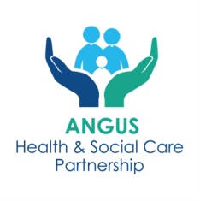

Angus Mental Health and Wellbeing ECS Hub

INFORMATION SHEET

Please look at the support organisations available in your community before you refer to the hub, as they may be able to help you, you can access this information via the QR codes below:
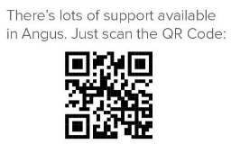
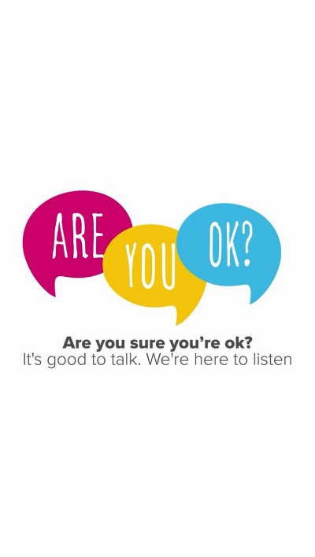
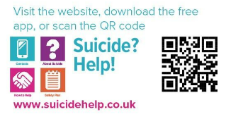

What is the ECS Hub?
The ECS Hub helps people aged 16 and over who need support for mental health, wellbeing, self-harm, or substance use. A team of professionals, including nurses, social workers, psychologists, peer support workers, and community link workers, reviews each referral to connect you with the right services quickly and efficiently.
If you are an older person and you think you need mental health and wellbeing support from a peer or social prescriber please self refer to the ECS hub. If you believe that you need specialist community mental health support and you are over 65 years of age speak to your General Practitioner (GP).
Why Use the Hub?
The ECS Hub ensures you get the right support without having to repeat your story to different workers.
What Happens After You Are Referred?
Your referral will be reviewed, and you will be contacted within 10 working days by phone or letter.
Outcome Possibilities:
- Phone Consultation – a call to discuss your needs and available support. Calls may come from an NHS blocked number.
- Pre-Appointment Tasks - you might be asked to complete tasks (e.g., reading materials, keeping a mood diary) to prepare for your appointment. Completing these will help us support you better.
If Your Condition Worsens
If your mental health or substance use worsens while you wait, please contact:
- The service listed in your appointment letter.
- Your GP for further assistance.
Please see below details of what each service can provide. If you have complex needs, you may be seen by one or more of the services below to provide your support, care and treatment but this will be co-ordinated through the hub.
SERVICE INFORMATION
Community Link Workers
Community Link Workers (formerly known as Social Prescribers) work out of GP practices and help individuals connect with local support and services, or community groups and activities.
Community Link Workers aim to empower people to take an active role in improving their wellbeing. They can provide support for social issues which affect a person like financial or housing difficulties, social isolation and loneliness, or anxiety and stress. Community Link Workers use a person-centred approach and talk about what really matters to the individual. They work with people to identify the challenges they are facing and support them to set goals and overcome barriers to allow them to take greater control of their physical and mental health.
This service is available to anyone aged 16 or over, registered with a GP practice in Angus.
Mental Health and Wellbeing Peer Support Service
The service will provide you with support from someone who has faced their own mental health and wellbeing challenges. The peer workers can provide emotional, practical and social support. They will help you to access further support if required and can help with a range of self-help tools that may help improve your mental health & wellbeing. They will share with you strategies that have worked for them during difficult times.
Because of their own experience they can relate to people who are still struggling to improve their own mental health and wellbeing. The peer workers can provide inspiration and hope that it is possible to have a positive fulfilling future despite coping with significant challenges.
The service is aimed at people with less complex mental health and well-being challenges and will provide a maximum of three appointments.
Distress Brief Intervention (DBI)
Distress Brief Interventions (DBIs) are an innovative way of supporting people in distress.
Trained third sector staff will contact the adult within 24-hours of referral and provide community-based problem solving support, wellness and distress management planning, supported connections and signposting.
Angus Adult Psychological Therapies Service

Angus Adult Psychological Therapies team offer help to those with mild to moderate mental health problems.

Treatment is provided in a number of ways: Supported self-help, Computer based therapy, Group treatment and Individual treatment. Most treatments will encourage you to: Explore your difficulties, Agree aims for treatment, Complete tasks between appointments and Learn how to cope with difficult situations.

Your first appointment will be an assessment appointment and will last up to 60 minutes. If the assessment indicates that you would benefit from psychological intervention, treatment options will be discussed with you. Individual sessions usually last between 45 minutes and an hour and group sessions last for up to 2 hours. Treatment is time limited, and you are likely to be seen for somewhere between 6 and 10 sessions. Progress depends on regular attendance. It is therefore important that you attend all appointments given to you.

Community Mental Health Team

The Community Mental Health Team provides care, support and treatment for people with complex mental health needs. Support can be provided by Clinical Psychologists, Community Mental Health Nurses, Community Support Workers, Consultant Psychiatrists, Occupational Therapists and Social Workers (Mental Health).

Your first appointment would be an in-depth assessment which includes gathering information about your past history, current mental state and undertake a risk assessment and develop a risk management plan, if required. The outcome of the in-depth assessment is to work with you to agree how your ongoing needs can be best met.

It is important that you are actively involved in developing and contributing to your own health and wellbeing plan and using strategies you learn to stay well.

Services offered include to people with complex mental health needs include:

- Assessing need and care planning
- Crisis management
- Risk management
- Education and skills development
- Identifying goals and how to reach these
- Guided self help
- Supporting behaviour change
- One to one or group support
- Relapse prevention
- Problem solving skills
- Talking therapies
- Access to community support including Self Directed Support
- Medication
- Carers Support

Angus Integrated Drug and Alcohol Recovery Service (AIDARS)

The Angus Integrated Drug and Alcohol Recovery Service (AIDARS) is an integrated health and social work service. The team offer the following services and supports:
- Motivational and enhancement therapy
- In-patient and community detox for alcohol, opiates and opiate replacement therapy
- Recovery care planning and self-directed support
- Overdose awareness (including Naloxone dispensing), harm reduction, and BBV testing and support
- Relapse prevention in groups and one-to-one, supported by medication if required
- Psychological interventions
- Carer’s support
- All referrals to AIDARS will be assessed as to which Substance Use service would be best placed to meet a patients identified needs, and referral may be passed to Substance Use Third Sector partner: Hillcrest Futures or Tayside Council on Alcohol
- We understand that problems related to substance use and mental health and well-being can be closely linked, and we would work closely with Mental-Health and Well-being services to support you with these problems

