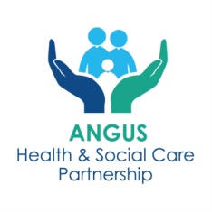
Angus Mental Health and Wellbeing ECS Hubs

INFORMATION SHEET – EASY READ VERSION

Please look at the support organisations available in your community before you refer to the hub, as they may be able to help you, you can access this information via the QR codes below:
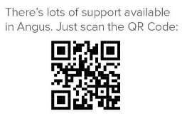
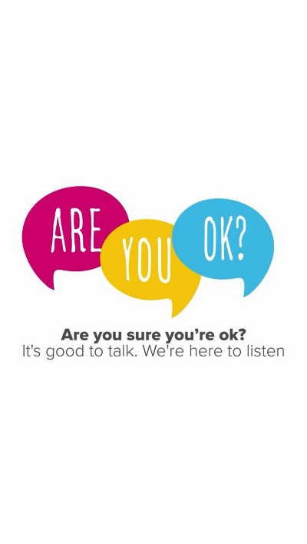
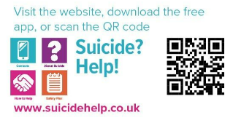

What is the ECS Hub?
The ECS Hub helps people aged 16 and over who need support for mental health, wellbeing, self-harm, or substance use.
Why Use the Hub?
The ECS Hub ensures you get the right support without having to repeat your story to different workers.
What Happens After You Are Referred?
Your referral will be reviewed, and you will be contacted within 10 working days by phone or letter.
Services included in the Mental Health and Wellbeing ECS Hub are:
Community Link Workers (formerly known as Social Prescribers)
- Support individuals with social issues affecting their wellbeing such as financial or housing difficulties, social isolation and loneliness, or anxiety and stress.
- Available for anyone aged 16+ registered with an Angus GP.

Mental Health and Wellbeing Peer Support 16+
- For individuals with mild to moderate mental health challenges.
- Offers up to three one-to-one sessions, workshops, and information drop-ins.
Mental Health and Wellbeing Peer Support - 11-16 years olds (attending secondary school) - referrals to this service is not via the hub but by contacting the providers direct via the contact information below:
- North Angus - Hillcrest Futures - email youngpeopleangus@hillcrestfutures.org.uk or call 01307 460101
- South Angus – Penumbra – email: AngusYoungPersons@penumbra.org.uk or call 01241 873900
Distress Brief Intervention (DBI)
- Provides problem-solving support and distress management for up to 14 days.
- Third-sector staff contact individuals within 24 hours of referral.

Angus Adult Psychological Therapies Team

- Offers 6-10 sessions of psychological intervention for mild to moderate disorders. May involve one to one or group intervention.
- Available for ages 18 to 65 years (also 16 & 17 year olds who have left school)
- For Adults Over 65 years or appropriate for referral to CMHT OP – referral for Psychology should be made via standard referral procedures.

Community Mental Health Team (CMHT)

- Multi-disciplinary support for complex mental health needs, including crisis management, therapy, and relapse prevention.

Angus Integrated Drug and Alcohol Recovery Service (AIDARS)

- Provides detox services, harm reduction, psychological interventions, and carer support.
- Works closely with third-sector partners and mental health services.

