
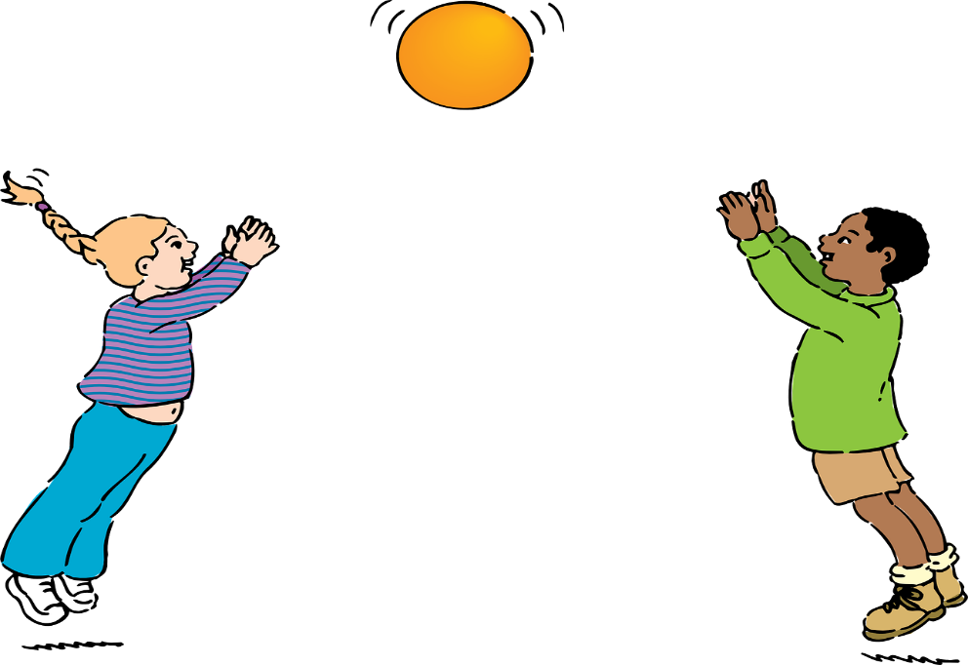

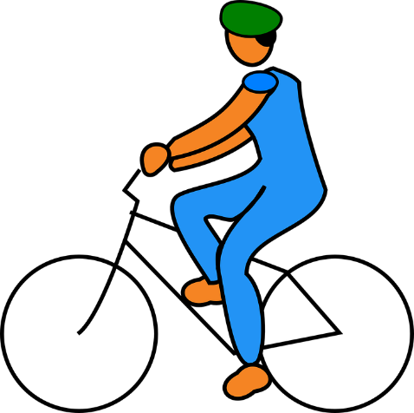
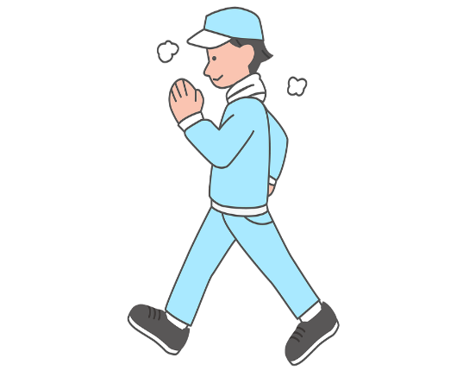

Activity Record
This Photo by Unknown Author is licensed under CC BY-NC
Day | How many minutes walking | How many minutes seated | How many minutes exercise |   Are you happy with this?
Day | How many minutes walking | How many minutes seated | How many minutes exercise | Are you happy with this?
Day | How many minutes walking | How many minutes seated | How many minutes exercise | Are you happy with this?
Day | How many minutes walking | How many minutes seated | How many minutes exercise | Are you happy with this?
Day | How many minutes walking | How many minutes seated | How many minutes exercise | Are you happy with this?
Day | How many minutes walking | How many minutes seated | How many minutes exercise | Are you happy with this?
Day | How many minutes walking | How many minutes seated | How many minutes exercise | Are you happy with this?
Day | How many minutes walking | How many minutes seated | How many minutes exercise | Are you happy with this?
Day | How many minutes walking | How many minutes seated | How many minutes exercise | Are you happy with this?
Day | How many minutes walking | How many minutes seated | How many minutes exercise | Are you happy with this?
Day | How many minutes walking | How many minutes seated | How many minutes exercise | Are you happy with this?
Day | How many minutes walking | How many minutes seated | How many minutes exercise | Are you happy with this?
Notes

