
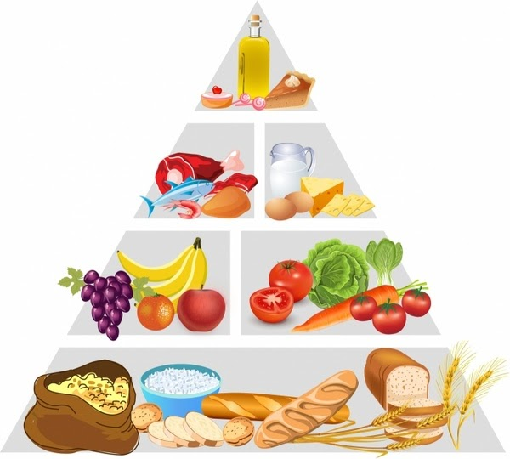

Food Diary

DAY |  | Notes
Breakfast
Snack
Lunch
Snack
Dinner
Alcohol

DAY |  | Notes
Breakfast
Snack
Lunch
Snack
Dinner
Alcohol

DAY |  | Notes
Breakfast
Snack
Lunch
Snack
Dinner
Alcohol

DAY |  | Notes
Breakfast
Snack
Lunch
Snack
Dinner
Alcohol

DAY |  | Notes
Breakfast
Snack
Lunch
Snack
Dinner
Alcohol

DAY |  | Notes
Breakfast
Snack
Lunch
Snack
Dinner
Alcohol

DAY |  | Notes
Breakfast
Snack
Lunch
Snack
Dinner
Alcohol

DAY |  | Notes
Breakfast
Snack
Lunch
Snack
Dinner
Alcohol

DAY |  | Notes
Breakfast
Snack
Lunch
Snack
Dinner
Notes

DAY |  | Notes
Breakfast
Snack
Lunch
Snack
Dinner
Notes

DAY |  | Notes
Breakfast
Snack
Lunch
Snack
Dinner
Notes

