

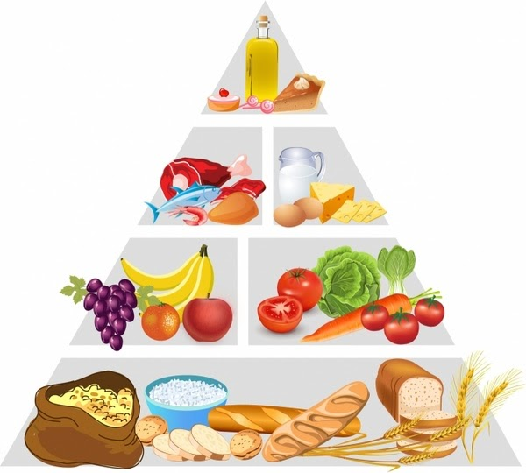
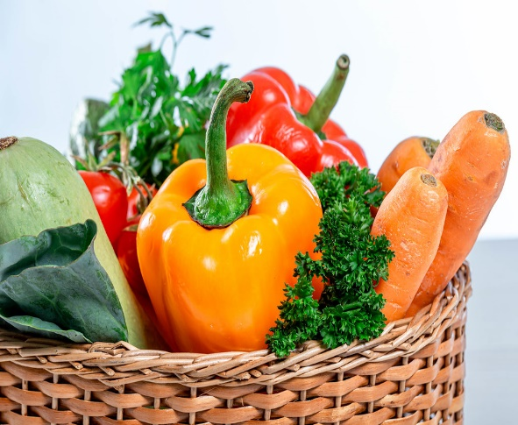
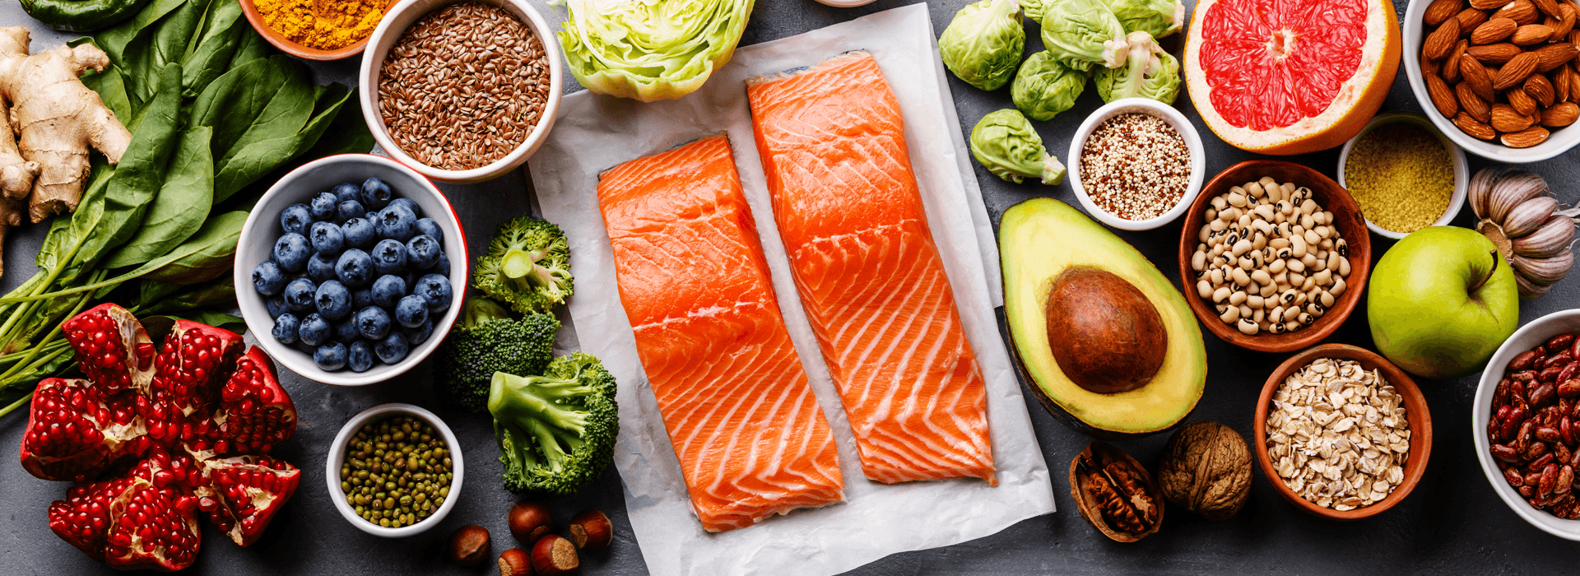
Food and Mood Diary
This Photo by Unknown Author is licensed under CC BY

Day | Summary of food/drink consumed | Water intake | Mood  1-10 | Stress level  1-10 |   Are you happy with this?
Day | Summary of food/drink consumed | Water intake | Mood  1-10 | Stress level  1-10 | Are you happy with this?
Day | Summary of food/drink consumed | Water intake | Mood  1-10 | Stress level  1-10 | Are you happy with this?

Day | Summary of food/drink consumed | Water intake | Mood  1-10 | Stress level  1-10 | Are you happy with this?
Day | Summary of food/drink consumed | Water intake | Mood  1-10 | Stress level  1-10 | Are you happy with this?
Day | Summary of food/drink consumed | Water intake | Mood  1-10 | Stress level  1-10 | Are you happy with this?

Day | Summary of food/drink consumed | Water intake | Mood  1-10 | Stress level  1-10 | Are you happy with this?
Day | Summary of food/drink consumed | Water intake | Mood  1-10 | Stress level  1-10 | Are you happy with this?
Day | Summary of food/drink consumed | Water intake | Mood  1-10 | Stress level  1-10 | Are you happy with this?

Day | Summary of food/drink consumed | Water intake | Mood  1-10 | Stress level  1-10 | Are you happy with this?
Day | Summary of food/drink consumed | Water intake | Mood  1-10 | Stress level  1-10 | Are you happy with this?
Day | Summary of food/drink consumed | Water intake | Mood  1-10 | Stress level  1-10 | Are you happy with this?

Day | Summary of food/drink consumed | Water intake | Mood  1-10 | Stress level  1-10 | Are you happy with this?

Day | Summary of food/drink consumed | Water intake | Mood  1-10 | Stress level  1-10 | Are you happy with this?

Notes

