Mindfulness  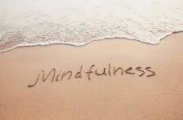 | Noun – 1) the quality or state of being conscious or aware of something.  2) a mental state achieved by focusing one's awareness on the present moment, while calmly acknowledging and accepting one's feelings, thoughts, and bodily sensations, used as a therapeutic technique.  Information on understanding Long Term Health Conditions  Notice things around you – are you getting dressed, sleeping, eating well?  Worry book – what’s a worry/problem? What can you control?  Mindfulness CD’s or Apps Meditation Breathing Exercises  Adult Colouring
Active  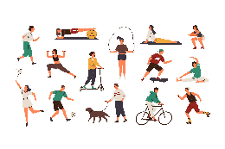 | Exercise improves mental health by reducing anxiety, depression, and negative mood and by improving self-esteem and cognitive function. Exercise has also been found to alleviate symptoms such as low self-esteem and social withdrawal.  House chores – hoovering, dusting, hanging washing  Getting dressed, washing  Get moving – Health walks, seated exercises  Set some health goals  Celebrating those small goals – SMART Targets
Giving   | Give yourself Time Call a friend/family Make a gift  Gratitude Jar – reflecting on what is good  Volunteering – charity shops, befriending, schools  BIG KNIT – Knitting squares for blankets for people in need  Listening – feeling valued, sharing and caring
Interests  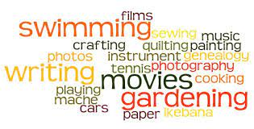 | Rediscovering old skills or interests! Learn something new!  Gardening Cooking Trainspotting Knitting Drawing  Colouring Painting Education History Swimming  Cycling Yoga Collecting Exercise Music  Glass Painting Singing Woodwork Crochet Bingo  Socialising Badminton Short Tennis Table Tennis Sport
Connecting  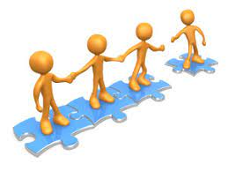 | Smiling at Shop staff Coffee Mornings Welcome Sessions  Hobbies/Interests Attending Local Groups Calling a Friend  Speak or Meet with Family or Friends  Look at Local Magazine for Activities in the Area

Mindfulness

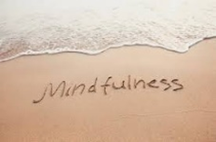

Active
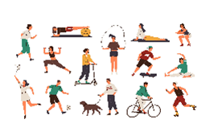

Giving



Interests



Connecting



