Enhanced Access (EA) (Out of Hours) Services (Excluding Mental Health Services)

**Phlebotomy Service**

Patients can be booked in for a home visit to take bloods. Service runs during normal working hours, weekdays only. A walk-in service is also available at Seacroft Hospital (next to Outpatients) Mon-Fri 08:30 – 11:45 & 13:00 – 15:45.**CHECK WITH YOUR MANAGER IF YOU HAVE THIS SERVICE**

**GP Appointments**



The BHR spoke model offers GP appointments (weekdays 4-8pm) (face to face and telephone) from Bellbrooke Surgery.

Additional telephone appointments (F2F or telephone) are also available on weekends (Sat 9-3pm & Sun 9-1pm)*.*

**First Contact Physiotherapist (FCP)**

**(Pts aged 16yrs +)**

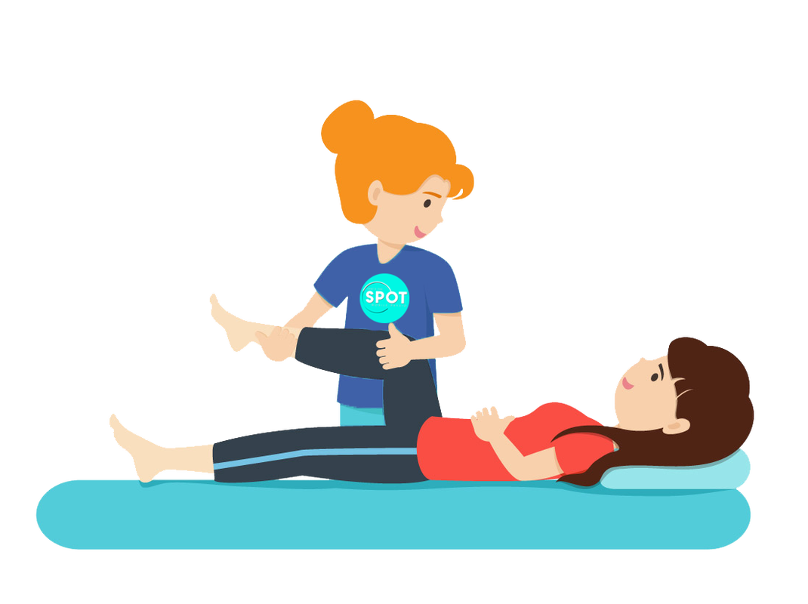

Offers telephone appointments to assess, diagnose, treat and manage **arthritis pain, sprains, strains, sports injuries, spinal pain and sports injuries** as a point of first contact saving the need for a GP appointment. 16*+ years only*

**Nurse & HCA Appointments**



Offers Nurse & HCA appointments (face to face) out of hours on weekends from Bellbrooke Surgery. Avoid booking pts in for: injections*, dressings* & baby imm’s / ECGs *injections/dressings can be provided if patient has their own supply

**Virtual Clinical Pharmacist Appointments**



Telephone appointment for patients who need to speak to a Pharmacist regarding a standard / routine medication issue, but don’t need to attend the surgery are available Monday to Saturday (no acute requests please). *Refer more complex med reviews etc. to PCN Pharmacy team*

**LARC Service**

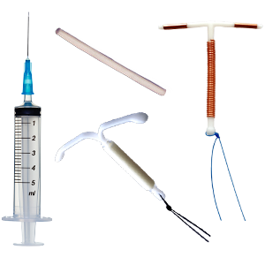

The long-acting reversible contraception (LARC) clinic is available patients requiring Contraceptive Implants, Contraception Injections and Coils (IUS and IUD)

**Booking/Referral Method**

Appointments are available via the EA Appointment Ledger on SystmOne via Site: EA-BHR PCN (Bellbrooke). Practice allocation is colour coded. Additional weekend appointments at Bellbrooke & St George’s Centre are bookable via NHS 111 & via the EA Appointment Ledger on SystmOne under: City wide same day response.

**Booking/Referral Method**

Appointments available via the EA Appointment Ledger on SystmOne under site Leeds South & East Phlebotomy Appointments. (Scroll right to bottom of options). Practice allocation is colour coded. If urgent bloods and no slots email selgpgroup@nhs.net

**Booking/Referral Method**

Initial screening appointments are available via the EA Appointment Ledger on SystmOne under EA-BHR PCN Fitting/Removal appointments are booked by the clinician (Bellbrooke)

**Booking/Referral Method**

Appointments are available via the EA Appointment Ledger on SystmOne under EA-BHR PCN (Bellbrooke)

**Booking/Referral Method**

Appointments are available via the EA Appointment Ledger on SystmOne under EA-BHR PCN (Bellbrooke)

Practice allocation is colour coded for Nurse appt slots. First come first served presently on HCA slots.

**Booking/Referral Method**

Appointments are available via the EA Appointment Ledger on SystmOne under EA-BHR PCN (Bellbrooke)

Practice allocation is colour coded

**Team Share**

4pm on Fridays for weekend appointments.

4pm day before for weekday appointments.

**Team Share**  Not applicable for these appointments. No practice allocation set

**Team Share**

Team Share is 1pm on weekdays for same weekday appt and 2pm Fridays for weekend slots appointments.

4pm day before for weekday appointments.

**Team Share**

Not applicable

**Team Share**

4pm on Tuesdays for Nurse & HCA appointments for the following weekend

**Team Share**  4pm the day prior to appointments.

PCN & Additional Services (Excluding Specific Mental Health Services)

**Dietitian**

Offers individualised dietary advice to Diabetic patients (Type 2) HbA1c>58 or newly diagnosed >48, wishing to improve their diabetic control OR pts with BMI>35 who are not under specialised care.

18+ years old only

**Sexual Health**



Offers under18s drop in, STI self testing postal kits, emergency contraception, contraception, chlamydia testing, Pregnancy testing as well as support & advice

**HCA (Mental health focus)**



Supporting practices to complete the physical health checks for SMI patients and coordinating this work for practices.

**PCN Pharmacy Team**



The PCN Pharmacy Team can support practices and patients with structured medication reviews, medication clinics and medication queries (PCN hub).   
***Patients can also be referred to the Community Pharmacy Scheme for minor ailments.***

**Health & Wellbeing Coaches**



Offers a non-clinical patient-led coaching service supporting patients to develop their self-management strategies & take pro-active steps to improve health and wellbeing particularly in relation to LTC’s.

Listening & encouraging pts to self-assess & self-reflect to build knowledge, skills & confidence to set and work towards self-identified health behaviour change goals.

**Patient Ambassadors (Social Prescribers)**



Providing individual support for patients as well as connecting people to community groups and agencies for practical and emotional support for a range of issues including housing, benefits, money, social isolation or anything else.

**PCN First Contact Physiotherapist**

**(Pts aged 18yrs +)**



Can assess, diagnose, treat and manage musculoskeletal (MSK) problems as a point of first contact saving the need for a GP appointment, *18+ years only*

**Linking Leeds Social Prescribing**



Connecting people to community groups and agencies for practical and emotional support for a range of issues including housing, benefits, money, social isolation or anything else. One off or up to 12 weeks support

**Booking/Referral Method**

Refer to care co-ordination hub for pt to be assigned to appropriate caseload, ensuring reason for referral is clear – access via template (orange triangle) called Care Coordination Hub BHR PCN

**Booking/Referral Method**

PCN Pharmacists appointments at each practice for routine med. reviews & queries (see separate flyer). Additional pharmacist slots can be booked via EA-BHR PCN (Bellbrooke) – NB –these are med reviews only – not SMR / and not acute requests (as not prescribers)

**Booking/Referral Method**

Patients can self-refer via Linking Leeds Website or telephone.

[Link to Referral Form](https://linkingleeds.com/referral-form/) 0113 336 7612. Practices can refer via through remote booking or the blue dot on SystmOne

**Booking/Referral Method**

Appointments are available via the EA Appointment Ledger on SystmOne under EA-BHR PCN (Bellbrooke). F2F or telephone options available as well as Initial Appointment / Follow up slots-specified in slot type

**Booking/Referral Method**

Jess’s slots are available on the practices own systems. Practices not yet allocated some time should contact jessica.hemingway2@nhs.net

**Booking/Referral Method**

Via [www.leedssexualhealth.com](http://www.leedssexualhealth.com) OR 01133920333 (mon-fri 8.30-4.30pm)

**Booking/Referral Method**

Refer to care co-ordination hub for pt to be assigned to correct caseload, ensuring reason for referral is clear – access via template (orange triangle) called Care Coordination Hub BHR PCN

**Booking/Referral Method**

Appointments are available via the EA Appointment Ledger on SystmOne under EA-BHR PCN (Bellbrooke). F2F or telephone options available -specified in slot type

**ADULT SERVICES – MENTAL HEALTH**

**HEROES**



The HEROES groupwork programme is an 8 week/20 hr recovery focused mental health treatment. We are wholly trauma informed and suitable for anyone struggling with their mental health, regardless of diagnosis. Suitable for anyone 18 years+ struggling with mental health ailments e.g. Childhood trauma, Complex PTSD, 'Personality Disorder', Depression, Stress, anxiety, panic attacks and beyond.

GROUP SESSIONS – NUMBER OF SESSIONS?

WHAT DO YOU TREAT? CLARIFY DETAIL

**Leeds Mental Wellbeing Service Therapists (previously IAPT)**

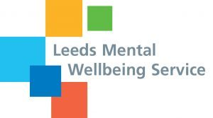

Age 17+. Providing support and psychological therapies GAD, panic, OCD, mild bulimia and PTSD. Includes 1:1, group, classes and online support options. Online self-therapy and classes for depression, sleep, anxiety etc. Mild/Moderate or Moderate Severe (Low Risk).

**Primary Care Mental Health Services (Leeds Mental Wellbeing Service)**

The Primary Care Mental Health Team (PCMHT) provide Mental Health Assessment, short term intervention & signposting for adults within Primary Care when a pt does not meet criteria for other services or has barriers in accessing services. Mental Health Practitioners are based in practices across the PCN and aim to work collaboratively with service users to identify their primary need in the here and now. This may include signposting / referrals onwards to other services (e.g., third sector or secondary care services. Where appropriate the service can also offer access to 1:1 and / or group psychological therapies and psychologically informed interventions. For patients with moderate and complex mental health problems, often long standing, affecting function.

[Link to Crisis Card](https://www.leedsandyorkpft.nhs.uk/advice-support/wp-content/uploads/sites/3/2019/02/CrisisCard.pdf)

**Healthy Minds Service**



Offers a virtual short term mental health support service for low-risk patients aged 18 and over who are feeling low, irritable, anxious, or stressed, are experiencing poor sleep or concentration, or have had a recent bereavement and would like help with emotional wellbeing.

*Link to the MindWell (Adults) website which includes further information on all services, self help advice and self referral links in Leeds -* [*https://www.mindwell-leeds.org.uk/professionals/service-and-referral-links/*](https://www.mindwell-leeds.org.uk/professionals/service-and-referral-links/)



**PCN Mental Health (SMI) Team**



Pts 18yrs+ on QOF mental health register are supported by the PCN team. As detailed previously, there is a HCA to support with SMI annual reviews in practice. A Mental Health Care Coordinator supports the coordination of personalised care plans and ‘What Matters to Me’ (WMTM) discussions.

The Mental Health Care Coordinator will support practices to review patients coded as ‘in remission from SMI’. Ensuring pts are highlighted for review where needed.

The team will proactively identify patients – practices should not refer into this service.

**Booking/Referral Method**

Refer to care co-ordination hub for pt to be assigned to appropriate caseload, ensuring reason for referral is clear – access via template (orange triangle) called Care Coordination Hub BHR PCN

**Booking/Referral Method**

Appointments are available via Remote Booking.

There is currently no practice allocation. Appointments are weekday only & telephone appointments only.

**Booking/Referral Method**

Patients can self-refer by phone 0113 843 4388 or via the website [www.leedscommunityhealthcare.nhs.uk/our-services-a-z/leeds-mental-wellbeing-service/home/](http://www.leedscommunityhealthcare.nhs.uk/our-services-a-z/leeds-mental-wellbeing-service/home/)

**Booking/Referral Method**

Referrals to the PCMHT would be made by a clinician following an initial patient assessment via the blue dot on SystmOne. The service aim is to contact the patient within 10 working days.

**Who can a child speak to when upset/in crisis?**

 **Childline**

0800 1111 [www.childline.org.uk](http://www.childline.org.uk)

Childline is available to help anyone under the age of 19 in the UK with any issues, big or small. Phone, text or chat online.

**Teen Connect**

0800 800 1212 / 0771 5661559

<https://www.lslcs.org.uk/services/connect-helpline/teen-connect/>

Teen Connect is a helpline for 13 – 18 year olds living in Leeds. Phone/online chat

**Leeds Survivor Led Crisis Service (LSLCS)**

0113 260 9328 [www.lslcs.org.uk](http://www.lslcs.org.uk)

LSLCS provide out of hours emotional support to people aged 16+ in emotional crisis. Phone/face to face.

**CHILDRENS SERVICES – MENTAL HEALTH**

**Mindmate – Single Point of Access (SPA)**

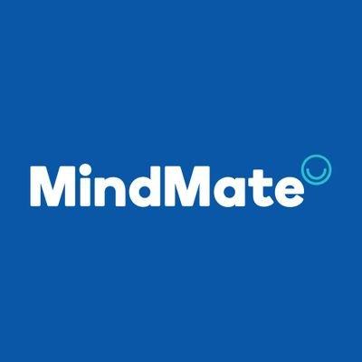

Mindmate is a Leeds-based service and main referral route for young people, their families and professionals who support them. Helps explore emotional wellbeing and mental health and refer to the most appropriate service. Mindmate is for all children and young people who have a Leeds GP, of school age and under the age of 18. Referrals are usually triaged within 14 days. **The Mindmate service is the correct route for access to CAMHS.**



Accessible, free, accredited mental health support. Any young person aged 10-18 can sign up anonymously online at Kooth.com. No waiting lists and no thresholds.

Please email these packs of digital info resources to students

- [For Kooth Users (10-18 year olds)](https://drive.google.com/drive/folders/16c5yKcGmGwrh1AQdf1p1i2ONoMkvrjRq)

Please email these digital info resources to parents/ carers [Kooth guides for parents / carers](https://drive.google.com/drive/folders/16c5yKcGmGwrh1AQdf1p1i2ONoMkvrjRq)

.

**Booking/Referral Method**

Patients can self-refer (parent/carer consent required if patient under 13) [Patient/Carer Self Referral Form](https://self-referral.mindmate.org.uk/) Professional referrals can be made via Mindmate Single Point of Access using [Referral Form](https://www.mindmate.org.uk/wp-content/uploads/2020/11/MindMate-referral-form_Oct20.pdf) email to [leeds.mindmatespa@nhs.net](mailto:leeds.mindmatespa@nhs.net) Service Telephone Number 0300 5550324

**BHR PCN Primary Care Network Services & Referral Routes (Version 2– May 2023)**

**DEMENTIA SERVICES**

**Memory Assessment**



Offers a full assessment (90 mins) and a diagnosis (or non-diagnosis) of Dementia or mild cognitive impairment (within 12 weeks of referral). Medication will be initiated if appropriate. A further 2 sessions of support are provided following initial full assessment.

**Memory Support Workers**

Personalised practical advice and support to people with memory problems (incl. families & carers) to enable them to stay independent for as long as possible. Works with patients prior to and after a memory assessment and can take re-referral if patient needs change.

**.**

**National Dementia Helpline**

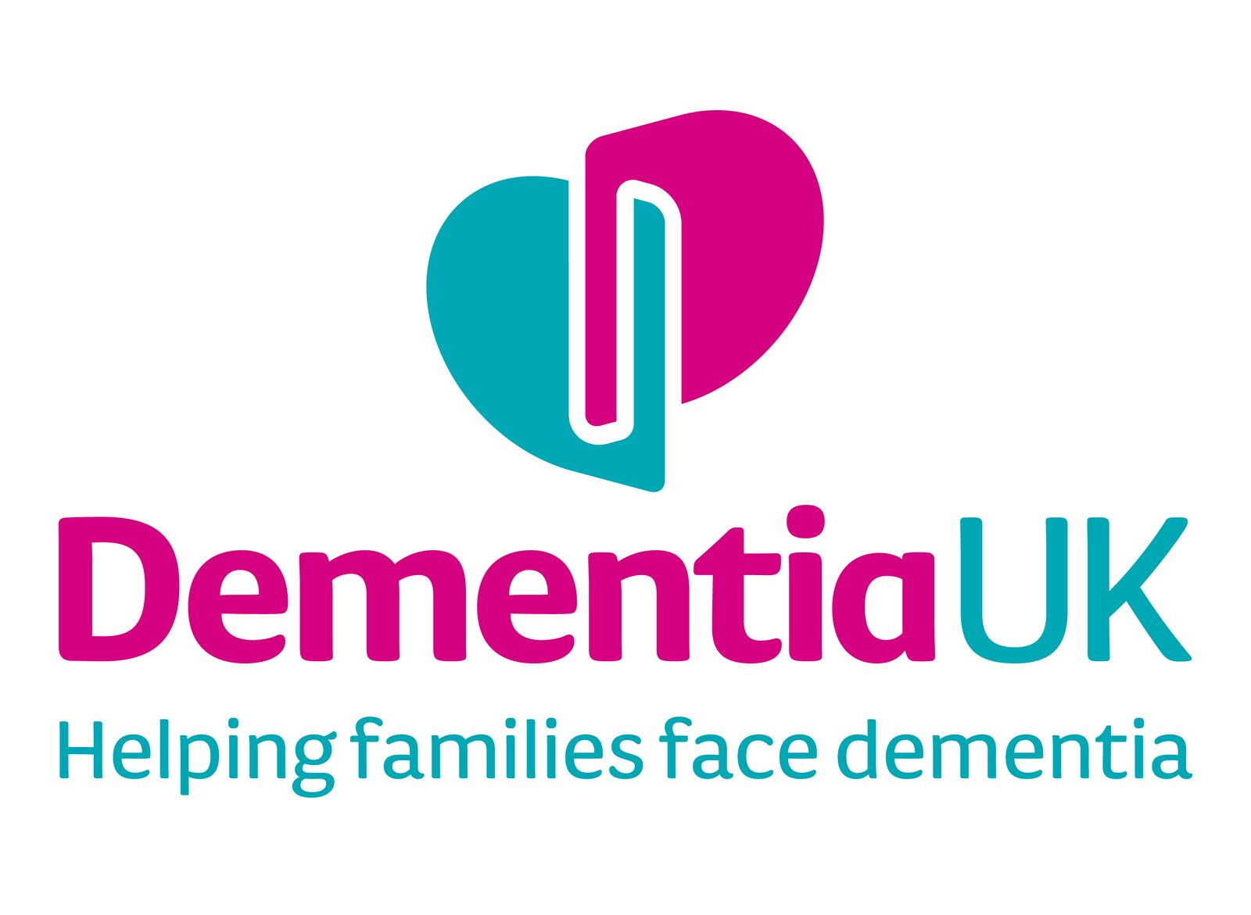

The National Dementia Helpline offers key information, advice and support for patients and their families/carers.

0800 888 6678

[www.dementiauk.org](http://www.dementiauk.org)

**Booking/Referral Method**

Via LYPFT Single Point of Access: [referral.lypft@nhs.net](mailto:referral.lypft@nhs.net)

Or via DART referral to: -

* Over 65 Memory Services
* Younger People with Dementia (YPWD) Service

**Waiting for a Memory Assessment?**

The following website offers advice and support to anyone waiting for a memory assessment

[www.nextsteps.org.uk](http://www.nextsteps.org.uk)

**Booking/Referral Method**

Email with patient name, DOB, GP, NHS no., address, contact no. & referral reason [memorysupport.lypft@nhs.net](mailto:memorysupport.lypft@nhs.net)

The service also offers an out of hours Dementia Connect Support phoneline **0300 156 3456**