NPMC
NPMC@Willen
NPMC@Kingfisher

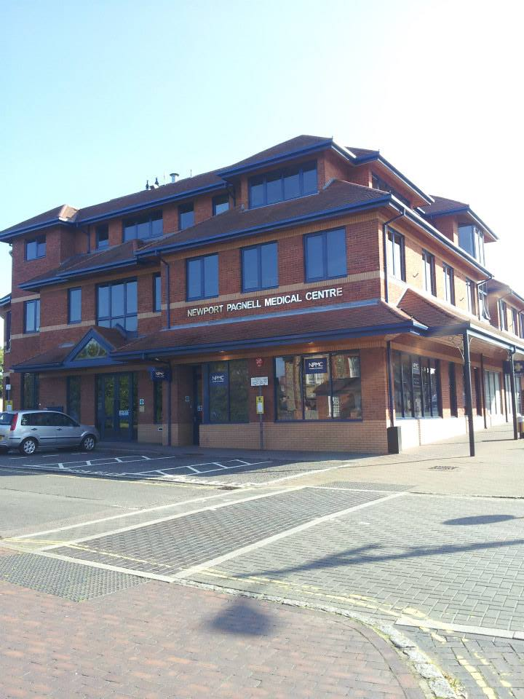

Practice Complaints Procedure

July 2024
NPMC NPMC@Kingfisher NPMC@Willen
Queens Avenue, 26 Elthorne Way Beaufort Drive
Newport Pagnell, Newport Pagnell Willen, Milton Keynes
MK16 8QT MK16 0JR MK15 9EY

Tel: 01908 611767
Email: blmkicb.npmcmail@nhs.net
Website: www.npmc.nhs.uk

If you have a complaint or concern about the service you have received from the doctors or any of the personnel working at the Medical Centre, please let us know. We operate a Practice Complaints Procedure as part of an NHS Complaints System, which meets national criteria.

How to Complain

We hope that most problems can be sorted out easily and quickly, often at the time they arise and with the person concerned. If your problem cannot be sorted out in this way and you wish to make a complaint, we would like you to let us know as soon as possible - ideally, within a matter of days or at most a few weeks - because this will help us to establish what happened more easily. In any event, this should be within 12 months of the incident or as soon as the matter first came to your attention.

You should address your complaint to NPMC in writing and mark it for the attention of ‘Complaints’. Your complaint will be directed to the most appropriate person to deal with your concerns promptly and in the correct way. You should be as specific and concise as possible. You can complain in writing, (download a complaint form from our website www.npmc.nhs.uk and email it to blmkicb.npmcmail@nhs.net) or complain verbally.

Complaining on Behalf of Someone Else

We keep strictly to the rules of medical confidentiality. If you are not the patient, but are complaining on their behalf, you must have their permission to do so. A third-party consent form (below) will be required unless the patient is incapable (because of illness) to complete this.

What We Do Next

We shall acknowledge your complaint within three working days and will investigate the issue raised and respond. If we expect a delay, we will explain the reason for the delay and tell you when we expect to finish.

When we investigate your complaint, we aim to:

- Offer you the option to discuss the way forward either by telephone or in person, at a mutually convenient time.

- Make sure you receive an apology, where this is appropriate.

- Ensure the complaint is properly investigated.

- Identify what we can do to ensure the problem does not happen again.

- You will receive a final letter setting out the result of any Practice investigations.

Taking it Further

If you remain dissatisfied with the outcome you may refer the matter to:

Parliamentary and Health Service Ombudsman
Citygate
47 – 51 Mosley Street
Manchester
M2 3HQ
Tel: 0345 0154033

Email: phso.enquiries@ombudsman.org.uk
Website: www.ombudsman.org.uk

Who Else Can I Talk To?

If you prefer, you may raise your complaint with NHS England
In writing: NHS England
PO Box 16738
Redditch
B97 9PT
By email to: england.contactus@nhs.net
If you are making a complaint please state: ‘For the attention of the Complaints Team’ in the subject line.
By telephone: 0300 311 22 33
Opening hours are: 8am to 6pm Monday to Friday, except Wednesdays when we open at the later time of 9.30am. We are closed on bank holidays.
The Advocacy People

This is a National service that supports people who wish to make a complaint about their NHS care or treatment. It is a free and confidential service that is independent of the NHS and tailored to individual client need.

Telephone: 0330 440 9000

Email: info@theadvocacypeople.org.uk

Website: www.theadvocacypeople.org.uk

Writing to: The Advocacy People
PO Box 375
Hastings
East Sussex
TN34 9HU

The Care Quality Commission

The CQC inspect GP Practices and other Primary Medical Services in England to check that they are meeting the National Standards of quality and safety

Tel: 03000 616161

Email: enquiries@cqc.org.uk

Writing to: CQC National Correspondence
Citygate
Gallowgate
Newcastle upon Tyne, NE1 4PA

Alternatively, you may wish to speak to our Patient Participation Group

Email: blmkicb.npmcppg@nhs.net



PRIVATE AND CONFIDENTIAL

NPMC, NPMC@Kingfisher & NPMC@Willen
Suggestions, Feedback and Complaints form

If you would like to make a suggestion, or have a complaint please fill in the details below. Upon receipt of this form we will respond in writing within 3 working days.

We will ensure that any complaint is properly investigated and will give you a written statement of the investigation and conclusion.

Date: | Your name:  DOB:
Details of the Feedback/Complaint:

What you would like us to do:

Date received: |  | Received by: | Passed to:
Shaded areas for office use only
Are you happy for the patient participation group to contact you to discuss your complaint?

Yes/No: Signature of patient:
(if complaining in person)

PRIVATE AND CONFIDENTIAL

NEWPORT PAGNELL MEDICAL CENTRE
PATIENT THIRD-PARTY CONSENT FORM

Patient’s Name..............................................................................................................

Address........................................................................................................................

.................................................................................................................................

Tel no............................................................

Enquirer/Complainant Name:.............................................................................................

Address........................................................................................................................

...............................................................

Tel no............................................................

IF YOU ARE REQUESTING INFORMATION OR COMPLAINING ON BEHALF OF A PATIENT OR YOUR ENQUIRY OR COMPLAINT INVOLVES THE MEDICAL CARE OF A PATIENT, THEN THE CONSENT OF THE PATIENT WILL BE REQUIRED. PLEASE OBTAIN THE PATIENT’S SIGNED CONSENT BELOW.

I fully consent to my Doctor releasing information to, and discussing my care and medical records with the person named above in relation to this complaint, and I wish this person to complain on my behalf.

This authority is for an indefinite period / for a limited period only (delete as appropriate)

Where a limited period applies, this authority is valid until.........................(insert date)

Signed: ........................................................ (Patient only)

Date: .............................................................

