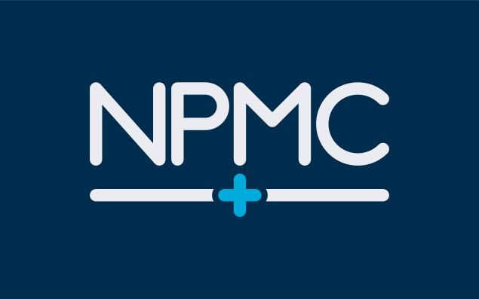
PRIVATE AND CONFIDENTIAL

NPMC & NPMC@Willen
Comments, Suggestions and Feedback form

If you would like to make a suggestion or give us some feedback please fill in the details below.

Thank you for taking the time to complete this form, we are grateful to receive all views and suggestions from our patients.

Date: | Your name:  DOB
Details of Feedback

What you would like us to do:

Date received: |  | Received by: | Passed to:

Shaded areas for office use only

Signed: ........................................................ (Patient only)

