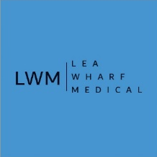

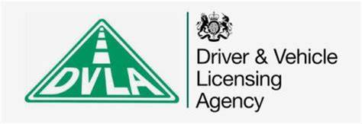
DVLA

If you have a DVLA form for the GP to complete , please ensure your details are completed first.
Provide your form to the reception at Lea Wharf or the DVLA will write to us.
We then invoice the DVLA and write to them to advise of our fee. Once we have received payment , this will be completed within 28 days from payment.

In some cases, the DVLA may request additional documentation or evidence from the GP, especially if the medical condition is complex. The GP may need to attach supporting medical records, test results, or a letter providing further clarification.
If the patient’s condition is subject to regular changes or monitoring, the GP might note that additional information or follow-up assessments may be required in the future.

If you are required to attended the surgery for a DVLA medical assessment , we will contact you to book this.

After completing the form, the GP will return it to the patient. In some cases, the GP may send the completed form directly to the DVLA, depending on the agreement with the patient. The patient can then submit the form to the DVLA for review.

The GP will only complete the form with truthful and complete medical information. Providing inaccurate or incomplete details could have serious implications for the patient’s driving status and public safety.

We do no accept payment from the patient , this must be paid from the DVLA directly.

If you wish to know the status of your DVLA request , please contact the DVLA on 0300 790 6806

www.gov.uk/government/organisations/driver-and-vehicle-licensing-agency

