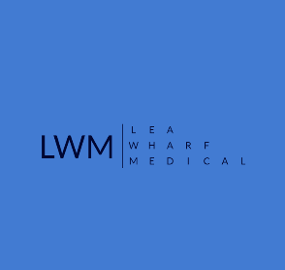

LEA WHARF MEDICAL CONSENT LETTER

Consent for Representative/s to discuss medical records on patient’s behalf.

Patient Name ____________________________________________
Date of Birth ________________________________
Address__________________________________________________________________________________________________________________________________ _____________________________________________________________________

- Representative/s Name _________________________________________
Contact Number ________________________
Relationship to patient_______________________________________________________

- Representative/s Name _________________________________________
Contact Number ______________________
Relationship to patient____________________________________________________________

I hereby give consent to the above-named representative/s to have a copy of my:
Full medical record from birth
Partial medical record from ________ to _________
I understand that once I have signed this consent the request will be processed, and all information will be sent to the third party within 28 days.

Signed _________________________________________
Date _________________

