 MINUTES FOR PATIENT PARTICIPATION GROUP (PPG) MEETING OF MONDAY 16TH JUNE 2025

ATTENDEES: SR, EA, BC, RM, AM, SE, JR, JK, LM, ROB

INTRODUCTIONS

New PPG member present - Introductions

PPG OVERVIEW

New PPG member – Overview for information

- A Patient Participation Group (PPG) is a group of patients, carers and GP practice staff who meet to discuss topics of mutual interest.
- Discuss constructive suggestions for improving the practice and share concerns that could affect the wider practice population.
- To support health awareness and patient education.
- Use patient experience to help improve the service e.g. assist the practice in making sure their website is ‘Patient Friendly’, produce newsletters from PPG – The practice does not currently have a newsletter
- Engage with the local community and patients via fundraising events and useful health information, to ensure the PPG is representative.
- Recommendation is that an external member of the practice should be chair of the PPG group – discussion followed-no volunteers and so Dr Kidd is happy to continue to chair. Any member can volunteer at any point
- Meetings 3/annum – 2 so far this year
- Quorate number 5 members external to practice are required to make decisions – if less than 5 external members confirm their attendance in advance the meeting will be rescheduled

08:00AM RUSH

- Reviewed May 2025 average call data
- Call volume between 08:00am-09:00am 37 calls (number appears low - May has 2 bank holiday Mondays which will lower the average number of calls dramatically as Monday is the busiest day)
- Abandoned 9 (ended call before joined queue)/missed 4 (ended call whilst in the queue)/answered 24
- Discussed that pt may Abandon (end call before joining the queue) due to the recorded message that is played regarding online triage system
- Discussed number of staff needed at 8am – 5 staff – 1 Reception desk – 3 answering calls – 2 Booking appointments from Triage forms
- Types of calls between 8am-9am - 14.3 appointments/ 0.7 prescriptions/ 2.8 general enquiries
- Review May 2025 average Online triage form data
- Average amount of forms submitted between 8:00-9:00am 139 (Again consider may bank holidays x 2)
- Digital Quality Improvement Project –
Aim - Achieve a 5% increase in the utilisation of online consultation forms, rising from 1,939 contacts in March 2024 to 2,036 contacts by March 2025. Concurrently, we seek to reduce inbound calls to the practice by 5%, decreasing from 5,081 in April 2024 to 4,827 in April 2025
Results - The number of online consultation forms received in January 2025 were 3017 forms, which is an increase of 55%, with an increase for February 2025 (shorter month) of 2573 online consultation forms, which is still an increase of 32% compared to the figures from March 2024, far exceeding our 5% target.
The number of phone calls to the practice in January 2025 were 4758 calls, which is a reduction of 6.5%, with a further reduction in February 2025 (shorter month) with 4624 calls, which is a reduction of 9%, when compared to the figures from April 2024, again far exceeding our 5% target.
Benefits – Reducing waiting on hold times making the practice more accessible to those digitally excluded patients.
Increased accuracy in appointment booking – via online forms – priority/length/clinician.
By targeting digitally capable patients, we anticipate an overall improvement in service delivery for all patients, including those who face barriers to accessing online platforms.
- PPG members weren’t aware that the phone/online forms had changed from opening at 08:30am to 08:00am. Reminder that it was discussed in previous PPG meeting.

- Additional – Quick survey around the room. Where do patients look for practice updates?

Text message, waiting area poster (Prominent Notices useful)

APPOINTMENT POLICY

‘To ensure that our patients have access to timely and appropriate healthcare services while making efficient use of our practice team and digital systems /online services. The policy applies to both patients and the practice team, aiming to streamline the appointment booking process, reduce delays, ensure that patients are seen by the right person at the right time and encourage the use of digital resources, to help guide people to other services if appropriate, or support patients to self-serve if they can. This frees up time for the practice team to deal with patients who otherwise may be digitally excluded’

PROPOSED OCTOBER MANDATE/NEW CONTRACT

- From 1 October 2025, and in line with NHS England guidance, GP practices will need to enable online consultation tool availability throughout core hours (8:00am to 6:30pm, Monday to Friday) to support:
- Non-urgent appointment requests
- Medication queries
- Administrative requests
- Started-admin requests already available core Opening hours

Challenges –

- Balance of demand vs availability of appointments
- Switch from current appointment management
- Safeguards are in place to ensure that urgent clinical matters are redirected appropriately
- Routine appts - how far in advance is reasonable - 2 weeks agreed is the ideal
- Balance patient suitability of offered appt vs correct clinician/service
- Current online tool doesn’t allow distinguishing urgent vs routine

Peak times –

Many practices find that one day of the week (typically Monday) is very busy

Even though most practices skew their clinical sessions/availability towards Mondays/other predicted busy times, this skew may not be enough to even out the workload through the week, buffer-keep some appts Tues/Wednesday for less urgent problems-can be freed for on the day if not used

Signposting/missed appointments discussed

- Self-care
- Pharmacy First/minor illness service/MECS
- NHS 111/ direct to hospital
- Appointment reminders will be sent via the text messaging system to patients 24 hours before their appointment is due. This helps to reduce the number of missed appointments and ensures patients are reminded of their scheduled time. The practice team will ensure the system is set up for automatic reminders including the option for patients to cancel appointments via text message.
- The practice are also looking into a telephony tool that allows pt to call the surgery number and select a designated number to check/cancel appointments

DIGITAL EXCLUSION

- Patients are encouraged to use the NHS App as their primary point of contact for non-urgent services. Through the app, patients can:
- View, book, and cancel appointments.
- Request and check the status of repeat prescriptions.
- Access their medical records, including viewing and sharing test results and correspondence from and with other healthcare professionals.
- We recommend that all patients register for the NHS App, which allows the NHS to communicate securely and cost-effectively, and enables patients to access wider NHS services.

Practice Aims –

- To be digitally inclusive
- How can we help to achieve that for our pt - Any ideas?
- Why could people be digitally excluded, and how can we alleviate this?
- Drop-in sessions?
- The Benefits

Discussion:

Reasons pt could be excluded –

- Particular Health problems

- Vulnerable group

- Language barriers

- Age

- Lifestyle

- Cost of Technology

How Can we alleviate this:

- Drop-in sessions with feedback

- Reassurance that there the option to call the practice is still available

- Cascade the Benefits

Additional -

- Contact the local libraries in the area to enquire if they provide digital support drop in sessions

FRAUD ALERT
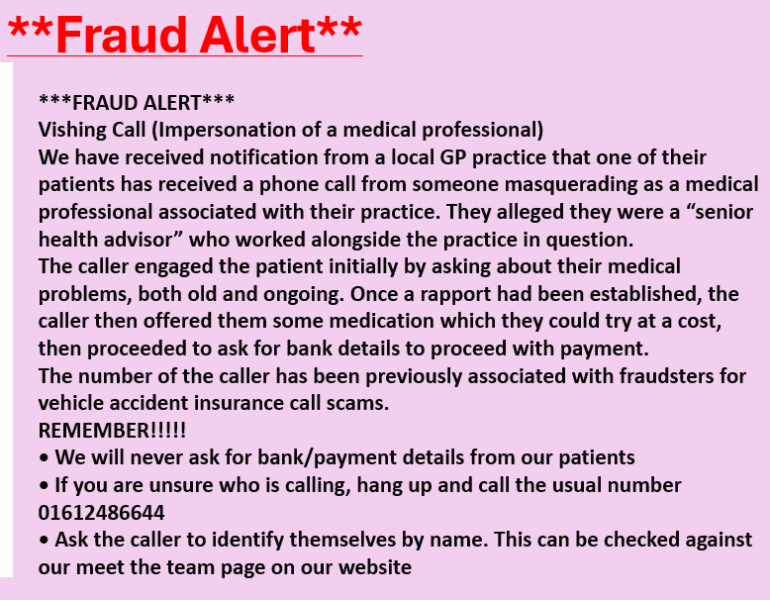

- The incident was not a pt registered at Bodey
- Not much information shared but wanted to re-assure that pt data is secure
- Suspect the caller identified themselves by calling from the doctor’s surgery rather than knowing the individual practice the pt was registered with
- Advice given about confirming who is calling as poster above

AOB

- During Covid there was a line at Reception desk to encourage patients to distance when checking in. Can the surgery re-implement this to discourage patients overhearing private and confidential conversations. Surgery will look into options.
- Sainsburys car park Speed issue (review from prev meeting) – Lauren contacted Sainsburys who are going to contact head office and get back to her as they state the car park is privately owned
- Telephone appointments – why are these not timed, and a 4-hour window is given. Discussed that clinicians manage their own clinics and to allow for any urgent cases that may delay or cause the clinician to run behind – pt are not expecting a call at a certain time. Can the window be reduced?
- PPG member had recent Pharmacist appointment. Was told the pharmacist would call between 9am-1pm and they called at 08:50am – will review with practice staff
- Discussed in previous meeting expanding the practice building. The practice applied for funding which was rejected – will apply again.

ACTIONS

- ROB - Contact the local libraries in the area to enquire if they provide digital support drop in sessions.
- ROB/LM – To investigate a provision at the front desk to encourage patients to distance.
- ROB to cascade to the practice team regarding telephone call windows.

Date of next meeting:

Middle of October - TBC

