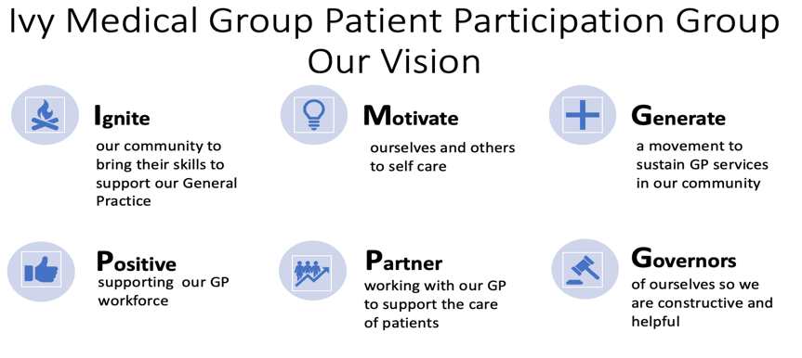


Ivy Medical Group (IMG) Patient Participation Group (PPG)

DRAFT PPG Formal Meeting Minutes (to be approved at the next meeting)

01 April 2025

Agenda item | Notes | ACTION/OWNER/DATE
- Attendees | Tracy Madge (TM), Martin Maynes, (MMa), Bob Barrett (BB), Liz Breeze (LB), Sharon Hill (SH), Grace Riley (GR), Melanie Maddock (MM), (BL),David Morley (DM) | Action: to note
- Welcome and apologies | Chair welcomed all, and introduced members of the PPG.  Chair noted quite a few apologies and will contact members to encourage attendance  Chair noted only three patients attended, suggesting no urgent issues for Ivy at present. Will consider cancelling patient engagement event in June  Apologies Dr Panesar, Lindsay Hall, Dan Howarth, Anne Butler, Christina Juliff, Ingrid Glover.  . | Action: to note  Action : Chair  Action: Chair (post meeting note - June meeting cancelled)
- Conflicts | No conflicts declared | Action: to note
- Minutes from the last meeting | Agreed as an accurate record and actions completed/progressed | Completed
- Action Log | Action Log was updated by workstream leads. Following points were made  - The use of a microphone for hard of hearing patients deemed to be too expensive. Instead will encourage meeting participants to speak up  - Blood test chart had proved difficult as the process is quite complicated. Instead we will encourage patients to use NHS app to access results  - Still policy to promote triage instead of telephone  - It was felt human story re staff not really necessary and staff confidentiality was important. Instead focus would be on keeping the website up to date with staff names and roles displayed.  - Lowdham outreach. Ivy has access to a room in the pharmacy but at present insufficient staff to progress this fully. However, would pilot one Thursday per month as a bookable clinic.  - New induction loop to be ordered | Action:  To note  To note  Ongoing  To note  Action MM  Action MM
- Patient Questions and Answers | Patients present were invited to ask any questions relating to the Ivy. The following questions/issues were raised.  Patient with palliative care had not been prioritised in line with policy. Patient will be asked to contact MM who will deal with this issue  Patient asked whether Ivy received any money from the telephone service. The answer is no. | Action: MM  To note
Workstream Updates | PPG workstream leads gave updates on their areas.  Patient Engagement  New initiative will focus on encouraging patients with diabetes to use NHS App. 45 pts identified from the database who will be invited to take part in a bookable session. Room booking required.  Still only 25% of patients use online triage. Agreed to target 50 - 60 age group, possibly by use of a survey  Also will target U18. Grace to contact CLW 6th form head and aim to set up a session for their students.  Premises  Outline Business Case (OBC) sent to ICB and positively received apart from value for money (VFM). ICB want cost neutral solution which was proving difficult  Dr P in discussion with ICB re next steps.  It is possible that the PPG may be asked to start campaigning for new premises if no progress is made  Dr P remains committed to providing a GP service locally.  Communication  Liz and Tracy continue to regularly visit practice and update notice boards etc. Dan also continues to distribute health posters locally. | Actions: To Note  Action TM  Action TM  Action GR
 | End of Life  No update  U18  To note that a child social prescriber is available. Will contact university practice to establish what students need.  Health Awareness  Steady flow of information leaflets/articles produced by Bob, now with AI Assistance! Next topics will be frailty and loneliness/anxiety | Actions: To Note
Practice Update | Melanie Maddock gave an update on issues the practice was working on. Particularly encouraging to note that the practice was receiving many compliments as well as complaints.  Complaints are at a low level at present, with the biggest issues being around triage. Most complaints can be dealt with effectively by practice staff and patients usually just wanted explanations. Noted that social media criticism has thankfully reduced lately.  Noted that on 24th April the practice will introduce a new phone system. This is far superior to current package and offers patients a “call back” feature so they don’t have to wait on the line. Also offers text updates. This will be advertised on social media and website
- Meeting Close | Meeting Close - 6pm
- Next meeting | DATE  Formal 6PM - Thursday 17th July, BJ Village Hall | To Note

