Patient Participation Group: Health Insights
A periodic look at topical health-related issues.
Digital Health
Not keen on technology? What to do to avoid being left behind.
As we will see later in the article greater use of the NHS App and other online systems to access healthcare will be coming
Firstly, don’t panic, the NHS will still use traditional methods to access care for those who can’t or won’t use digital/technical routes
But for the rest of us IT’S FASTER, SAFE AND EASY so:

- Install the NHS App on your Smart Phone or Tablet device, and set up an NHS Account. For help on how to do this see later.


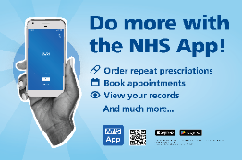
Get to know the App and what it can do for you.

Why use the App for your Healthcare
The App really does contain a huge amount of NHS health information as well as enabling access to health services, requesting prescriptions, access to test results and full GP patient records. As with most technology if we don’t use it we forget how to use it so open the App now and then to refresh yourself with what it can do.

Book an appointment or request help with a medical or admin issue


The following functionality is in the App….and more.

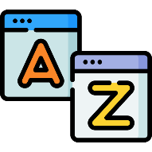
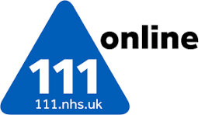
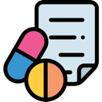
Order your repeat prescriptions using the Electronic Prescription Service for collection at a Pharmacy of your choice. No more ‘lost’ paper prescriptions, everything will be available in the App
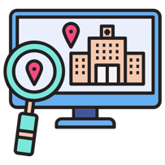
See your GP Records You can see your full, coded medical records and any agreed actions, Some hospital records such as future and past appointments may be available as well.
Get urgent or out of hours medical help. 111 Online works just like the phone and avoid speech or hard of hearing issues
Check on a medical conditions and potential treatments using approved NHS information rather than unchecked Internet search results.

See your GP requested Test Results. You can see your test results as soon as your GP has reviewed them and agreed actions. No need to call the practice for routine results.
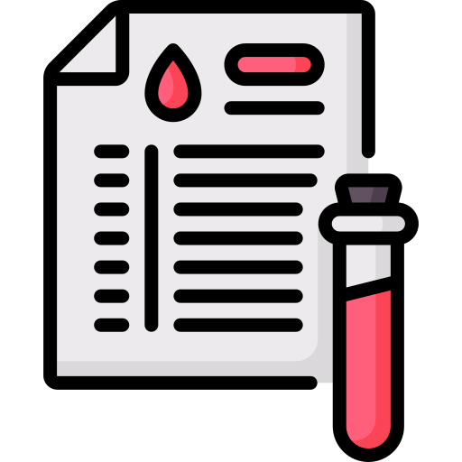


Find your nearest GP, Dentist, Pharmacy, Urgent care or Emergency Dept. Useful if ill on holiday or travelling. The app provides directions as well.
Get personal help
If you are an Ivy Medical Group patient there are regular help sessions on Tuesday mornings at the Apple tree surgery where Elaine Osborne, our NHS App guru can help with installation and setup of the App in one-to-one sessions. These are bookable via reception or direct with Elaine on 07423 747532 or elaine.osborne5@nhs.net
.
So, what is ‘Digital Health’?
The recently released Government vision for the NHS – the NHS Ten Year Plan intention is to reinvent the NHS with three radical shifts.
- Hospital to community
- Analogue to digital
- Sickness to prevention
There is a lack of detail at this stage as to how this will be achieved but this article refers to number 2 – analogue to digital. This will mean use of digital rather than written records throughout the NHS and much greater use of online methods for communication rather than letters or phone calls. There is also the recently announced NHS Online initiative whereby online access to hospital and diagnostic services will be available online rather than solely via your GP. How this will work is also yet to be divulged, All this is what we mean by Digital Health

What can we expect as patients?
It will certainly mean greater use of the NHS App (and other forms of online access) for people to access healthcare. This will also mean an expansion of the use of online consultations and the seeking of appointments or advice through online booking systems. Such a system has been operated by The Ivy Medical Group since April 2023. As from 1st October every GP Practice should be using some form of online consulting tool so it looks like this approach is here to stay.
A change in expectations?
Now, we all expect to see a GP face to face, but in future seeing a doctor will be based upon need, rather than on what we expect. So, expectations may have to change especially around GP appointments.
There are advantages to the online approach, notably that you can get medical advice/help and treatments such as drugs and tests etc, without necessarily having to see a GP. Also, typically an online request can be made before the Surgery opens (from 7.00am if an Ivy Medical Group patient), so a patient can ask for help before going to work rather than having to wait for opening hours to call by phone or by going to the practice..
A lot of the time help can be given via a phone call, a text message or email and via an electronic prescription being sent straight to the pharmacy of your choice. This means that priority for a face-to-face appointment can be given to those with conditions that need to be seen. All online requests will be reviewed by a Clinician and the most appropriate means of providing help will be selected.
More information on the NHS App and its use?
There is a guide about the App and help with installation here https://www.nhs.uk/nhs-app/about-the-nhs-app/

Produced by the Patient Participation Group (PPG) of The Ivy Medical Group (IMG) who run a series of health promotion initiatives with the full support of the practice; this is our fourteenth Health Insight topic.

Acknowledgements – Graphics from NHS England and Medical Icons from Flaticon - Freepik and Karyaktiv

