

PATIENT INFORMATION BOOKLET

Bilston Health Centre
Prouds Lane
Bilston
Wolverhampton
WV14 6PW

Tel: 01902 490100
Website: https://www.drmudigondagp.co.uk

WELCOME TO OUR PRACTICE!
Dr Mudigonda’s GP surgery is a friendly, family run GP Practice that has been looking after patients in Bilston for the past 25 years. This booklet will give you and your family the information you require to enable you to get the best from the Practice.

CONTENTS
Your GP surgery team and consultation hours ……………………………………………………….. 3

How to register as a patient ………………………………………………………………………..…………. 5

Overview of sources provided ………………………………………………………………………………… 5

Appointments ………………………………………………………………………………………………….…….. 6

Medical queries not requiring and appointment ………………………………………………….…. 6

Home visits ……………………………………………………………………………………………………………... 7

Prescription services ..…………………………………………………………………………………………..... 7

Test results ..……………………………………………………………………………………………………………. 8

Complaints procedure ………………………………………………………………………………………………. 9

Patient rights …………………………………………………………………………………………………………… 10

Patient responsibilities ……………………………………………………………………………………………. 10

Out of Hours Services……………………………………………………………………………………………….. 11

GP net earnings ………………………………………………………………………………………………………. 11

How the practice uses your data ……………………………………………………………………………… 12
PRACTICE OPENING HOURS
Monday 8:30 am – 6:30 pm
Tuesday 8:30 am – 6:30 pm
Wednesday 8:30 am – 6:30 pm
Thursday 8:30 am – 1:00 pm
Friday 8:30 am – 6:30 pm
Saturday Closed
Sunday Closed

PRACTICE STAFF
CLINICAL TEAM:
GPs:
Dr Varun Mudigonda (m); MBChB, MRC (GP)
Dr Sana Arshad (f); MBBS, MRCP, MRC (GP)

GP Registrars:
Dr Faisal Alamgir (m); MBChB
Dr Damilola Balogun (m); MBChB
(NB: As we are a training practice, GP registrars are on rotational training programmes and subject to change)

Other Clinicians:
Mrs Rita Kainth (Independent Prescriber); BSc (Hons), MPharm (Hons), PGClinDip, IP
Ms Baljit Kaur (Practice Nurse); RN
Mrs Marie Holmes (Healthcare Assistant)

NON-CLINICAL TEAM:
PRACTICE MANAGER:
Dr Mohan Mudigonda (m); LLB (Hons), LLM, PhD

ADMIN ASSISTANT:
Murid Ali (f)

SENIOR RECEPTIONIST:
Jackie Darrell (f)

RECEPTION TEAM:
Elaine Walford (f); Jodie Homer (f); Manisha Shrivastav (f); Debbie Perry (f)
HOW TO REGISTER AS A PATIENT
Registering with us as a patient could not be simpler. You can either:
- Come into the surgery and complete a registration form in paper copy or;
- Register on our website at: https://www.drmudigondagp.co.uk; simply go to the section “New Patients” which is accessible from the Home screen.
We are accepting all new patients that reside within our catchment area.
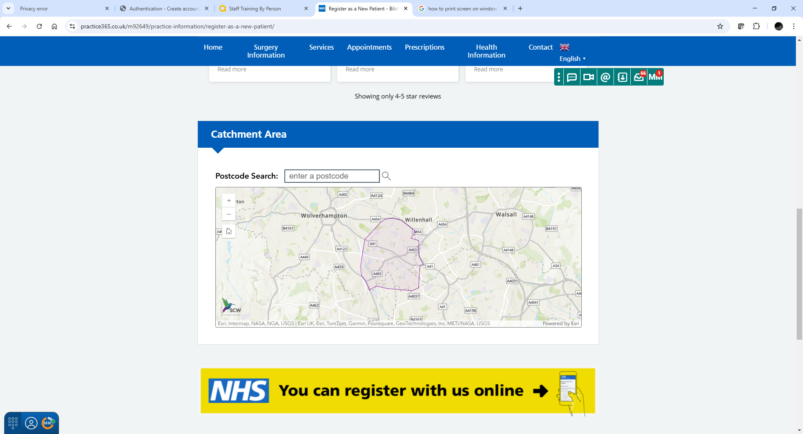
The ‘New Patients’ section of our website has a postcode checker so you can check whether you fall within the catchment area (We are sadly unable to register anybody who resides outside of it).
Once you have registered as a patient, you will need to complete a New Patient Health Check. Our reception staff will be happy to book this in for you.
PRACTICE OVERVIEW AND SERVICES PROVIDED
- Male and Female GPs
- Training Practice with GP registrars on rotation
- Clinical Prescriber clinics for medication reviews and advice
- Weekly Child Immunisation clinics
- Vaccination services for seasonal influenza, RSV and travel vaccinations (upon request, not including yellow fever)
- Cervical screening
- Diabetes reviews (including foot checks)
- Mental Health and Depression reviews
- Health checks for vulnerable groups including Learning Disabilities and Carers
- COPD and Asthma reviews
- Electronic Prescription Service
- Free parking
APPOINTMENTS
TO REQUEST A ROUTINE APPOINTMENT (7-14 DAYS), OR AN EMERGENCY SAME DAY APPOINTMENT:
- Telephone reception on 01902 490100 or:
- Visit the surgery in person and speak with a receptionist.
- You will be asked what you need help with when you contact us; this is so you can be given an appointment that is best suited to your needs.
- Appointments are usually face-to-face; telephone appointments are available upon request if warranted and at the discretion of the clinicians.

MEDICAL QUERIES NOT REQUIRING AN APPOINTMENT
- Non-urgent or admin related queries can be made by:

  - Calling reception on 01902 490100
  - Using the “Contact us online” link on our homepage – https://www.drmudigondagp.co.uk
  - Emailing the practice at bcicb.drmudigonda@nhs.net or m92649.docman@nhs.net.

- Sick notes can be requested before 11am every weekday via the above methods.

- Test results can be requested after 11am every weekday via the above methods.

- Practice premises are fully accessible for patients with disabilities

HOME VISITS

Requests for home visits must be made before 10.30am and are available only for patients who are deemed to be housebound i.e. incapable of attending the surgery in person due to illness.

Please note that logistical difficulties (e.g. lack of transport or childcare) do not qualify as reasons for requesting home visits.

The doctor may telephone prior to, or instead of visiting.

Visits requested later than 10.30am and not deemed urgent will be made the following day.

Whenever possible, we would ask that patients try and attend the surgery in person, as facilities here are far better for examination and treatment.

The reception team will ask you about your symptoms briefly; although you do have the right not to divulge this to our receptionists, it does help them to judge the urgency of the call if you are willing to briefly describe your needs.

Our reception team are trained to deal with your call so please do not be offended if you are asked about the reason for calling.

PRESCRIPTION SERVICES

Repeat Prescriptions can be ordered via the following methods:
- Visiting reception and requesting in person;

- Via email at bcicb.drmudigonda@nhs.net or m92649.docman@nhs.net;

- Via the Patient Access or NHS Apps on a smartphone; you will need to register for online booking to make use of this, but reception will be happy to assist you, so please do not hesitate to ask.

Please note that we are unable to accept prescription requests via telephone.

Please allow 48 hours for prescriptions to be processed.

Patients who are on repeat medications will be required to see a GP or Clinical Pharmacist for review at least once annually. This is to ensure that your medications are being used appropriately and remain safe for you.

TEST RESULTS
Please contact the surgery any time after 11.00 am Monday to Friday (after 10 am on Thursdays).
We do not contact patients about routine non-urgent test results and request that you contact the practice to chase these up.
If test results require urgent action or require an appointment with a clinician, you will be contacted by a member of the practice.

Indicative wait times for test results are:
- Blood tests: 2 – 4 days
- Urine and swab tests: 3 – 7 days
- X-Rays/Radiological scans: 2 weeks or more depending upon hospital workload
Test results cannot be given out before a doctor has had a chance to check and interpret them. Please remember that our receptionist staff are not medically trained and will not be able to interpret your results themselves. Once results have been checked by a clinician, receptionist staff will be able to let you know the overall outcome.

COMPLAINTS PROCEDURE
Most problems can be sorted out quickly and easily, often at the time they arise with the person concerned.
If, however you are unable to resolve your complaint informally, you do have the right to raise a formal complaint.
Formal complaints should be made:
- In writing with as much detail as possible
- Within 6 months of the incident or within 6 months of you becoming aware of the matter
If you are a registered patient, you can complain about your own care
If you wish to complain about someone else’s treatment, you can do this with express permission from the relevant individual.
Written complaints can be submitted in the following ways:
- Via email to the practice manager, Mohan Mudigonda, as bcicb.drmudigonda@nhs.net
- Via a feedback form which can be requested at reception
- Via a letter to the practice manager which can be handed in at reception or posted to:

Dr Mohan Mudigonda
Practice Manager
Bilston Health Centre
WV16 6PW

If you are dissatisfied with the response you receive, you have the right to escalate the matter outside the practice.

The Black Country ICB can be contacted as follows:

- Via telephone on 0300 0120 281
- Via email at bcicb.time2talk@nhs.net
- Via post at: Time2Talk, NHS Black Country Integrated Care Board (ICB), Civic Centre, St Peter’s Square, Wolverhampton, WV1 1SH

PATIENT RIGHTS
We promise to make your welfare our highest priority at all times by providing all services in an efficient and ethical manner.
- All our patients will be provided with a named accountable GP, so you can be assured that there is a clinician who oversees your care. However, you have every right to book an appointment with any clinician of your choice; you are not limited to only seeing your named GP.

- All our patients will be received courteously and you will be able to identify all staff by name.

- We will respect your religious and cultural beliefs.

- Our practice premises will be clean, comfortable and maintained to the standard required by current modern medical practice.

- Waiting times will be kept to a maximum of 30 minutes, if there are any delays you will be informed of the reason.

PATIENT RESPONSIBILITIES
- You will not be able to see a clinician without a prior appointment. In the highly unlikely event of this being permitted, the decision on whether to do so or not is entirely at the discretion of the clinician

- Missed appointments cost the practice an average of £50. Although we fully appreciate that this might often be unavoidable, we request that patient’s contact the surgery as soon as possible if an appointment needs to be cancelled, as this appointment can then be offered to somebody else.
- We request that you use your appointment time to discuss one problem only; this is so clinics do not overrun any more than is necessary. If you have multiple issues that you would like to discuss with a clinician, please speak to a receptionist who will be able to assist you with booking a double or triple appointment (subject to availability).

- The practice has a zero-tolerance policy on physical and verbal abuse, aggression and bullying of staff or fellow patients. This includes making demands rather than requests and the use of emotional blackmail to obtain a service or appointment.

Any such behaviour will result in removal from the practice list and, if deemed necessary, a police report will also be made.

OUT OF HOURS SERVICES
As we are part of the Wolverhampton South East Collaborative Primary Care Network, evening and weekend pre-bookable appointments are available at nearby practices for when we are closed. Patients can contact the PCN directly on 01902 491888, or alternatively, contact our reception desk on 01902 490100 for information on these extended services.

The surgery is closed between 6.30pm and 8.30am Monday to Friday and all day on Saturdays and Sundays. During these times, if you think you are having a heart attack or stroke, you must immediately dial 999. If you have an urgent query that cannot wait until the surgery re-opens, you can contact NHS 111.
Alternatively, you may also attend the Urgent Treatment Centre at New Cross Hospital or the Phoenix Walk-in Centre at 715B Parkfield Road (open until 8pm)

All Out of Hours Services are commissioned by the Black Country Integrated Care Board.

GP NET EARNINGS
NHS England require that the net earnings of GPs engaged in the practice is publicised and the required disclosure is shown below. However, it should be noted that the prescribed method for calculating earnings is potentially misleading because it takes no account of how much time GP’s spend working in the practice and it should not be used to form any judgement about GP earnings nor to make any comparison with any other practice.
All GP practices are required to declare the mean earnings (i.e. average pay) for GP’s working to deliver NHS services to patients at each practice.
The average pay for GP’s working in the Dr V Mudigonda in the last financial year was £68,267 before tax and national insurance. This is for 1 full time GP, 0 part time GPs and 1 locum GP who worked in the practice for more than 6 months.
HOW THE PRACTICE USES YOUR DATA
This practice keeps medical records confidential and complies with the General Data Protection Regulation.
We hold your medical record so that we can provide you with safe care and treatment.
We will also use your information so that this practice can check and review the quality of the care we provide. This helps us to improve our services to you.

- We will share relevant information from your medical record with other health or social care staff or organisations when they provide you with care. For example, your GP will share information when they refer you to a specialist in a hospital. Or your GP will send details about your prescription to your chosen pharmacy.

- Healthcare staff working in A&E and out of hours care will also have access to your information. For example, it is important that staff who are treating you in an emergency know if you have any allergic reactions. This will involve the use of your Summary Care Record. For more information see: https://digital.nhs.uk/summary-care-records or alternatively speak to your practice.

- You have the right to object to information being shared for your own care. Please speak to the practice if you wish to object. You also have the right to any mistakes or errors corrected.

