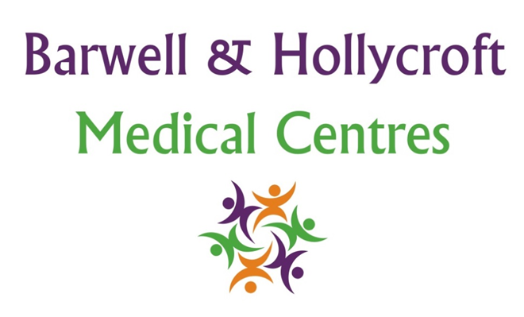
Confidentiality Policy
at Barwell & Hollycroft Medical Centres
(Website Version)

Creation and Implementation:
Version: | Created: | Created by: | Approved by: | Review date: | Comments:
1 | 29/01/25 | Rohitkumar Rajyaguru | The Partners | 31/01/2025

Review of Policy:
Version: | Review date: | Edited by: | Approved by: | Comments:

At Barwell & Hollycroft Medical Centres, we understand the importance of protecting your personal health information. We are fully committed to ensuring that all your personal and medical details are kept confidential, secure, and handled with the utmost care. This policy explains how we manage your data and the circumstances in which we may share your information.
Commitment to Patient Confidentiality
We are dedicated to maintaining the privacy and confidentiality of your health information. All staff at Barwell & Hollycroft Medical Centres are trained to uphold strict confidentiality standards and are required to adhere to legal and ethical guidelines regarding patient privacy. Your trust in us is vital, and we take every measure to protect your personal information.
Circumstances Under Which Information Might Be Shared
In some cases, we may need to share your personal health information, but we will always ensure that it is done in accordance with data protection laws. These are the key situations in which information may be shared:
- With Other Healthcare Providers: If you are referred to a specialist or require treatment from another healthcare provider, we may share relevant medical information to ensure your care is coordinated and that all professionals involved in your treatment have the necessary information.
- For Legal or Safety Reasons: In certain situations, we may be required by law to share your information. This could include instances where there is a risk of harm to you or others, or if required by regulatory bodies or law enforcement.
- For Administrative Purposes: Your data may be shared within the practice to help with administrative functions like appointment scheduling or managing your healthcare records.
How Confidential Information is Stored and Handled by Staff
We take stringent measures to ensure that your personal health information is stored and handled securely:
- Electronic Systems: Your health records are stored electronically in a secure system, protected by password controls and encryption to prevent unauthorised access.
- Paper Records: Any paper records containing personal information are securely stored either in locked cabinets or stored off-site with a company fully compliant with the handling and storage of data within the NHS. Your records can only be accessed only by authorised personnel.
- Access Control: Only those staff members who require access to your information to provide care will be permitted to view your records. All staff are regularly trained in confidentiality practices and data protection.
Patient Consent for Sharing Information
In most cases, we will seek your consent before sharing your health information with others, such as when referring you to a specialist or another healthcare provider. We will explain why your information needs to be shared, what information will be shared, and how it will be used.
- Referrals and Specialist Consultations: If your GP or healthcare provider refers you to a specialist, your relevant medical information will be shared with them to ensure you receive appropriate care.
- Withdrawal of Consent: You have the right to withdraw your consent for sharing information at any time, although this may affect the treatment and care we are able to provide.
Your Rights
You have the right to access your personal health information. If you would like to view the records we hold about you or if you have any concerns about how your information is being used, please contact us. You also have the right to request corrections to your data if it is inaccurate or incomplete.
For more information and ways to let us know your choices please visit
Choose if data from your health records is shared for research and planning - NHS

Contact Us
If you have any questions or concerns about how we handle your confidential information, please do not hesitate to contact us at 01455 849149. We are here to help and will be happy to discuss any aspects of our confidentiality policy with you.
We are committed to providing you with the best possible care while safeguarding your privacy. Thank you for trusting Barwell & Hollycroft Medical Centres with your personal health information.

