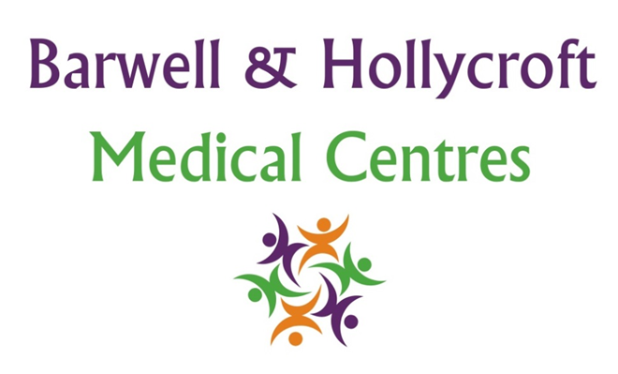
Access to Medical Records Policy
at Barwell & Hollycroft Medical Centres
(Website Version)

Creation and Implementation:
Version: | Created: | Created by: | Approved by: | Review date: | Comments:
1 | 29/01/25 | Rohitkumar Rajyaguru | The Partners | 31/01/2025

Review of Policy:
Version: | Review date: | Edited by: | Approved by: | Comments:

At Barwell & Hollycroft Medical Centres, we believe in transparency and empowering our patients to have access to their own health information. This policy outlines how you can request access to your medical records, the timeframe for receiving them, and your rights to correct any inaccuracies. We are committed to ensuring your personal health information is accessible when needed and handled with care.
Requesting Access to Your Medical Records
You have the right to access the medical records we hold about you. To request access, please follow the steps outlined below:
- How to Request Access: To request a copy of your medical records, please contact the practice by phone on 01455 849149 or in writing via our practice email or by post. You will need to provide some personal details (such as your full name, date of birth, and address) to help us locate your records.
- Third-Party Requests: If you are requesting access to your records on behalf of someone else (such as a family member), you will need to provide written consent from the patient authorising the release of their records.
Timeframe for Providing Access to Records
We aim to respond to all requests for access to your medical records as quickly as possible. Under the General Data Protection Regulation (GDPR), we are required to provide access within one month of receiving your request. If the request is complex or if we need to obtain further information, we may extend this period by an additional two months. If this happens, we will notify you and explain the reason for the delay.
Potential Fees for Record Requests
In most cases, access to your medical records will be provided free of charge. However, we may charge a fee for providing copies of your records in certain circumstances, particularly if the request is excessive or if multiple copies are requested. The fees will be reasonable and based on administrative costs, such as printing and postage.
- Charges: If there are any charges for your request, we will inform you in advance and provide a clear breakdown of the costs.
Amending or Correcting Inaccuracies in Records
If you believe that any information in your medical records is incorrect or incomplete, you have the right to request that the records be amended. If you would like to correct or update any of your health information, please follow these steps:
- Requesting Corrections: To request an amendment to your records, please contact the practice on 01455 849149 or in writing. We will assess your request and make the necessary changes if the information is found to be inaccurate or incomplete.
- Disagreements: If we disagree with your request for correction, we will explain the reason why and allow you the opportunity to provide a statement that will be added to your records.
Contact Us
If you have any questions about accessing your medical records or need assistance with your request, please do not hesitate to get in touch with us. You can reach us at 01455 849149 or via email. We are here to help and will ensure your request is handled promptly and securely.
Thank you for trusting Barwell & Hollycroft Medical Centres with your healthcare. We are committed to providing you with the information you need to manage your health and wellbeing effectively.

