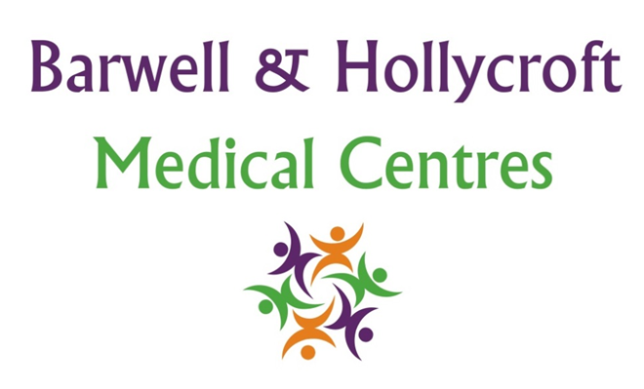
Accessibility Policy
at Barwell & Hollycroft Medical Centres
(Website Version)

Creation and Implementation:
Version: | Created: | Created by: | Approved by: | Review date: | Comments:
1 | 29/01/25 | Rohitkumar Rajyaguru | The Partners | 31/01/2025

Review of Policy:
Version: | Review date: | Edited by: | Approved by: | Comments:

At Barwell & Hollycroft Medical Centres, we are committed to providing an accessible and inclusive healthcare service for all of our patients. We understand that each patient may have unique needs, and we strive to ensure that everyone has equal access to the services we offer. This policy outlines how we make our practice accessible, both physically and through our online services, and how we support patients with specific needs or disabilities.
Physical Access to the Practice
We aim to ensure that our premises are fully accessible to all patients, including those with physical disabilities or mobility difficulties. The key features we offer include:
- Ramps and Lifts: We have ramps available to provide easy access for patients who use wheelchairs or mobility aids. Additionally, lifts are provided for ease of access to upper floors where required.
- Parking: Accessible parking spaces are available near the entrance of the practice for patients with disabilities. These spaces are clearly marked and intended for those with mobility needs.
- Toilets: Accessible toilets are available for patients who need them. These are equipped to meet the needs of individuals with mobility difficulties.
If you require additional assistance to enter the building or access any facilities, please let us know in advance, and we will do our best to accommodate your needs.
Accessibility of Online Services
We are committed to ensuring that our online services are accessible to all patients, including those who may have visual impairments or other accessibility needs. This includes:
- Website Compatibility with Screen Readers: Our website is designed to be compatible with screen readers and other assistive technologies. We aim to make all the information on our site easy to read and navigate for patients with visual impairments.
- Online Appointment Booking: Our online appointment booking system is designed to be simple to use, but if you encounter any difficulty with accessibility, please feel free to contact the practice. We can assist you in booking appointments over the phone or in person if necessary.
If you have specific requirements or face difficulties accessing our online services, please contact us, and we will make reasonable adjustments to ensure you are able to access the services you need.

Requesting Reasonable Adjustments for Appointments
We are committed to making reasonable adjustments for patients who require additional support due to disabilities or specific needs. If you need any adjustments to be made for your appointments, please let us know, and we will do our best to accommodate you. This could include:
- Extra time for appointments: If you require longer consultation times due to your condition or any other needs, we can arrange for longer appointments.
- Assistance with communication: If you have difficulty hearing, speaking, or understanding, we can arrange for an interpreter, or provide support in another way to ensure clear communication.
- Appointment reminders: If you require assistance with reminders for your appointments (e.g., via text, email, or phone call), please let us know, and we will be happy to arrange this for you.
We encourage you to inform us of any specific needs or adjustments before your appointment to ensure we can provide the best care and support.
Making the Practice More Inclusive for Patients with Specific Needs
We are always looking for ways to improve our practice and ensure that we provide an inclusive environment for all patients. Some of the initiatives we have in place to support inclusivity include:
- Accessible information: We can provide written materials in different formats, such as large print or easy-read formats, to make sure that information is accessible to patients with visual impairments or learning disabilities.
- Sign Language: If you require a sign language interpreter, please let us know in advance, and we will do our best to arrange one for you.
- Support for Mental Health and Learning Disabilities: We are committed to supporting patients with mental health issues or learning disabilities. If you need specific adjustments for your care, please let us know, and we can work together to find a solution.
We also welcome feedback from patients on how we can continue to improve our accessibility and inclusivity. If you have any suggestions or concerns, please feel free to contact us.

Contact Us
If you require any support, have specific needs, or need to make arrangements for your appointment, please get in touch with us:
- Phone: 01455 849149
We are committed to ensuring that all of our patients have equal access to the services we provide and that your experience at Barwell & Hollycroft Medical Centres is as comfortable and accessible as possible. Thank you for trusting us with your healthcare needs.

