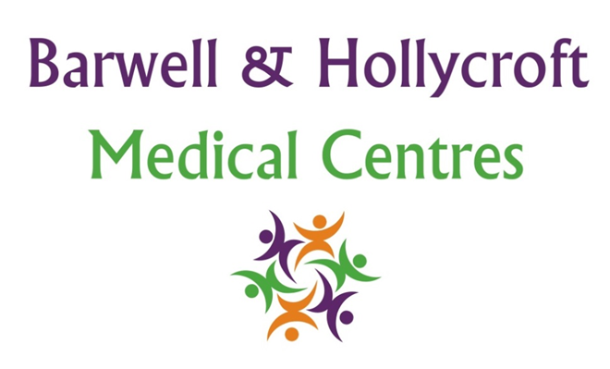
Appointment and Booking Policy
at Barwell & Hollycroft Medical Centres
(Website Version)

Creation and Implementation:
Version: | Created: | Created by: | Approved by: | Review date: | Comments:
1 | 29/01/25 | Rohitkumar Rajyaguru | The Partners | 31/01/2025

Review of Policy:
Version: | Review date: | Edited by: | Approved by: | Comments:

At Barwell & Hollycroft Medical Centres, we aim to provide the highest standard of care to all our patients. To help ensure that your appointments run smoothly, we have established a clear and simple appointment booking and cancellation policy. Please read the following guidelines carefully.
How to Book an Appointment
We offer several convenient ways for you to book an appointment:
- Online Booking System: You can book, reschedule, or cancel your appointments online through our patient portal for certain appointments. This system allows you to select a time that works for you and receive confirmation of your appointment.
- By Phone: If you prefer to speak with a member of our team, you can call the practice on 01455 849149 to book an appointment. Our reception team will be happy to assist you with booking a suitable time.
  - If you require an urgent / on-the-day appointment for a General Practitioner: you are encouraged to ring as early as possible. Our telephone lines open at 8am each morning Monday to Friday (excluding Bank holidays, Christmas and New Year). Please note, that our reception team will book you with the most appropriate clinician which may include a Pharmacist, Emergency Care Practitioner, Physiotherapist or any other suitable Healthcare professional.
  - If you would prefer to prebook an appointment for a General Practitioner: this can be done at any time of the day (during our normal opening hours).
  - All other appointments with our Health Care Assistants, Nurses etc are pre-bookable only.
As with all services, there are a finite number of appointments available so this may mean that there will be a waiting before your appointment. If you require assistance sooner, you will be redirected to an appropriate service to meet your urgent needs.
Cancellation and Did-Not-Attend Policy
We understand that life can be unpredictable, and sometimes you may need to cancel or reschedule an appointment. However, to ensure that all our patients have access to timely care, we ask that you follow these guidelines:
- Cancellation Notice: Please give at least 24 hours' notice if you need to cancel or reschedule your appointment. This allows us to offer your appointment slot to another patient.
- Did-Not-Attend: If you miss an appointment without notifying us, or cancel with less than 24 hours' notice, the appointment will be marked as Did-Not-Attend (or in the case of children Child-Not-Brought-To-Appointment). Multiple missed appointments will trigger a review of your medical records, an assessment of your health needs and you may be asked to register elsewhere. Typically, this is triggered after 3 missed appointments over a rolling 12 month period.
- How to Cancel: You can cancel an appointment either through our online booking system or by calling the practice directly.
We ask for your cooperation in keeping these guidelines to help ensure we can offer timely appointments to all our patients.
Urgent / Walk-ins (once we have reached capacity for the day)
We understand that some health issues require immediate attention. Unfortunately, we are not a Walk-In Centre or an Emergency Care Centre. For urgent medical needs you will be directed to other providers which may include the local Pharmacy, NHS 111, Walk-In Centres or an Emergency Department.
Patient Responsibility for Keeping Appointments
As a patient, it is your responsibility to ensure that you attend your appointments or provide sufficient notice if you need to cancel or reschedule. Missing an appointment or not giving enough notice for cancellations can result in delays for other patients who require care. We appreciate your understanding and support in keeping appointments or managing cancellations responsibly.
Requesting a Specific Doctor/Nurse etc.
If you have a preference for a specific clinician, we will do our best to accommodate this request. When booking your appointment, you can mention your preferred healthcare professional, and we will schedule your appointment accordingly, subject to availability. However, please be aware that, depending on the urgency of the appointment, it may not always be possible to see the specific professional you requested.

Contact Us
If you have any questions about booking, cancelling, or rescheduling an appointment, or if you need assistance with our online booking system, please don’t hesitate to get in touch with our reception team.
Regular Reviews and Updates
This policy is reviewed regularly. Any changes will be made to this policy online, and we encourage you to review this policy periodically.
We thank you for your cooperation in ensuring that appointments are well-managed for all of our patients.

