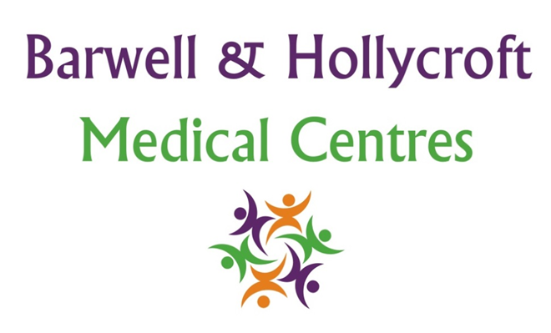
Children and Young People’s Policy
at Barwell & Hollycroft Medical Centres
(Website Version)

Creation and Implementation:
Version: | Created: | Created by: | Approved by: | Review date: | Comments:
1 | 29/01/25 | Rohitkumar Rajyaguru | The Partners | 31/01/2025

Review of Policy:
Version: | Review date: | Edited by: | Approved by: | Comments:

At Barwell & Hollycroft Medical Centres, we are committed to providing high-quality care for children and young people. We aim to support the health and well-being of minors and work closely with families to ensure the best care possible. This policy outlines how we support children and their families, including consent for treatment, confidentiality, and services available for children and adolescents.
Please be aware that the guidance cut-off age is 16 years old. If however the practice feels that a child over the age of 13 years old is competent to make certain decisions regarding the management of their own health, this will be respected by the practice.
Parental or Guardian Consent for Treatment
For most healthcare services, we require the consent of a parent or guardian for children under the age of 16. This includes both medical treatments and vaccinations. Parents or guardians are encouraged to attend appointments with their children to provide support and give informed consent for any necessary treatment or procedures.
- Children Under 16: Parental or guardian consent is usually needed for routine and non-emergency treatments and vaccinations.
- Children Over 16: Young people aged 16 and over are able to make decisions about their own healthcare and consent to treatment without needing parental consent, although we always encourage open communication with parents or guardians.
If you have any questions about consent for treatment or are unsure whether consent is required, please contact the practice. We will be happy to assist and provide guidance.
Confidentiality Considerations for Young People
We take confidentiality seriously at Barwell & Hollycroft Medical Centres. Young people aged 16 and over have the same right to confidentiality as adults. However, we encourage young people to involve their parents or guardians in decisions about their care where appropriate. For children under 16, confidentiality is respected, but we may need to discuss care with parents or guardians, particularly in the case of sensitive issues or where there is a need for parental consent.
- Confidentiality for Over-16s: If you are 16 or older, your health information will be kept confidential, and we will only share it with your permission (except in certain legal situations where sharing information may be necessary to protect you or others).
- Confidentiality for Under-16s: We will always aim to involve parents or guardians in discussions about care for children under 16, but we also respect the wishes of the child in relation to privacy, particularly if it concerns sensitive matters such as sexual health, mental health, or drug-related issues.
Services Available for Children and Adolescents
We offer a wide range of services for children and young people to ensure they receive the care and support they need as they grow. These services include:
- Routine Childhood Immunisations: We follow the NHS immunisation schedule and offer vaccinations for infants, children, and adolescents. These vaccines are important for protecting children from serious diseases.
- Adolescent Health Services: As children grow into teenagers, their healthcare needs evolve. We offer services related to sexual health, mental health, and general wellbeing. Young people can seek advice on issues such as contraception, sexual health, smoking cessation, and emotional wellbeing in a confidential and non-judgemental environment.

Contacting the Practice
If you have any questions about the care your child receives, or if you would like to book an appointment for your child, please don’t hesitate to get in touch with us:
- Phone: 01455 849149
- Email: Barwell.MC@nhs.net
We are here to support the health and wellbeing of your child and family, and we aim to provide the best care possible in a supportive, safe, and confidential environment. Thank you for trusting Barwell & Hollycroft Medical Centres with your child’s healthcare needs.

