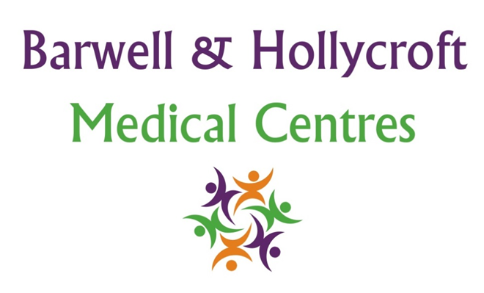
Chronic Disease Management Policy
at Barwell & Hollycroft Medical Centres
(Website Version)

Creation and Implementation:
Version: | Created: | Created by: | Approved by: | Review date: | Comments:
1 | 29/01/25 | Rohitkumar Rajyaguru | The Partners | 31/01/2025

Review of Policy:
Version: | Review date: | Edited by: | Approved by: | Comments:

At Barwell & Hollycroft Medical Centres, we are dedicated to providing comprehensive care for patients with chronic conditions, such as diabetes, hypertension, asthma, and other long-term health conditions. This policy outlines the services, support, and care pathways available to help manage these conditions and improve the overall health and wellbeing of our patients.
Overview of Services Available for Managing Chronic Conditions
We offer a range of services to support patients living with chronic conditions. These services are designed to help manage symptoms, reduce complications, and improve the quality of life for our patients. We focus on providing personalised care based on individual needs and health goals.
- Comprehensive Care: Our team, including doctors, nurses, and healthcare assistants, works together to create an individualised care plan for each patient. This plan may include regular monitoring, lifestyle advice, and treatment adjustments.
- Chronic Disease Appointments: We run specialist appointments for various chronic conditions, such as diabetes, asthma, and hypertension. These appointments are designed to offer regular reviews and provide dedicated time for discussing your condition and treatment plan.
Regular Check-Ups, Monitoring, and Treatment Protocols
Managing a chronic condition requires regular monitoring and check-ups to ensure that treatments are working effectively and that any changes to your condition are promptly addressed.
- Routine Reviews: We offer routine check-ups for patients with chronic conditions. These visits may include monitoring vital signs, blood tests, and assessing the progression of your condition.
- Treatment Protocols: We follow evidence-based guidelines to provide the best possible treatment for your condition. This includes regularly reviewing your treatment plan to ensure it is working and making adjustments when necessary.
Self-Management Support (Education and Lifestyle Advice)
Living with a chronic condition requires active involvement from patients in managing their own health. We are here to support you with the tools, resources, and education you need to take control of your health.
- Self-Management Education: We offer education and resources on how to manage your condition effectively, including understanding your condition, tracking symptoms, and using your medication appropriately.
- Lifestyle Advice: We provide advice on lifestyle changes that can help manage your condition, such as dietary modifications, exercise, smoking cessation, and weight management. Our team will guide you on how to make these changes in a sustainable and manageable way.
Medication Reviews and Adjustments
Medications are often a key part of managing chronic conditions. Regular reviews help ensure that medications are effective, safe, and appropriate for your needs.
- Medication Reviews: We offer regular medication reviews to check if your current medications are working well and if any changes are needed. This may involve adjusting dosages, switching medications, or introducing new treatments as necessary.
- Ongoing Monitoring: Our clinicians will work with you to monitor any side effects or changes in how your medications are working and make adjustments as needed to help you achieve the best outcomes.
Coordination with Specialists and Other Healthcare Providers
Chronic conditions often require care from multiple healthcare professionals. We work closely with specialists and other healthcare providers to ensure that your care is coordinated and comprehensive.
- Referrals to Specialists: If necessary, we can refer you to specialists for further treatment or investigation. This might include consultations with cardiologists, endocrinologists, respiratory specialists, or other experts.
- Integrated Care: We collaborate with other healthcare providers, such as dietitians, physiotherapists, and pharmacists, to ensure that you receive holistic care that addresses all aspects of your chronic condition.

Contact Us
If you have any questions about our Chronic Disease Management services or need assistance with managing a chronic condition, please feel free to contact us:
- Phone: 01455 849149
- Email: Barwell.MC@nhs.net
We are committed to supporting you in managing your chronic condition and ensuring that you receive the best possible care. Thank you for choosing Barwell & Hollycroft Medical Centres for your healthcare needs.

