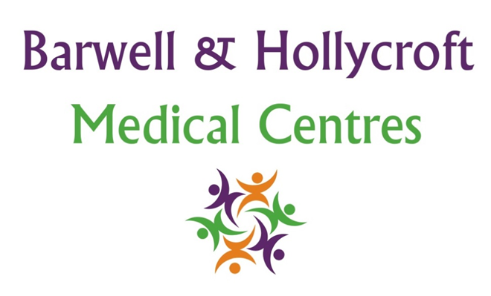
Clinical Governance and Quality Assurance Policy
at Barwell & Hollycroft Medical Centres
(Website Version)

Creation and Implementation:
Version: | Created: | Created by: | Approved by: | Review date: | Comments:
1 | 29/01/25 | Rohitkumar Rajyaguru | The Partners | 31/01/2025

Review of Policy:
Version: | Review date: | Edited by: | Approved by: | Comments:

At Barwell & Hollycroft Medical Centres, we are committed to providing the highest standard of care for our patients. This policy outlines our approach to clinical governance and quality assurance, ensuring that all aspects of our practice, from patient safety to clinical performance, meet rigorous standards of quality and continuous improvement.
Overview of Clinical Governance Frameworks and Responsibilities
Clinical governance refers to the framework through which we ensure the delivery of high-quality healthcare. It involves all of the systems and processes that we use to ensure patient safety, the quality of care, and the ongoing development of our services. Our clinical governance framework includes the following key elements:
- Leadership and Responsibility: Our clinicians, practice managers, and staff are responsible for ensuring that care is delivered safely, effectively, and in accordance with best practices.
- Clinical Standards: We adhere to national guidelines and best practices, ensuring that care is based on the most current, evidence-based information available.
- Monitoring and Evaluation: We regularly evaluate our clinical processes and practices to ensure that they remain effective and that improvements are continuously implemented.
Commitment to Evidence-Based Practices
We believe in delivering care that is based on the best available evidence. To ensure that our practice is at the forefront of medical care, we:
- Follow National and Local Guidelines: We adhere to clinical guidelines and protocols set out by recognised bodies such as the NHS, NICE (National Institute for Health and Care Excellence), and other authoritative sources.
- Ongoing Professional Development: We support our staff with regular training, education, and access to the latest research to ensure that their skills and knowledge remain up-to-date.
Regular Audits and Reviews of Clinical Performance
To maintain and improve the quality of care we provide, we carry out regular audits and reviews of our clinical performance. These include:
- Clinical Audits: Regular checks of clinical practices to ensure they meet required standards, with action taken where necessary to correct any issues.
- Performance Reviews: Ongoing monitoring of clinical outcomes to assess how effective our services are and identify areas for improvement.
Through these audits and reviews, we can ensure that the care we deliver remains safe, effective, and patient-centred.
Patient Safety Protocols and Procedures for Incident Reporting
Patient safety is our top priority. We have a robust set of protocols in place to manage patient safety and minimise risks. These include:
- Incident Reporting: We encourage all staff to report any incidents, errors, or near-misses so that we can learn from them and improve our practices. All incidents are reviewed in a timely manner, and appropriate steps are taken to prevent future occurrences.
- Risk Management: We proactively manage and minimise risks to patient safety through regular risk assessments, updated protocols, and continuous staff training.
- Patient Safety Monitoring: We monitor the safety of our services through regular reviews and by keeping up to date with emerging risks or issues that may affect patient care.
Procedures for Managing and Acting on Patient Feedback and Complaints
We value feedback from our patients, as it is a key part of our commitment to continuous improvement. If you have any concerns, complaints, or suggestions regarding your care, we are here to listen and respond. Our procedures for handling feedback and complaints include:
- Patient Feedback: We actively encourage patients to provide feedback on their experiences with our services, whether positive or negative. Feedback can be given in person, via email, or using patient satisfaction surveys.
- Complaints Process: If you are unhappy with the service or care you have received, we have a formal complaints procedure in place. All complaints are taken seriously and thoroughly investigated to ensure that any necessary improvements are made.
- Learning from Complaints: We treat complaints as an opportunity to learn and improve. After reviewing complaints, we take appropriate action to prevent future occurrences and improve our services.

Contact Us
If you have any questions about our Clinical Governance and Quality Assurance Policy or would like to provide feedback, please do not hesitate to contact us:
- Phone: 01455 849149
- Email: Barwell.MC@nhs.net
Thank you for entrusting us with your healthcare. We are committed to ensuring that Barwell & Hollycroft Medical Centres continue to provide the highest standards of care and that your experience with us is always a positive one.

