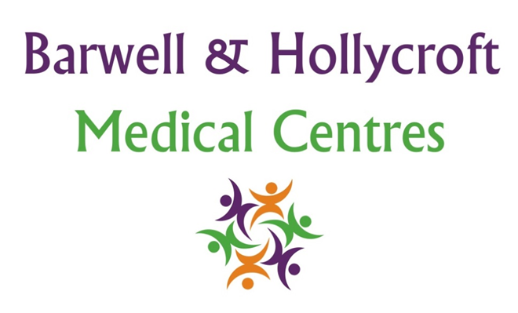
Emergency Services and Out-of-Hours Care Policy
at Barwell & Hollycroft Medical Centres
(Website Version)

Creation and Implementation:
Version: | Created: | Created by: | Approved by: | Review date: | Comments:
1 | 29/01/25 | Rohitkumar Rajyaguru | The Partners | 31/01/2025

Review of Policy:
Version: | Review date: | Edited by: | Approved by: | Comments:

At Barwell & Hollycroft Medical Centres, your health and wellbeing are our priority. While we are committed to providing excellent care during our normal working hours, we understand that medical needs can arise outside of these hours. This policy provides important information on how to access emergency care and out-of-hours services when the practice is closed.
Emergency Contact Details
In the event of a medical emergency outside of our normal working hours, please use the following services to ensure you receive the care you need:
- NHS 111: For non-emergency medical advice, you can contact NHS 111 at any time. They can offer advice, book appointments, or direct you to the most appropriate care. You can reach NHS 111 by dialling 111 from any phone.
- Urgent Care Centres: If you need urgent care but it is not a life-threatening emergency, you can visit a local urgent care centre. For more information on locations and opening hours, please visit NHS 111 website or call NHS 111.
- Emergency Services: In case of a medical emergency, such as a serious injury or life-threatening condition, please dial 999 immediately for urgent assistance and an ambulance.
Out-of-Hours Services and How to Access Them
If you require medical care when our practice is closed, you can access out-of-hours services provided by the NHS. These services are available in the evenings, weekends, and on bank holidays.
- NHS Out-of-Hours Care: If you need to see a doctor outside of normal working hours, NHS out-of-hours services can provide assistance. To access these services, simply dial 111, and they will help direct you to the right care, whether that be a GP appointment, a home visit, or an urgent care centre.
- Pharmacy Services: In the event that you need advice or prescription medication outside of office hours, many pharmacies offer extended hours and can provide over-the-counter treatments for common ailments.
Contacting the Practice for Urgent Matters Outside Normal Working Hours
If you have an urgent matter that cannot wait until the practice reopens, you can contact the practice by phone at 01455 849149. If it is outside of our normal working hours, your call will be forwarded to the NHS out-of-hours service (or you will be provided with details of who to contact), who will assess the situation and guide you on the next steps.
Please note that this service is intended for urgent matters only. For routine requests or non-urgent queries, we ask that you contact the practice during regular working hours.
Contact Us
For further information about our emergency services and out-of-hours care, or if you have any questions, please do not hesitate to contact us during office hours at 01455 849149. Our team is here to support you and provide assistance whenever you need it.
Thank you for choosing Barwell & Hollycroft Medical Centres. We are committed to ensuring you have access to the care you need, at any time of the day or night.

