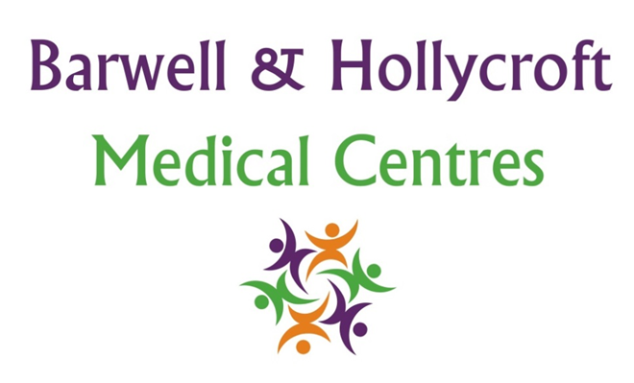
Fee and Charges Policy
at Barwell & Hollycroft Medical Centres
(Website Version)

Creation and Implementation:
Version: | Created: | Created by: | Approved by: | Review date: | Comments:
1 | 29/01/25 | Rohitkumar Rajyaguru | The Partners | 31/01/2025

Review of Policy:
Version: | Review date: | Edited by: | Approved by: | Comments:

At Barwell & Hollycroft Medical Centres, we are committed to providing high-quality healthcare to all our patients. While many services are provided free of charge under the NHS, there are some services that are not covered by NHS funding. This policy outlines the fees for those services and how we handle charges for non-NHS services.
Services and Charges Not Covered by NHS Funding
Some services we provide are not covered by the NHS, and for these, a fee will apply. The following is a list of common non-NHS services: (please note that fees are subject to change and therefore for an up-to-date price, please contact our reception team):
- Travel Vaccinations: Some travel vaccinations are not available through the NHS and may require a fee. The cost of these vaccinations varies depending on the vaccine and the number of doses required.
- Private Certificates: For non-NHS services such as fitness-to-travel certificates, private sick notes, or certain other medical certificates, a fee will apply. The cost will vary depending on the complexity and type of certificate requested.
- Non-NHS Letters or Reports: If you require a letter or report for employment or insurance purposes, this may incur a fee. Charges will depend on the time and effort required to prepare the letter or report.
- Other Non-NHS Services: In some cases, we may provide services that are not covered by the NHS, such as medical examinations for employment, pre-employment health checks, or examinations for legal purposes. Charges for these services will be based on the specific requirements.
Our priority will always be for our patients in providing NHS services and therefore there may be instances where we are unable to provide these non-NHS services. In this instance, we will try our very best to direct you to the most appropriate service who can assist you.
Payment Methods Accepted
We accept the following payment methods for non-NHS services:
- Cash (if paying in person)
- Bank Transfer (details available upon request)
Payment for non-NHS services is due at the time of service or upon receipt of the invoice, unless otherwise agreed.
Insurance or Third-Party Billing Procedures
If your fees are being covered by an insurance company or another third party (such as an employer or legal firm), please inform us in advance. We will liaise directly with them and provide them with an invoice for the work needed.
We will aim to process third-party claims as efficiently as possible, but please be aware that the work requested will not be completed until the invoice has been settled by the third party.
Access to Free Services Under the NHS
While certain services incur a charge, we want to ensure that all patients are aware of the NHS services they can access free of charge. These include:
- General Medical Care: Appointments with a GP or nurse etc. for general healthcare needs.
- Emergency Care: Urgent medical care is free at the point of access, whether it’s through the NHS 111 service, Accident & Emergency, or urgent care centres.
- NHS Vaccinations: Routine vaccinations and immunisations, such as childhood vaccines and flu jabs (for those who meet NHS criteria).
- NHS Prescriptions: Prescriptions are free for certain individuals, such as those over the age of 60, under 16, or with specific medical conditions. For others, a prescription charge may apply.
If you are unsure whether a service is covered by the NHS or if you are eligible for free services, please feel free to ask us. Our reception team will be happy to assist you and provide guidance on available NHS services.

Contact Us
If you have any questions about our fees, services, or how to access NHS care, please do not hesitate to contact us. You can reach us at 01455 849149 or by email at Barwell.MC@nhs.net. We are happy to provide more information and assist with any queries you may have.
Thank you for choosing Barwell & Hollycroft Medical Centres. We strive to offer transparent pricing and excellent care to all our patients.

