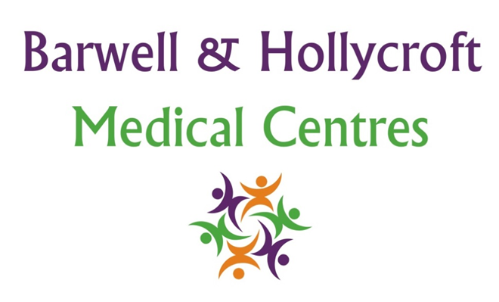
Health Promotion and Preventative Care Policy
at Barwell & Hollycroft Medical Centres
(Website Version)

Creation and Implementation:
Version: | Created: | Created by: | Approved by: | Review date: | Comments:
1 | 29/01/25 | Rohitkumar Rajyaguru | The Partners | 31/01/2025

Review of Policy:
Version: | Review date: | Edited by: | Approved by: | Comments:

At Barwell & Hollycroft Medical Centres, we believe that preventing illness and promoting good health are essential components of healthcare. We are committed to supporting our patients in making healthy choices, maintaining good health, and identifying potential health risks early. This policy outlines the practice’s approach to health promotion and preventative care to help our patients lead healthier lives.
Preventative Screenings
We offer a range of preventative screenings to help detect health conditions early and reduce the risk of more serious illnesses. Early detection can make a significant difference in treatment outcomes.
- Cancer Screenings: We offer cancer screenings, including breast cancer screening (mammograms), cervical smear tests (for women), and bowel cancer screening (for eligible patients). These screenings are essential for early detection and can save lives.
- Immunisations: We offer a variety of immunisations, including routine childhood vaccinations, flu vaccines, and other vaccines for adults such as pneumococcal and shingles vaccines. Regular immunizations protect you from preventable diseases.
- Blood Pressure Checks: Regular blood pressure checks are vital for preventing cardiovascular diseases such as heart attack and stroke. We encourage patients to have their blood pressure checked as part of routine health assessments, particularly for those over the age of 40 or with a family history of heart disease.
Health Education Initiatives
We are committed to supporting our patients by offering health education on a range of topics, aimed at promoting healthy behaviours and reducing health risks.
- Smoking Cessation: Smoking is a leading cause of many preventable diseases, including lung cancer, heart disease, and stroke. We offer support to patients who want to quit smoking, including advice, resources, and referrals to specialist services such as local quit-smoking programs.
- Weight Management: Maintaining a healthy weight is important for reducing the risk of diabetes, heart disease, and other chronic conditions. We provide advice on healthy eating, physical activity, and weight management, as well as access to local weight management services.
- Nutrition and Healthy Eating: We provide advice on nutrition, encouraging a balanced diet rich in fruits, vegetables, and whole grains, and offering support to those managing specific dietary needs or conditions, such as diabetes or high cholesterol.
Patient Reminders for Routine Checks and Preventative Care
We understand that it can be easy to forget routine check-ups and preventative care appointments. To help you stay on track with your health, we provide reminders for important checks.
- Routine Health Reminders: We send reminders for routine health screenings, vaccinations, and check-ups. These reminders are sent by phone, text, or email, depending on your preferences.
- Follow-Up Care: If you have missed a routine appointment or screening, our team will work with you to reschedule it as soon as possible to ensure that you stay on top of your health.
Support for Healthy Lifestyle Changes
We are committed to helping our patients adopt healthy lifestyles. Making small, manageable changes to your daily habits can have a positive impact on your health.
- Exercise and Physical Activity: We encourage physical activity as part of a healthy lifestyle. We provide advice on exercise routines, local activity programs, and how to stay active regardless of age or physical ability.
- Mental Wellbeing: We support mental health and emotional wellbeing by offering advice on stress management, healthy coping strategies, and access to mental health resources, such as counselling and support groups.
Availability of Resources
We offer a variety of resources to help support your health and wellbeing.
- Leaflets and Information: We provide printed and digital resources on a range of health topics, including nutrition, exercise, and chronic disease prevention. These are available in the practice and on our website.
- Websites and Online Resources: We offer access to trusted health websites, including NHS resources, which provide additional information on a wide range of health and lifestyle topics.
- Community Programs: We work with local community groups to offer additional resources, such as support groups, exercise classes, and nutrition workshops. Our team can provide information about these programs and how to access them.

Contact Us
If you have any questions about our Health Promotion and Preventative Care services, or if you would like to book a screening, vaccination, or health check, please feel free to contact us:
- Phone: 01455 849149
We are here to support you in living a healthy life, and we encourage you to take advantage of the services and resources we offer to help prevent illness and promote long-term health. Thank you for choosing Barwell & Hollycroft Medical Centres.

