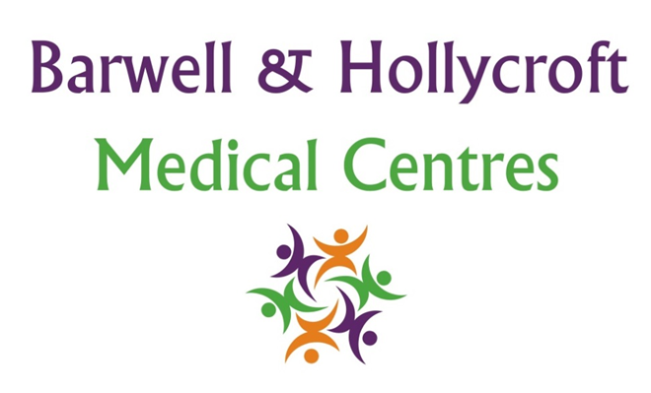
Infection Control Policy
at Barwell & Hollycroft Medical Centres
(Website Version)

Creation and Implementation:
Version: | Created: | Created by: | Approved by: | Review date: | Comments:
1 | 29/01/25 | Rohitkumar Rajyaguru | The Partners | 31/01/2025

Review of Policy:
Version: | Review date: | Edited by: | Approved by: | Comments:

At Barwell & Hollycroft Medical Centres, the safety and well-being of our patients, staff, and visitors is of the utmost importance. We have strict infection control measures in place to reduce the risk of infection and ensure that everyone who attends our practice is kept safe. This policy outlines the steps we are taking to maintain a clean and safe environment and provides guidelines for patients to follow.
How the Practice is Ensuring Safety and Cleanliness
We are committed to maintaining a safe and hygienic environment for everyone. The following measures are in place:
- Regular Cleaning and Disinfection: Our practice is cleaned frequently throughout the day, with special attention given to high-touch surfaces such as door handles, reception desks, waiting area furniture, and clinical rooms. All areas are thoroughly cleaned at the end of each day to ensure a safe environment for the next day.
- Infection Control Training: All practice staff undergo regular infection control training to ensure they understand the best practices for maintaining hygiene and safety within the practice.
- Personal Protective Equipment (PPE): Our staff are provided with appropriate PPE, including masks, gloves, and aprons, as necessary, to prevent the spread of infection.
Patient Guidelines
We ask all patients to follow these guidelines to help protect themselves and others:
- Wearing Masks (if asked to do so): We request that all patients wear a face mask or face covering when entering the practice and during their visit, unless medically exempt. This helps to reduce the spread of infections, particularly in shared or enclosed spaces.
- Hand Hygiene: Please sanitise your hands when you enter and leave the practice. Hand sanitiser is provided at reception and throughout the practice. We encourage all patients to wash their hands regularly, especially after touching surfaces.
- Social Distancing (if applicable): We ask that patients respect social distancing guidelines while in the waiting areas and other communal spaces. Please try to maintain at least 1 metre distance from others, where possible.
- Appointments: If you are unwell or symptomatic, please follow the steps below for attending the practice safely.

Symptoms or Protocols for Suspected Infectious Conditions
If you have any symptoms of an infectious condition, such as cough, fever, cold, flu, or any other respiratory symptoms, diarrhoea/vomiting, or potentially rashes like Chickenpox / measles, we ask that you follow these steps:
- Do Not Attend the Practice in Person: If you have symptoms of illness, particularly respiratory symptoms, please contact us before attending in person. We can offer advice and, if necessary, arrange for a remote consultation or guide you on next steps.
- Other Infectious Symptoms: If you have any other symptoms or suspect you may have an infectious condition, please call ahead. We may be able to provide a consultation by phone or video, or we may ask you to attend a designated area of the practice where we can safely assess you.
How to Attend the Practice Safely if Symptomatic or Exposed
If you have been exposed to someone with an infectious condition or have symptoms yourself, please follow these steps:
- Call Ahead: If you need to attend for an appointment but have symptoms of illness or have been in contact with someone who has tested positive for an infectious condition, please call 01455 849149 before your visit. Our team will discuss your symptoms and advise on how to proceed.
- Attend with Caution: If you must attend the practice in person, please wear a mask (if asked to do so), follow all hygiene protocols, and inform our reception staff about your symptoms upon arrival. We will ensure you are seen safely, and we may take additional precautions if necessary.
- Self-Isolation: If you have been advised to self-isolate due to exposure to an infectious condition, please do not attend the practice during your isolation period. Contact us for advice on how to receive care remotely.

Contact Us
If you have any questions about infection control or need guidance on how to attend the practice safely, please don’t hesitate to get in touch with us:
- Phone: 01455 849149
We appreciate your cooperation in helping us maintain a clean and safe environment. By following these guidelines, we can continue to provide the best possible care while keeping our patients, staff, and community protected. Thank you for choosing Barwell & Hollycroft Medical Centres.

