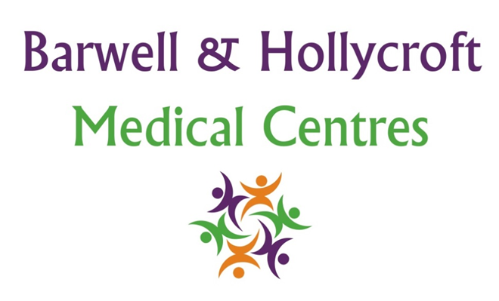
Infection Prevention and Control Policy
at Barwell & Hollycroft Medical Centres
(Website Version)

Creation and Implementation:
Version: | Created: | Created by: | Approved by: | Review date: | Comments:
1 | 29/01/25 | Rohitkumar Rajyaguru | The Partners | 31/01/2025

Review of Policy:
Version: | Review date: | Edited by: | Approved by: | Comments:

At Barwell & Hollycroft Medical Centres, we are dedicated to ensuring that our practice environment is safe and hygienic for all patients and staff. This Infection Prevention and Control Policy outlines the procedures we follow to prevent the spread of infections and protect the health and safety of everyone who visits our practice.
Hand Hygiene Protocols
Good hand hygiene is one of the most effective ways to prevent the spread of infections. Our staff and patients are encouraged to follow proper hand hygiene practices.
- Staff Hand Hygiene: All staff are trained in proper hand hygiene techniques and are required to wash their hands thoroughly before and after patient contact, as well as when handling equipment or materials that may be contaminated.
- Patient Hand Hygiene: We encourage patients to wash their hands before and after appointments. Hand sanitising stations are available throughout the practice for your convenience.
- Hand Hygiene Products: We provide alcohol-based hand sanitiser stations in all areas of the practice to ensure that both staff and patients can access hand hygiene products easily.
Cleaning and Disinfection Procedures for Medical Equipment and Surfaces
We maintain a strict cleaning and disinfection protocol to ensure that all areas within the practice are hygienic.
- Medical Equipment: All medical equipment is cleaned and disinfected after each use, according to NHS guidelines and best practice procedures. This includes reusable equipment such as stethoscopes, thermometers, and blood pressure cuffs.
- Surfaces and High-Touch Areas: Frequently touched surfaces, such as door handles, waiting room chairs, and reception desks, are cleaned and disinfected regularly throughout the day.
- General Practice Cleanliness: A professional cleaning service ensures that the practice is cleaned thoroughly at the end of each day. All areas, including treatment rooms, waiting areas, and toilets, are disinfected to reduce the risk of infection.
Policies for Managing Infections
We have specific procedures in place to manage infectious diseases and prevent their spread.
- Infectious Diseases Management: If a patient presents with symptoms of an infectious disease, such as influenza or tuberculosis, our staff are trained to manage the situation with care and follow infection control guidelines. This may include directing patients to isolated areas if needed.
- Reporting and Isolation: In the event of highly contagious infections (e.g., tuberculosis or suspected cases of COVID-19), we have protocols to isolate patients from others in the practice and minimise the risk of spreading the infection.
- Influenza Management: We offer flu vaccinations annually to protect both our patients and staff from seasonal influenza. If a patient presents with flu-like symptoms, we follow procedures to protect others in the practice and ensure appropriate care.
Use of Personal Protective Equipment (PPE)
Our staff wear appropriate personal protective equipment (PPE) to reduce the risk of infection transmission.
- PPE for Clinical Staff: All clinical staff (e.g., doctors, nurses, healthcare assistants) wear PPE, including gloves, masks, aprons, and eye protection, when performing procedures that may involve contact with bodily fluids or when there is a risk of exposure to infection.
- PPE for Patients: In certain situations, patients may be asked to wear masks (such as when displaying symptoms of respiratory illness) to reduce the risk of spreading infections. We appreciate your cooperation in these circumstances.
- PPE for Non-Clinical Staff: Non-clinical staff may also wear PPE, such as face masks, when appropriate, particularly when dealing with patients who exhibit symptoms of contagious illnesses.
Guidelines for the Management of Infectious Diseases
To ensure the safety of all patients and staff, we follow national and local health authority guidelines for managing infectious diseases.
- Isolation Procedures: If a patient is suspected of having a contagious infection, we have dedicated isolation areas within the practice to reduce the risk of exposure to others. These areas are thoroughly cleaned and disinfected after use.
- Notification of Public Health Authorities: If required, we will notify local public health authorities about specific infectious diseases as part of our legal and ethical obligations. This ensures the safety of the wider community.
- Advice for Infectious Disease Cases: We provide patients with information on how to manage their infection and reduce the risk of transmission to others. This may include advice on staying at home, hand hygiene, and seeking further medical care if necessary.
Contact Us
We are committed to maintaining the highest standards of infection control and patient safety. If you have any concerns or questions about our infection prevention procedures, please contact us:
- Phone: 01455 849149
- Email: Barwell.MC@nhs.net
Thank you for your cooperation in helping us provide a safe, hygienic environment for everyone who visits Barwell & Hollycroft Medical Centres.

