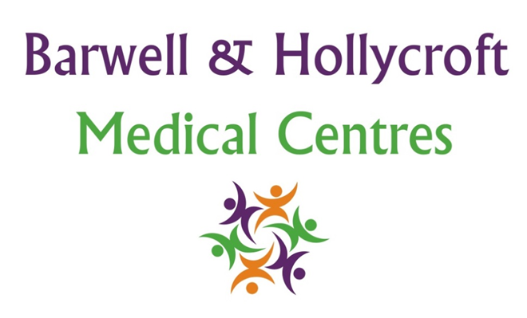
Management of patient information / medical records in foreign languages
at Barwell & Hollycroft Medical Centres
(Website Version)

Creation and Implementation:
Version: | Created: | Created by: | Approved by: | Review date: | Comments:
1 | 29/01/25 | Rohitkumar Rajyaguru | The Partners | 31/01/2025

Review of Policy:
Version: | Review date: | Edited by: | Approved by: | Comments:

Policy Overview
It is the responsibility of the patient to ensure that any documents, letters, or communications that are written in a language other than English are professionally translated into English before they are submitted to this practice. The practice will not review or add documents in any language other than English to a patient’s medical record unless the translation has been completed by a certified professional translation service.
Rationale for this Policy
- Clinical Safety and Accuracy: It is clinically unsafe for healthcare professionals to make decisions based on incomplete or potentially inaccurate information. Medical documents that are not professionally translated may lead to misinterpretation, resulting in inappropriate clinical decisions. Ensuring that all documents are accurately translated is vital for providing safe and effective care.
- Ensuring Comprehensive Medical History: Accurate translation allows the practice to gain a full understanding of the patient’s medical history, medications, allergies, and previous treatments. Incomplete or misinterpreted information could cause delays in treatment or the administration of the wrong treatments.
- Consistency and Quality of Care: Having translated documents ensures the consistency and quality of care, particularly in situations requiring urgent medical decisions, where every detail matters. For example, in emergency care, even minor inaccuracies could lead to potentially life-threatening consequences.
- Legal and Ethical Compliance: Healthcare professionals have a legal and ethical obligation to make decisions based on accurate and comprehensive information. Accepting unverified or improperly translated documents could place the practice in breach of professional standards and regulatory requirements, compromising patient safety.
- Standardisation of Medical Records: To maintain uniformity across all patient records, documents must be in English. This helps ensure that all relevant healthcare providers involved in a patient’s care can access, review, and act upon the information in a consistent and effective manner, without the potential for errors due to language barriers.
- Confidentiality and Security: Having all patient documents in English ensures that confidentiality is maintained throughout the practice. Translating documents by a certified service ensures that sensitive health information is handled securely and accurately, reducing the risk of breaches due to language misunderstandings.
- Practice Resources and Efficiency: The practice does not have the resources or expertise to interpret documents in languages other than English. Relying on professional translation services ensures that the process remains efficient, and that all information is processed in a timely and accurate manner, without burdening healthcare staff with additional language-related tasks.
Implementation
Patients should provide a certified translation for any medical documents, letters, test results, or correspondence received in a language other than English before submitting them to the practice.
The practice will accept documents translated by a recognised translation service. We recommend using a translation service with certification or a professional body membership for quality assurance.
If patients are unable to arrange translation services themselves, they may seek assistance from local organisations or contact the practice for further guidance on obtaining a certified translator.
By adhering to this policy, we ensure that all patients receive safe, accurate, and timely care based on a complete and properly interpreted medical history.
Contact Us
If you need any further advice or support with this policy, or if you have any questions, please contact us at 01455 849149 or by email at Barwell.MC@nhs.net. We are happy to assist and will work with you
Thank you for choosing Barwell & Hollycroft Medical Centres. We are committed to making sure all our patients receive the best care, regardless of language or communication barriers.

