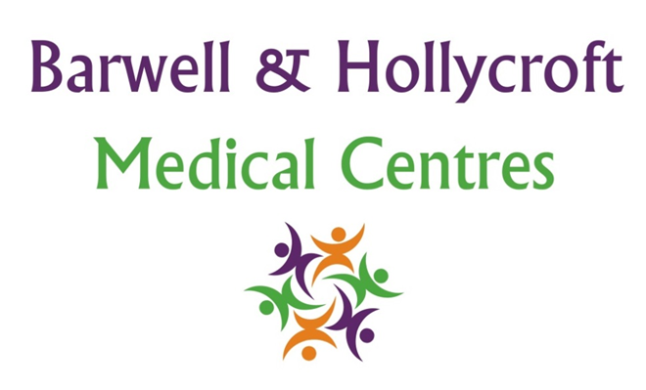
Mental Health and Wellbeing Policy
at Barwell & Hollycroft Medical Centres
(Website Version)

Creation and Implementation:
Version: | Created: | Created by: | Approved by: | Review date: | Comments:
1 | 29/01/25 | Rohitkumar Rajyaguru | The Partners | 31/01/2025

Review of Policy:
Version: | Review date: | Edited by: | Approved by: | Comments:

At Barwell & Hollycroft Medical Centres, we understand the importance of mental health and wellbeing in overall health. Our practice is committed to providing support, resources, and care for patients experiencing mental health challenges. This policy outlines how we assist with mental health concerns and provide access to the necessary services to ensure our patients receive the support they need.
Mental Health Services Available Within the Practice
We provide a range of mental health services within our practice, focusing on early intervention, support, and guidance. Our team includes GPs and healthcare professionals who are trained to identify and manage common mental health conditions.
- General Support: Our GPs are available to discuss mental health concerns, provide guidance, and offer initial treatment for conditions such as depression, anxiety, and stress. We can provide prescriptions for medications, including antidepressants, if required, and offer lifestyle advice to support mental wellbeing.
- Ongoing Care: For patients requiring ongoing care, we can provide regular follow-up appointments to monitor progress, adjust treatment plans, and offer continued support.
Referrals to Mental Health Professionals or Counselling Services
If you require more specialised care, we can refer you to mental health professionals, such as psychologists, counsellors, or psychiatrists.
- Counselling Services: We work with a variety of counselling and therapeutic services, including talking therapies like cognitive behavioural therapy (CBT). Your GP can discuss options with you and refer you to the most appropriate service for your needs.
- Specialist Mental Health Services: For patients with more complex mental health issues, we can refer you to community mental health teams or other specialist services like our Mental Health Facilitators for comprehensive care and treatment.
Crisis Intervention Protocols
We understand that mental health crises can arise suddenly, and it’s essential to act quickly to ensure safety and provide support.
- Crisis Support: If you are experiencing a mental health crisis, such as suicidal thoughts or severe distress, please contact us immediately. Our team will provide immediate support and may refer you for urgent treatment or assessment.
- Emergency Response: If there is an immediate risk of harm, we will refer you to emergency services or arrange for you to be seen urgently by a mental health crisis team. Your safety and wellbeing are our primary concern.
Patient Confidentiality and Handling of Sensitive Mental Health Information
We are committed to protecting your privacy and ensuring that any information related to your mental health is handled with the highest level of confidentiality.
- Confidential Care: Any information you share with us regarding your mental health will be kept confidential and stored securely. We will only share this information with other healthcare professionals when necessary, and only with your consent.
- Consent for Sharing Information: In cases where it may be beneficial to share mental health information with other services (such as mental health professionals or specialists), we will seek your consent before doing so, unless there is a legal or safeguarding reason to share the information without your consent.
Support Resources for Patients
We also provide information on additional resources that can offer support for mental health and wellbeing.
- Hotlines and Support Lines: There are various helplines available if you need immediate emotional support. These include:
  - Samaritans: 116 123 (available 24/7 for anyone experiencing emotional distress)
  - Mind: 0300 123 3393 (mental health charity offering advice and support)
  - NHS 111: For urgent mental health advice when the practice is closed.
- Community Services: In addition to the services we provide, there are community-based organisations that can offer support, including local mental health charities, peer support groups, and wellbeing initiatives.

Contact Us
If you have any questions or need assistance with mental health support, please feel free to contact us:
- Phone: 01455 849149
We are here to support your mental health and wellbeing and can help guide you to the appropriate resources and care. Thank you for trusting Barwell & Hollycroft Medical Centres with your healthcare.

