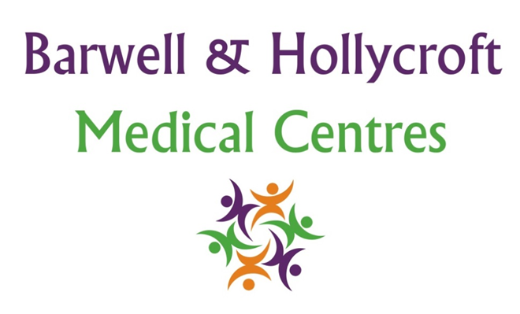
Patient Complaints and Feedback Policy
at Barwell & Hollycroft Medical Centres
(Website Version)

Creation and Implementation:
Version: | Created: | Created by: | Approved by: | Review date: | Comments:
1 | 29/01/25 | Rohitkumar Rajyaguru | The Partners | 31/01/2025

Review of Policy:
Version: | Review date: | Edited by: | Approved by: | Comments:

At Barwell & Hollycroft Medical Centres, we are committed to providing high-quality care to all of our patients. We value your feedback and believe that any complaints you have about our services can help us to improve. This policy outlines the procedure for submitting complaints or feedback and how we will handle them in a fair and transparent manner.
How to File a Complaint
We encourage patients to share their concerns with us directly so we can address them promptly. Most complaints can be managed in person, and we would therefore encourage you to speak to a member of our practice in the first instance.
You can file a complaint or provide feedback through the following methods:
- In Person: You can speak directly with a member of our reception team, who will be happy to assist you in filing your complaint or feedback.
- By Phone: Call us at 01455 849149 to speak with a member of the team. We are available to discuss any concerns you may have.
- In writing: If you prefer, you can write in to us with your complaint.
We will make sure that your complaint is handled in a confidential and respectful manner, and we will aim to resolve the issue as quickly as possible.
Expected Response Times for Complaints and Feedback
We aim to acknowledge all complaints and feedback within 3 working days of receiving them. Depending on the nature and complexity of the issue, we will keep you informed about the progress of the investigation. We aim to resolve all complaints within 10 working days, but in some cases, more time may be required to fully investigate and resolve the issue. If there is a delay, we will inform you and explain the reason.
How Complaints Will Be Handled
Once we have received your complaint or feedback, we will:
- Acknowledge Receipt: We will acknowledge your complaint within 3 working days, confirming that we have received it and are looking into the matter.
- Investigation: We will thoroughly investigate your complaint, gathering all necessary information to understand the situation fully. This may include speaking to relevant staff members, reviewing records, or conducting further enquiries.
- Resolution: Once the investigation is complete, we will provide you with a clear response, including the outcome and any actions we plan to take to resolve the issue. If applicable, we will explain any changes that will be made to prevent similar issues in the future.
- Ongoing Communication: If the issue is complex or takes longer to resolve, we will keep you informed of the progress.
We aim to resolve complaints in a way that is satisfactory to you, but we also understand that in some cases, you may wish to escalate your concerns.
Escalating Complaints: Regulatory Bodies and Health Commissioners
If, after following our complaints process, you feel that your concerns have not been resolved to your satisfaction, you have the right to escalate the matter to the relevant regulatory bodies:
- NHS England: If your complaint relates to NHS services or you are unhappy with the resolution provided by the practice, you may contact NHS England for further advice or to escalate your concern.
  - Website: www.england.nhs.uk/contact-us/
  - Phone: 0300 311 22 33
  - Email: england.contactus@nhs.net
We value your feedback and are committed to resolving issues promptly and fairly. Your experience helps us to continually improve the services we provide to all our patients.

Contact Us
If you have any questions about our complaints or feedback process, or if you would like to discuss a concern, please do not hesitate to contact us at 01455 849149. Our team is here to help and will be happy to support you through the process.
Thank you for helping us improve our services. Your satisfaction is important to us, and we are committed to resolving any concerns in a professional and timely manner.

