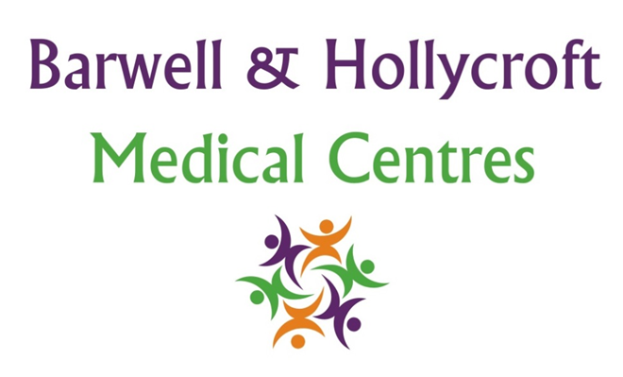
Patient Rights and Responsibilities Policy
at Barwell & Hollycroft Medical Centres
(Website Version)

Creation and Implementation:
Version: | Created: | Created by: | Approved by: | Review date: | Comments:
1 | 29/01/25 | Rohitkumar Rajyaguru | The Partners | 31/01/2025

Review of Policy:
Version: | Review date: | Edited by: | Approved by: | Comments:

At Barwell & Hollycroft Medical Centres, we are dedicated to providing high-quality healthcare services to all our patients. In return, we ask that patients respect certain responsibilities to help us maintain a safe, efficient, and supportive environment for everyone. This policy outlines your rights as a patient, as well as your responsibilities when interacting with our practice.
Patients' Rights
As a patient of Barwell & Hollycroft Medical Centres, you have the right to:
- Quality Care: You have the right to receive appropriate, high-quality healthcare services that are based on your individual needs. This includes access to medical professionals who are competent, caring, and professional in their approach.
- Respect and Dignity: You are entitled to be treated with respect, dignity, and consideration at all times. Our staff will communicate with you in a manner that respects your privacy, values, and preferences.
- Confidentiality: Your personal health information will be kept confidential, in line with our confidentiality and data protection policies. We will not share your health details without your consent, unless required by law.
- Informed Consent: You have the right to be fully informed about your medical care and treatment options. This includes being involved in decisions about your health and having your questions answered clearly and honestly.
- Non-Discrimination: You are entitled to receive care that is free from discrimination, whether based on age, gender, race, disability, sexual orientation, religion, or any other factor. We are committed to providing care to all patients equally.
- Access to Services: You have the right to access services that are available at the practice, including booking appointments, receiving repeat prescriptions, and accessing your medical records, as outlined in our policies.
Patient Responsibilities
To help us provide the best care and ensure the smooth running of the practice, we ask that patients take responsibility for the following:
- Attending Appointments: We ask that you make every effort to attend your scheduled appointments. If you are unable to attend, please notify us in advance, ideally 24 hours prior to your appointment. This allows us to offer your slot to another patient. Failure to attend appointments without prior notice may lead to restrictions on future bookings and in certain circumstances, removal from our practice register.
- Providing Accurate Information: It is essential that you provide accurate and complete information about your health and medical history. This helps us ensure that we are able to offer you the most appropriate care and treatment.
- Following Treatment Plans: To ensure the effectiveness of your treatment, you are responsible for following any prescribed treatment plans and medication instructions. If you are unsure about any aspect of your care, please feel free to ask your healthcare provider for clarification.
- Respecting Practice Staff: We ask that you treat all our staff members with courtesy and respect. Verbal or physical abuse, aggressive behaviour, or intimidation will not be tolerated under any circumstances. We are committed to providing a safe and respectful working environment for all our staff. The NHS has a Zero Tolerance Policy which we as a practice will adhere to.
- Keeping Us Informed: It is important that you inform us of any changes to your personal information, such as your contact details or emergency contacts, to ensure that we can always reach you when necessary.
Consequences of Missing Appointments or Abuse of Staff
- Missed Appointments: If you fail to attend an appointment without notifying us in advance, it may affect your ability to book future appointments at the practice. Repeated missed appointments may lead to review of your registration with the practice.
- Abuse of Practice Staff: We have a zero-tolerance policy towards abuse, whether verbal or physical, towards our staff members. Any patient found to be abusive or threatening to staff may be removed from our patient list, and further action may be taken if necessary. This policy is in place to ensure a safe, professional environment for both patients and staff.

Contact Us
If you have any questions about this policy or need further clarification on your rights and responsibilities, please do not hesitate to contact us at 01455 849149. Our team is always here to help and support you.
Thank you for your understanding and cooperation. By working together, we can ensure the smooth operation of the practice and the best possible care for all our patients.

