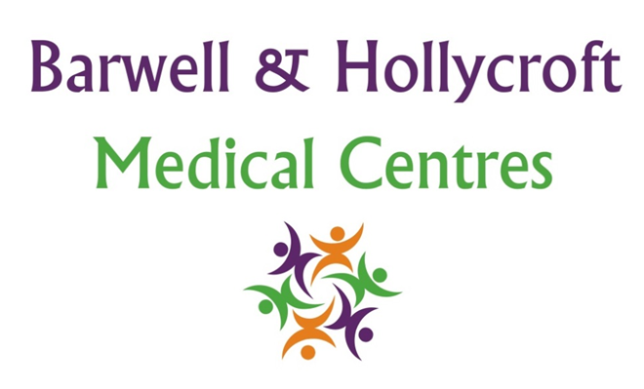
Prescriptions and Medication Policy
at Barwell & Hollycroft Medical Centres
(Website Version)

Creation and Implementation:
Version: | Created: | Created by: | Approved by: | Review date: | Comments:
1 | 29/01/25 | Rohitkumar Rajyaguru | The Partners | 31/01/2025

Review of Policy:
Version: | Review date: | Edited by: | Approved by: | Comments:

At Barwell & Hollycroft Medical Centres, we are dedicated to ensuring that you receive the right medication for your health needs in a timely and efficient manner. This policy outlines how prescriptions are managed, including how to request them, our policies on repeat prescriptions, and the responsibilities both you and our practice have in relation to your medication.
How to Request Repeat Prescriptions
If you require a repeat prescription, you can request it using the following methods:
- Online: You can order repeat prescriptions via our online portal. Simply log in to your account and select the medications you need.
- In Person: You can visit the practice and submit a written request for your repeat prescription. Please use the prescription request slip provided, which will list your current medications.
- Through your Pharmacy: certain groups of patients who are not able to manage their own prescriptions can have their local Pharmacy manage the requesting of their medications.
Please note that we do not take Repeat Prescription requests via telephone.
We encourage you to request your repeat prescription well in advance to avoid running out of medication.
Prescription Validity and Repeat Prescriptions
- Prescription Validity: A prescription is typically valid for a specific period. Once this period expires, you may need a follow-up consultation or review with the surgery to ensure your medication is still appropriate for your needs. We will contact you when it is time for your reviews.
- Repeat Prescriptions: For medications that are prescribed on a repeat basis, we recommend that you request at least 2 working days before running out. Please note that it is your responsibility to keep track of your medication and request refills in advance unless the Pharmacy manages this for you.
Emergency Prescriptions
If you require an emergency prescription (for example, in cases of lost medication or urgent need), please contact the practice as soon as possible. We will do our best to assist you, but please be aware that certain medications, particularly controlled drugs, may require additional authorisation.
You may also be able to obtain an emergency supply of your medication from your regular Pharmacy.
Expected Timeframe for Prescription Requests
- Routine Requests: Please allow 48 hours (2 full working days) for the processing of repeat prescription requests. This ensures our team has enough time to review your request and prepare your medication for collection or delivery.
- Emergency Requests: In emergency situations, we will prioritise your request and aim to process it as quickly as possible but we cannot guarantee that this will process on the same day.
Medication Reviews and Patient Responsibility
- Regular Medication Reviews: For your safety and wellbeing, we recommend that you have a medication review at least once a year, or more frequently if your health needs change. This review allows us to check that your medication is still appropriate, adjust dosages if necessary, and address any side effects or interactions.
- Patient Responsibility: It is important that you keep track of your medications, including when you need a repeat prescription. If you are unsure about any of your medications, or if you have questions about side effects or potential interactions, please do not hesitate to contact the practice.
Please remember that it is your responsibility to inform us if you are experiencing any issues with your medication, or if your condition changes, so that we can provide the best care possible.

Contact Us
If you have any questions about prescriptions or need assistance with your medication, please speak to your local Pharmacist or contact us at the practice. We are here to help and ensure that you receive the care and support you need.
Thank you for trusting Barwell & Hollycroft Medical Centres with your healthcare needs. We are committed to supporting your wellbeing through effective management of your prescriptions and medication.

