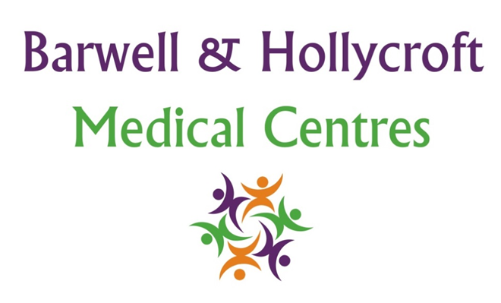
Privacy and Data Protection Policy (GDPR Compliance)
at Barwell & Hollycroft Medical Centres
(Website Version)

Creation and Implementation:
Version: | Created: | Created by: | Approved by: | Review date: | Comments:
1 | 29/01/25 | Rohitkumar Rajyaguru | The Partners | 31/01/2025

Review of Policy:
Version: | Review date: | Edited by: | Approved by: | Comments:

At Barwell & Hollycroft Medical Centres, we are committed to protecting the privacy and security of your personal information. This Privacy and Data Protection Policy explains how we collect, store, process, and protect your data in compliance with the General Data Protection Regulation (GDPR) and other relevant data protection laws. We value your trust and aim to ensure transparency in how your data is managed.
Types of Data We Collect
In order to provide you with the best care, we need to collect and process certain types of information:
- Personal Information: This includes details such as your name, address, date of birth, phone number, and email address.
- Medical Information: This includes your health history, current conditions, treatments, diagnoses, test results, prescriptions, and other medical details.
- Emergency Contact Information: We may ask for emergency contact details to assist in urgent situations.
- Other Relevant Information: This might include information about your lifestyle, such as smoking or alcohol consumption, if relevant to your care.
How We Use Your Data
We use the information we collect for a range of purposes, including:
- Providing Healthcare Services: We use your data to deliver the medical treatment, care, and advice you need. This includes diagnosis, prescriptions, referrals, and ongoing management of your health.
- Administrative Purposes: We use your data for appointment scheduling, reminders, informing you of results, and other necessary administrative functions that help us manage your care effectively.
- Communication: We may contact you about your appointments, test results, and other aspects of your healthcare, ensuring you stay informed about your health.
How We Protect Your Data
We take the security of your personal data very seriously. To ensure your information is safe, we employ a variety of security measures:
- Data Encryption: We use secure encryption methods to protect your data when it is stored or transmitted, ensuring it is not accessible to unauthorised parties.
- Restricted Access: Only authorised staff members who are trained in data protection are allowed access to your personal and medical information.
- Physical Security: We ensure that paper records are stored securely and electronic systems are protected from unauthorised access through secure login procedures and other security protocols.
Your Rights Regarding Your Data
Under the GDPR, you have specific rights over your personal data, which include:
- Right of Access: You can request a copy of the personal data we hold about you.
- Right to Correction: If you notice any inaccuracies in the data we hold, you can ask us to correct it.
- Right to Deletion: You can request that we delete your data, though this is subject to certain legal obligations and circumstances.
- Right to Data Portability: You can request your data in a format that can be easily transferred to another healthcare provider if necessary.
- Right to Object: You have the right to object to the processing of your data for certain purposes, such as marketing.
If you wish to exercise any of these rights, please contact us at the practice.
Sharing Your Data
We understand that your personal and medical information is sensitive. We only share your data when necessary for your care or as required by law. Data may be shared with:
- Healthcare Professionals: If we refer you to a specialist or another healthcare provider, we may need to share relevant information about your medical history and treatment to ensure continuity of care.
- Laboratories and Testing Services: We may share your data with laboratories to process tests or receive results.
- Regulatory Authorities: We may be required to share your data with regulatory bodies or law enforcement agencies in certain situations, in compliance with legal requirements.
Any third parties we share your data with are required to comply with relevant data protection laws to ensure your information remains secure.

Contact Us
If you have any questions about how we handle your personal data or would like to exercise any of your rights under the GDPR, please don’t hesitate to get in touch with us.
We are here to help and are committed to ensuring that your data is treated with the highest level of care and respect.

Regular Reviews and Updates
This policy is reviewed regularly to ensure compliance with data protection laws and may be updated as necessary. Any changes will be made to this policy online, and we encourage you to review this policy periodically.
Thank you for entrusting Barwell & Hollycroft Medical Centres with your care. Your privacy is important to us, and we are dedicated to safeguarding your personal information.

