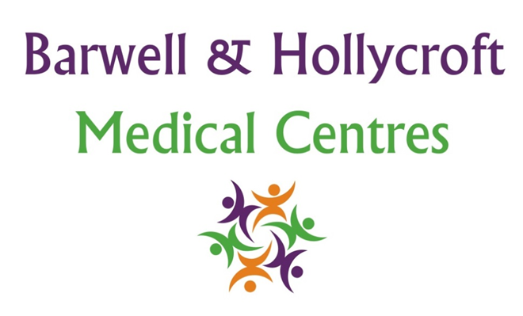
Safeguarding and Child Protection Policy
at Barwell & Hollycroft Medical Centres
(Website Version)

Creation and Implementation:
Version: | Created: | Created by: | Approved by: | Review date: | Comments:
1 | 29/01/25 | Rohitkumar Rajyaguru | The Partners | 31/01/2025

Review of Policy:
Version: | Review date: | Edited by: | Approved by: | Comments:

At Barwell & Hollycroft Medical Centres, the safety and wellbeing of children and vulnerable adults are our top priority. We are committed to safeguarding all our patients, particularly those at risk of abuse or neglect. This policy outlines the practice's approach to safeguarding and child protection, ensuring that we follow appropriate procedures to protect vulnerable individuals and work collaboratively with other agencies when necessary.
Process for Identifying and Reporting Concerns About Abuse or Neglect
Our staff are trained to recognise signs of abuse or neglect and are committed to acting promptly and appropriately if they have concerns about the safety of a child or vulnerable adult.
- Identifying Concerns: Our healthcare professionals are alert to signs of physical, emotional, or sexual abuse, neglect, and exploitation. We encourage parents, carers, and patients to share any concerns they may have about their own safety or the safety of others.
- Reporting Concerns: If any member of our team has concerns about abuse or neglect, they will follow our internal safeguarding procedures. This may involve reporting the concern to the appropriate authorities, such as social services or the police, to ensure that the individual is protected and receives the necessary support.
- Confidentiality: While we respect the confidentiality of our patients, the safety and protection of vulnerable individuals take precedence. If a concern is raised, we may need to share relevant information with safeguarding authorities to ensure the immediate safety of the individual involved.
Staff Training Requirements in Safeguarding and Child Protection
We believe that safeguarding is a collective responsibility, and all staff members are provided with the training necessary to recognise and respond to safeguarding concerns.
- Mandatory Training: All staff, including clinical and administrative teams, undergo regular safeguarding training. This includes identifying the signs of abuse or neglect, understanding the procedures for reporting concerns, and working within the guidelines set out by local safeguarding authorities.
- Ongoing Education: Our staff participate in regular updates and training on safeguarding best practices to ensure they remain knowledgeable and equipped to handle safeguarding matters sensitively and appropriately.
Procedures for Working with Other Agencies
Safeguarding is often a complex issue that requires collaboration with other agencies. We work closely with local authorities, social services, police, and other safeguarding professionals to ensure a coordinated response to any concerns.
- Collaboration: If necessary, we will share relevant information with safeguarding agencies, such as social services, to ensure the best interests of the child or vulnerable adult. We follow all legal and professional guidelines when working with other agencies.
- Multi-Agency Meetings: In some cases, a multi-agency approach may be required, where professionals from different fields work together to provide support and protection. We will cooperate fully with these efforts to ensure the safety and wellbeing of vulnerable individuals.
Guidelines for Addressing Suspected Cases of Domestic Violence or Exploitation
Domestic violence and exploitation can have a significant impact on the health and wellbeing of individuals. Our practice is committed to providing a safe space for anyone who may be experiencing such situations.
- Supporting Victims: If a patient discloses domestic violence or exploitation, our healthcare professionals will listen without judgement and provide support. We may offer resources, including contact details for domestic violence helplines, local refuges, and support services.
- Referral to Specialist Services: We may refer patients to specialist services that can offer additional support and safety planning. Our team will ensure that patients are informed of their rights and the options available to them.
- Sensitivity and Confidentiality: We approach all disclosures with sensitivity and respect for the individual's confidentiality. However, if there is a risk of immediate harm, we may need to take appropriate action to ensure their safety, including contacting the authorities.
Consent and Confidentiality Issues Related to Safeguarding Cases
Safeguarding is a delicate issue, and we are committed to balancing confidentiality with the need to protect vulnerable individuals.
- Informed Consent: In most cases, we will seek the patient’s consent before sharing information with safeguarding authorities. However, if there is a concern that a child or vulnerable adult is at risk, the safety of the individual may override the need for consent.
- Confidentiality: We will always aim to handle safeguarding cases with the utmost confidentiality, sharing information only with those agencies or professionals who need it to protect the individual involved. Information will only be disclosed as necessary and in accordance with relevant laws and regulations.
Contact Us
If you have any concerns or need support, please do not hesitate to contact us. The safety and wellbeing of our patients are our top priorities.
- Phone: 01455 849149
We are here to support you and ensure that everyone has access to safe and effective healthcare. Thank you for choosing Barwell & Hollycroft Medical Centres.

