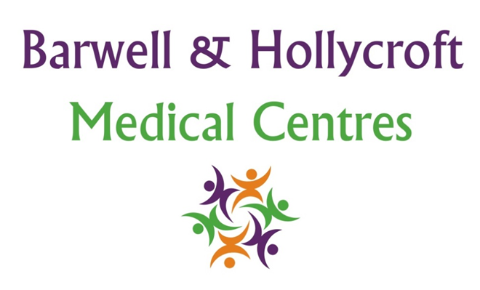
Social Media and Online Communication Policy
at Barwell & Hollycroft Medical Centres
(Website Version)

Creation and Implementation:
Version: | Created: | Created by: | Approved by: | Review date: | Comments:
1 | 29/01/25 | Rohitkumar Rajyaguru | The Partners | 31/01/2025

Review of Policy:
Version: | Review date: | Edited by: | Approved by: | Comments:

At Barwell & Hollycroft Medical Centres, we are committed to providing excellent patient care and maintaining professional relationships with our patients through all communication channels. This policy outlines the guidelines for how patients can interact with us through social media and other online platforms, while ensuring that privacy and confidentiality are respected.
Guidelines for Social Media Interactions
We value feedback and communication through our social media channels, including Facebook, Twitter, and other platforms. To ensure safe, respectful, and effective communication, we ask that all interactions be conducted with courtesy and professionalism.
- General Interactions: Patients are welcome to follow our practice on social media platforms to receive updates and information about services, health tips, and practice news. We encourage positive engagement and sharing of information with others.
- Medical Queries: While we welcome feedback and general questions, we do not provide medical advice through social media. Medical advice should be sought through appropriate channels, such as booking an appointment, visiting our website, or contacting the practice directly.
- Respectful Communication: Please be respectful when commenting or messaging. Any inappropriate language, abusive behaviour, or offensive comments will not be tolerated. We reserve the right to block or report any individuals engaging in inappropriate behaviour.
Boundaries for Using Social Media for Medical Advice
While we understand that social media is a popular way to communicate, it is not an appropriate platform for discussing specific medical conditions or seeking medical advice. To protect your health and privacy:
- Medical Queries: We encourage patients to contact us directly via telephone or online via our website for any advice or questions. Social media is not a secure or suitable platform for confidential medical discussions.
- Emergency Situations: In the case of a medical emergency, please dial 999 or visit your nearest Accident & Emergency department. Do not use social media to discuss emergencies or urgent medical needs.
Maintaining Privacy and Confidentiality
Patient confidentiality and privacy are of the utmost importance. Social media platforms are not secure channels for sensitive medical information. We ask that patients do not share personal health details, medical conditions, or other confidential information via social media.
- Confidentiality on Social Media: Please do not post any personal information about your health or treatment on social media. If you need to discuss sensitive issues, please contact the practice directly through secure communication methods.
- Staff Privacy: We also ask that you respect the privacy of our staff and avoid posting about specific interactions with individual team members on social media.
Secure Channels for Communication
To ensure the safety and confidentiality of your information, we offer secure channels for communication:
- Patient Portal: Our patient portal on our website provides a secure, private space where you can access your medical records, request appointments, and communicate with the practice about non-urgent medical queries. We encourage all patients to use the patient portal for any health-related queries that require a secure response.
- Telephone and Email: For non-urgent matters, patients can also contact us via phone (01455 849149) or email (Barwell.MC@nhs.net). Please note that email is not a completely secure method of communication, and we advise against sharing sensitive personal information through email.

Contact Us
For medical enquiries, appointment requests, or any other non-urgent matters, we encourage you to reach out through the following channels:
- Phone: 01455 849149
Thank you for helping us ensure a safe, respectful, and confidential online environment for everyone. We look forward to maintaining positive, productive interactions with our patients both online and offline.
If you have any questions about this policy or need assistance with digital communication, please do not hesitate to contact us.

