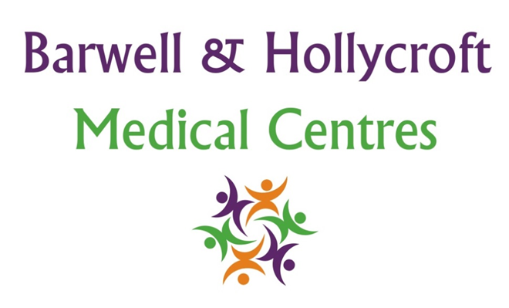
Staff Equality and Diversity Policy
at Barwell & Hollycroft Medical Centres
(Website Version)

Creation and Implementation:
Version: | Created: | Created by: | Approved by: | Review date: | Comments:
1 | 29/01/25 | Rohitkumar Rajyaguru | The Partners | 31/01/2025

Review of Policy:
Version: | Review date: | Edited by: | Approved by: | Comments:

At Barwell & Hollycroft Medical Centres, we are committed to providing a supportive and inclusive environment for both our staff and patients. This policy outlines our approach to equality, diversity, and inclusion in all areas of our work. We strive to ensure that every individual, regardless of their background, culture, or personal circumstances, is treated with dignity and respect.
Commitment to Non-Discriminatory Practices
We believe that all individuals should be treated fairly, regardless of their race, ethnicity, gender, age, disability, sexual orientation, religion, or any other characteristic. Our commitment to equality and diversity applies to:
- Staff Recruitment: We are dedicated to ensuring that our recruitment practices are fair and transparent. We aim to hire individuals based on their qualifications, skills, and experience, without discrimination or bias.
- Patient Care: We ensure that all patients are provided with high-quality, respectful care. Our practice is open to all, and we work hard to create an environment where patients feel valued and understood, no matter their background or identity.
Workplace Diversity and Respect for All Cultures, Backgrounds, and Abilities
We value the diversity of our staff and patients and recognise the strength it brings to our practice. This policy ensures:
- Respect for All Cultures: We encourage an atmosphere where differences are celebrated and cultural awareness is promoted.
- Supporting Individuals with Disabilities: We make reasonable adjustments for patients and staff with disabilities to ensure full participation and access to care.
- Respectful Environment: We aim to create a positive work environment where mutual respect is the foundation of all interactions between staff, patients, and visitors.
Training on Equality and Diversity for All Staff Members
Our staff receives regular training on equality and diversity. This includes:
- Understanding Equality: Ensuring that all staff understand the importance of providing care that is free from discrimination, bias, or prejudice.
- Cultural Competence: Providing staff with the tools to work effectively with people from diverse cultural backgrounds, ensuring they respect different values, beliefs, and practices.
- Handling Sensitive Situations: Equipping staff to handle sensitive issues with empathy and understanding, particularly when interacting with patients from vulnerable or minority groups.
Handling Complaints Related to Discrimination or Bias
We take any form of discrimination or bias seriously. If you feel that you have been treated unfairly, we encourage you to raise your concerns. Our practice has clear procedures for handling complaints:
- Making a Complaint: You can make a complaint by contacting us directly at Barwell.MC@nhs.net or by phone at 01455 849149.
- Investigation Process: Every complaint will be investigated thoroughly. We will work to resolve the issue promptly and will provide feedback on the outcome of the investigation.
- Protection from Retaliation: We ensure that patients and staff who raise concerns about discrimination are not subject to any form of retaliation or negative consequences.
Promotion of Inclusive Practices in Patient Care
We believe in offering care that meets the needs of all our patients. Our approach includes:
- Inclusive Care Plans: Ensuring that care plans are developed with respect to individual patient needs, including cultural and language preferences.
- Access to Interpreters: If necessary, we provide access to interpreters and translation services to ensure clear communication with patients who do not speak English or have hearing impairments.
- Respecting Religious and Cultural Beliefs: We are committed to understanding and accommodating the religious and cultural practices of our patients, wherever possible, to ensure their comfort and dignity.
At Barwell & Hollycroft Medical Centres, we are committed to creating a welcoming, inclusive environment for everyone. If you have any questions or concerns about this policy, or if you feel that we could do more to promote equality and diversity, please contact us.
Our practice telephone number is: 01455 849149
Our practice email address is: Barwell.MC@nhs.net
Thank you for helping us create a respectful and inclusive practice for all.

