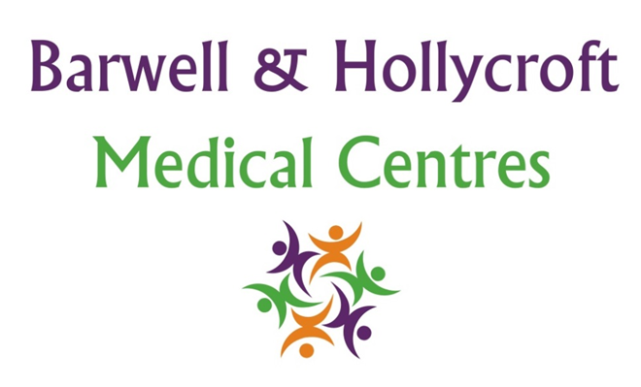
Staff Training and Professional Development Policy
at Barwell & Hollycroft Medical Centres
(Website Version)

Creation and Implementation:
Version: | Created: | Created by: | Approved by: | Review date: | Comments:
1 | 29/01/25 | Rohitkumar Rajyaguru | The Partners | 31/01/2025

Review of Policy:
Version: | Review date: | Edited by: | Approved by: | Comments:

At Barwell & Hollycroft Medical Centres, we are committed to providing high-quality care to our patients, and we believe that continuous professional development for our staff is crucial to achieving this goal. This policy outlines our approach to staff training, professional development, and performance reviews, ensuring that all of our team members have the skills and knowledge needed to provide excellent care and service.
Commitment to Ongoing Training for Clinical and Administrative Staff
We believe that ongoing training is essential to maintaining high standards of care and service. This applies to all staff, both clinical and administrative, to ensure they are fully equipped to meet the needs of our patients.
- Clinical Staff: Our clinical team, including doctors, nurses, and other healthcare professionals, regularly participate in training to ensure they are up-to-date with the latest medical practices, treatments, and clinical guidelines. This includes training in areas such as patient safety, infection control, and new treatment protocols.
- Administrative Staff: Administrative staff, including receptionists and office personnel, receive training to support their roles in managing appointments, patient records, and other key administrative tasks. They also receive training in customer service, confidentiality, and handling patient queries.
Procedures for Staff Performance Reviews and Professional Development
We are dedicated to supporting the professional development of our staff through regular performance reviews and ongoing development opportunities.
- Performance Reviews: Staff undergo annual performance reviews, where their work and professional development are assessed. These reviews focus on identifying areas for improvement, setting goals for the future, and discussing any additional training needs.
- Professional Development Plans: Based on the results of performance reviews, individual development plans are created for staff members to guide their professional growth. This ensures that all staff members have clear objectives and the resources they need to develop their skills further.
Requirements for Staff Certifications, Continuing Medical Education (CME), and Up-to-Date Clinical Knowledge
Our clinical staff are required to maintain current certifications and undertake continuing education to ensure they meet the highest standards of care.
- Certifications: Clinical staff are required to maintain all relevant certifications, such as those required by professional bodies (e.g., GMC for doctors, NMC for nurses), and participate in mandatory training programmes.
- Continuing Medical Education (CME): We encourage our healthcare professionals to attend relevant courses, conferences, and workshops to stay updated with the latest research, clinical practices, and innovations in their fields. This ensures that the treatments and services we provide are based on the most current evidence and best practices.
- Up-to-Date Clinical Knowledge: Clinical staff are expected to maintain up-to-date knowledge of the latest medical developments, guidelines, and clinical standards. This is achieved through ongoing education, peer discussions, and attending relevant courses and training sessions.
How Staff Development is Linked to Patient Care and Safety
The professional development of our staff is directly linked to the quality of care and safety we provide to our patients. By investing in training and development, we ensure that our team is equipped with the latest knowledge, skills, and practices to deliver safe and effective care.
- Improved Patient Care: Well-trained staff can make more informed decisions, offer better treatment options, and provide patients with the highest level of care possible. Training also improves communication between staff and patients, enhancing the overall patient experience.
- Patient Safety: Our staff training includes a strong focus on patient safety, including infection control, safeguarding, and responding to emergencies. By ensuring our team is well-prepared, we reduce the risks of errors, improve patient outcomes, and create a safe environment for all.
- Patient Satisfaction: By focusing on professional development, we ensure that our staff are able to provide excellent customer service, which plays a vital role in patient satisfaction. This includes skills such as empathy, communication, and effective problem-solving.

Contact Us
If you have any questions or concerns about our staff training and professional development processes, or if you would like more information about how we are ensuring high standards of care and safety, please feel free to get in touch with us:
- Phone: 01455 849149
- Email: Barwell.MC@nhs.net
We are committed to providing the highest level of care through continuous improvement and ensuring that our staff have the skills and knowledge necessary to meet your healthcare needs. Thank you for choosing Barwell & Hollycroft Medical Centres for your care.

